**How to Install Madflix2 Kodi 18 Leia Build**

Madflix 2 is a Netflix style Kodi Build for Leia 18 by frank from One Nation Portal.  
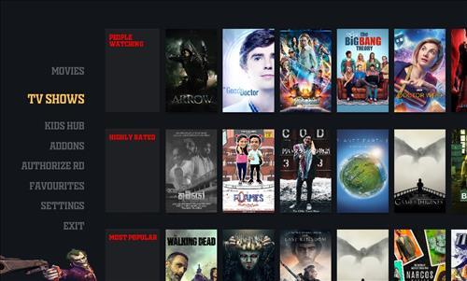  
   
This build has sections for Movies, TV shows, Kids hub, Add-ons, Authorize RD, Favourites and Settings.  
   
Using a VPN with Kodi is always recommended for privacy and security. [Try IPVanish](https://www.ipvanish.com/best-vpn-kodi/?a_aid=580f5f02d1df9&chan=bvking) which is Kodi friendly, has no logs, and unlimited bandwidth.  
 

**Steps to Install Madflix2 Kodi 18 Leia Build**

**Step 1)** From home screen go to **Settings**  
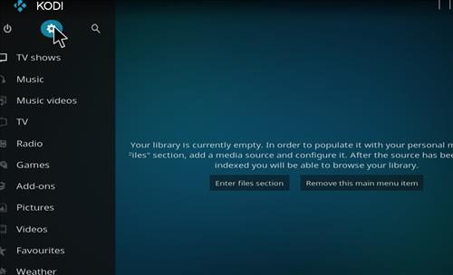  
   
**Step 2)** Click **File Manager**  
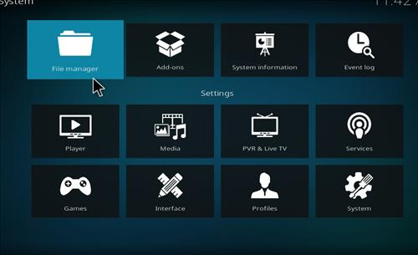  
   
**Step 3)** Click **Add Source**  
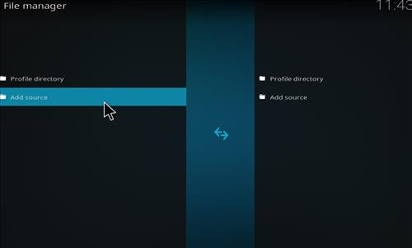  
   
**Step 4)** Click **None**  
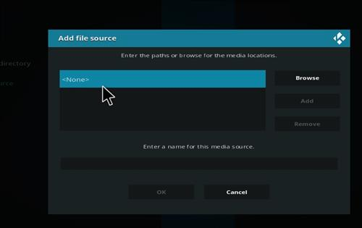  
   
**Step 5)** Enter the following address: **http://www.onenation.info/**  
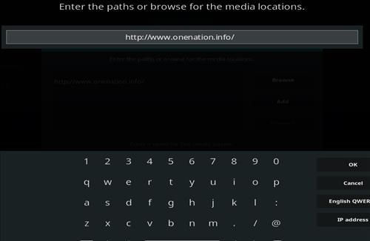  
   
**Step 6)** Name it **one nation**  
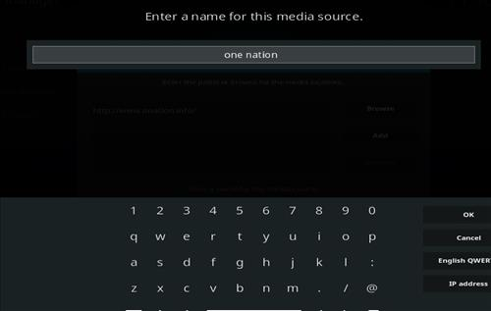  
 

**Step 7)** The boxes should match the picture below  
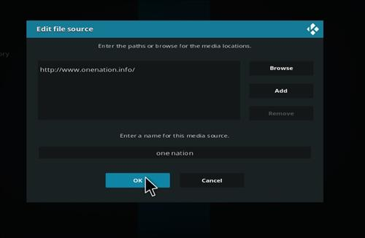  
   
**Step 8)** Go back to Home screen and click **Add-ons**  
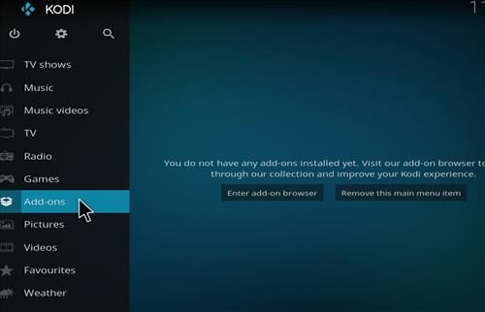  
   
**Step 9)** Click the add-on browser from the top left  
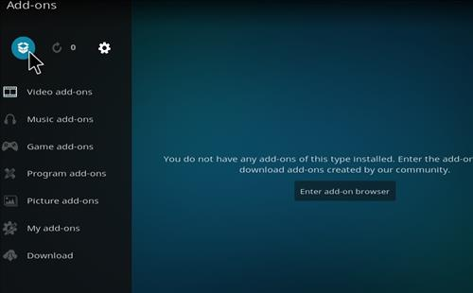  
 

**Step 10)** Click **Install from zip file**

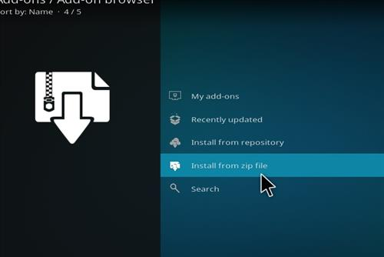  
 

**Step 11)** A box will open click **one nation**  
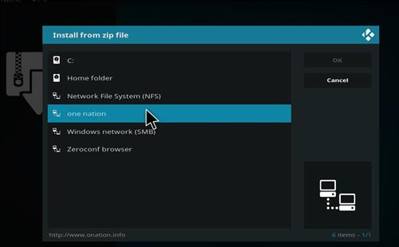  
   
**Step 12)** Click **portal**  
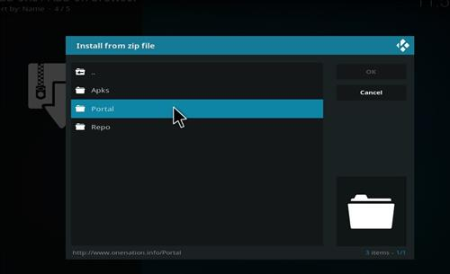  
 

**Step 13)** Click **plugin.onenationportal-1.1.zip**  
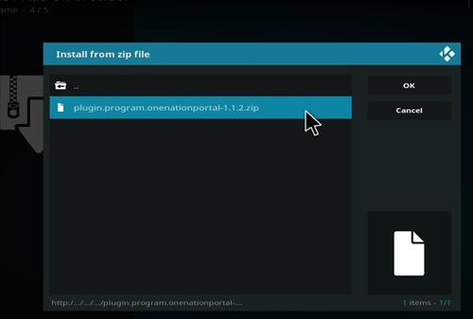  
   
**Step 14)** Wait for the top right to popup *One Nation Portal* Installed  
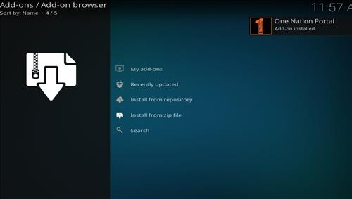  
 

**Step 15)** Click **Continue**  
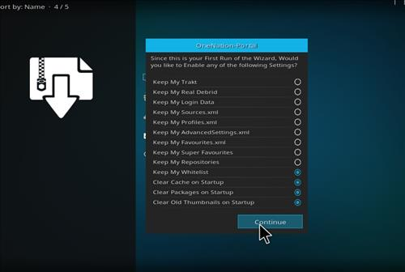  
   
**Step 16)** Click **Build Menu**  
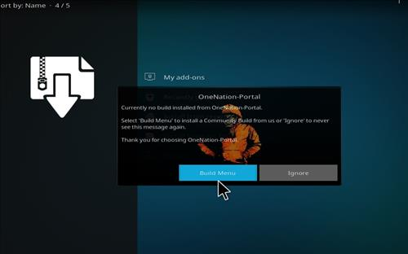  
 

**Step 17)** Click **Madflix**  
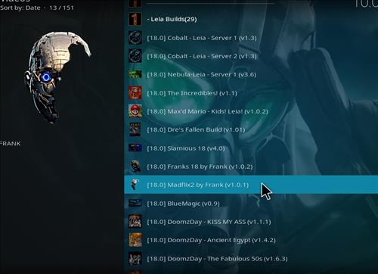  
   
**Step 18)** Click Fresh Install or Standard Install (Fresh Install is usually bests)  
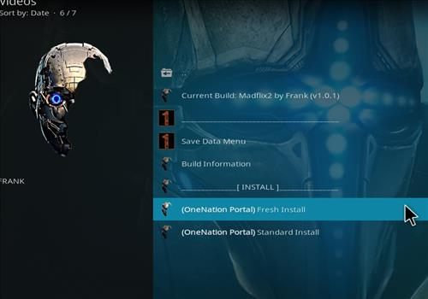  
 

**Step 19)** Click **Continue**  
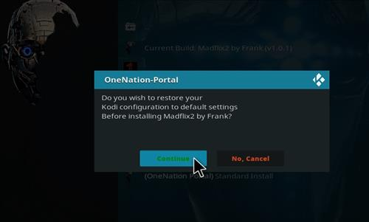  
   
**Step 20)** It will download and install  
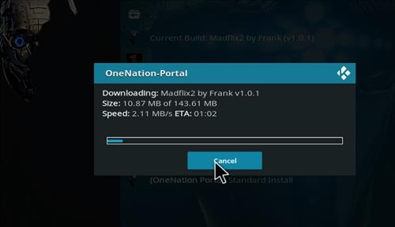  
 

**Step 21)** Click **force close**  
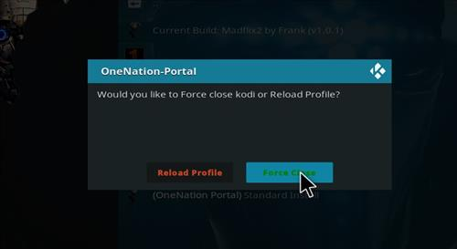  
   
**Step 22)** After it installs restart Kodi and it should come up. Be sure to give it time to build menus and update add-ons.  
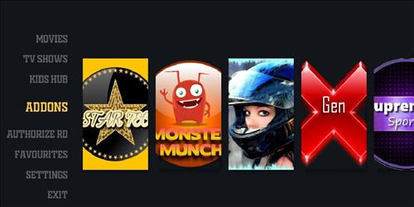  
   
 

**How to change the Skin back to Default Estuary**  
If this Build does not work for you here is how to change the Skin back to default Estuary and remove it.  
   
**Step 1)** From home screen go to **Setting**  
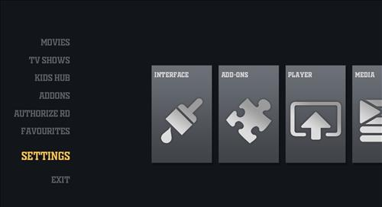  
   
**Step 2)** Click **Interface Settings**  
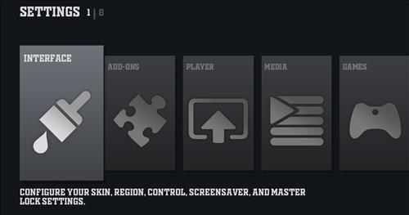  
 

**Step 3)** Click **Skin**   
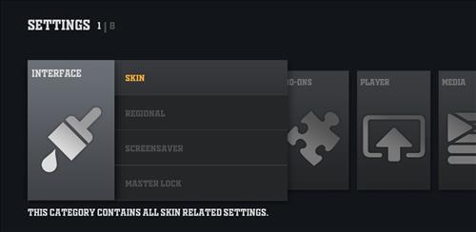  
   
**Step 4)** Click **Estuary**  
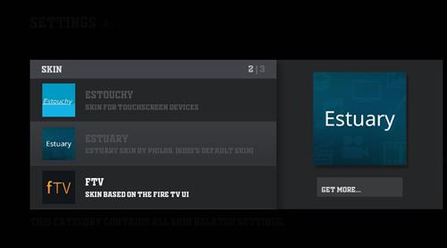  
 

**Step 5)** Click **Yes**  
