**How to Install One Alliance Reborn 1-Amazing Kodi Build 18 Leia**

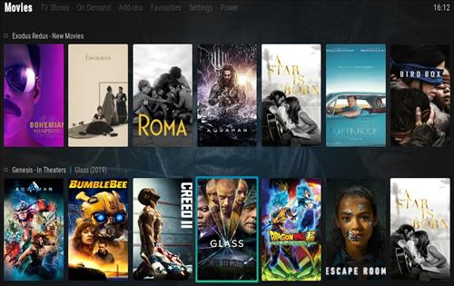  
  
One Alliance Reborn 1-Amazing is a great Kodi Build for the [new Leia 18](https://kodi.tv/article/kodi-180) release. It uses Aura 18 skin and it has size of 416 MB.  
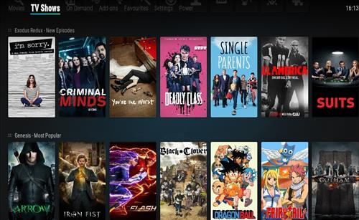

This build is filled with many great working Add-ons for Movies, TV shows, Live TV, ON Demand and Sports.  
   
Using a VPN with Kodi is always recommended for privacy and security. [Try IPVanish](https://www.ipvanish.com/best-vpn-kodi/?a_aid=580f5f02d1df9&chan=bvking) which is Kodi friendly, has no logs, and unlimited bandwidth.  
   
   
**Steps to Install One Alliance Reborn 1-Amazing Kodi Build 18 Leia**   
   
**Step 1)** From home screen go to **Settings**  
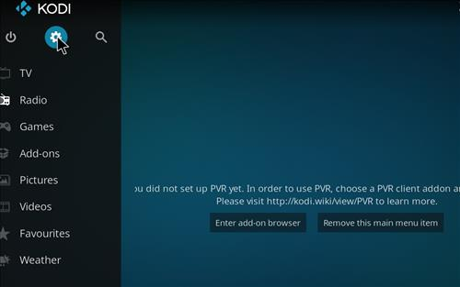  
 

**Step 2)** Click **File Manager**  
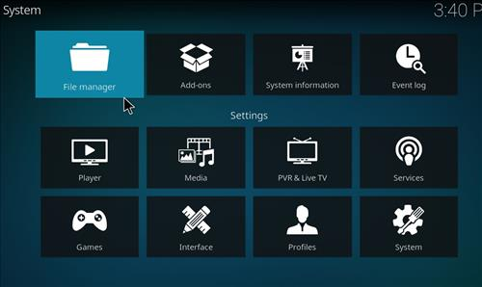  
   
**Step 3)** Click **Add Source**  
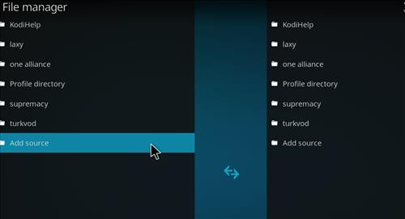  
 

**Step 4)** Click **None**  
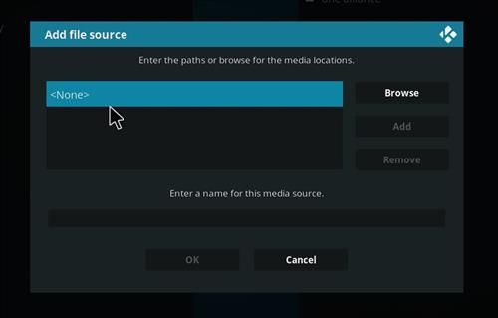  
   
**Step 5)** Enter the following address: **http://onealliancereborn.com/repo/**  
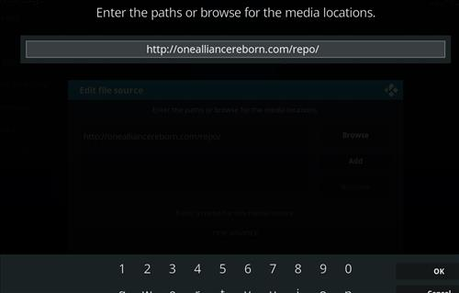  
 

**Step 6)** Name it **one alliance**  
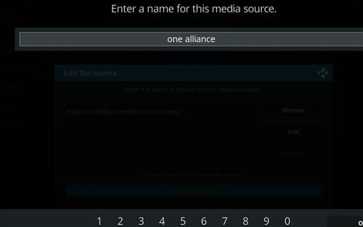  
   
**Step 7)** The boxes should match the picture below  
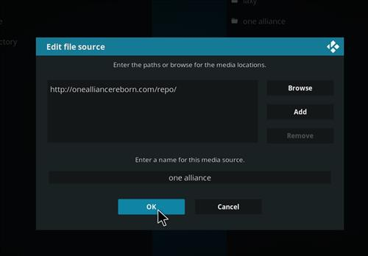  
 

**Step 8)** Go back to Home screen and click **add-ons**  
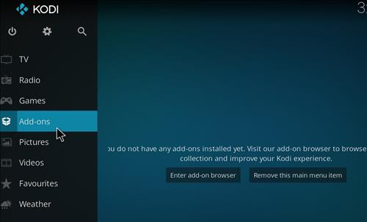  
   
**Step 9)** Click the add-on browser from the top left  
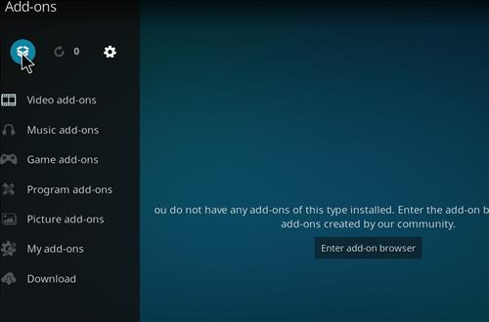  
 

**Step 10)** Click **Install from zip file**  
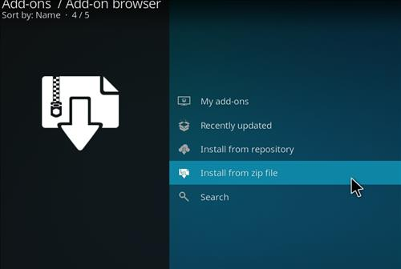  
   
**Step 11)** A box will open click **one alliance**  
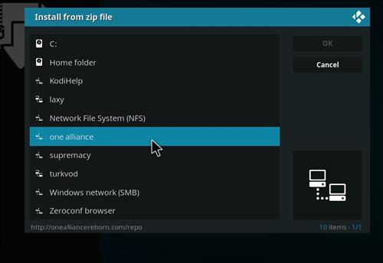  
 

**Step 12)** Click **plugin.program.onealliancerebornwizard-2.0.4.zip**  
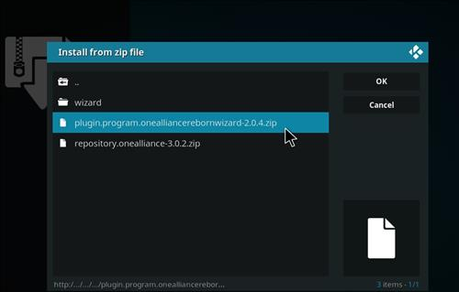  
   
**Step 13)** Wait for the top right to popup *OneAlliance Wizard* Installed  
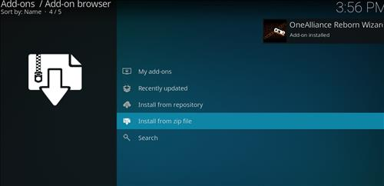  
 

**Step 14)** Click **Continue**  
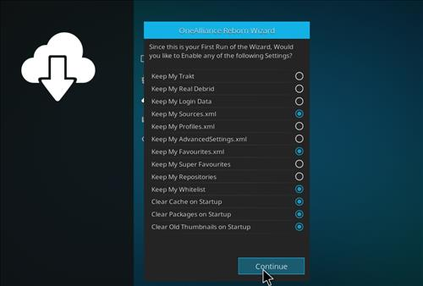  
   
**Step 15)** Click **Build Menu**   
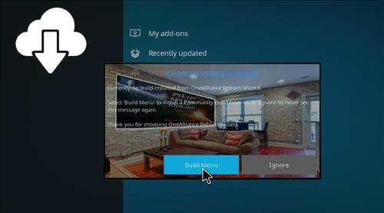  
 

**Step 16)** Click **Amazing Build for Kodi 18 Leia**  
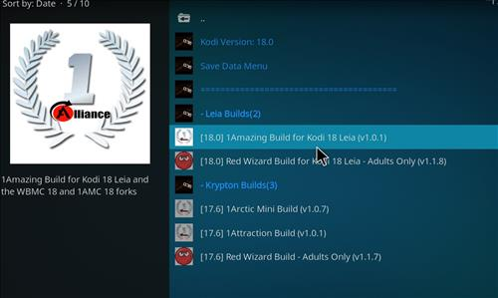  
   
**Step 17)** Click Fresh Install or Standard Install (Fresh Install is usually bests)  
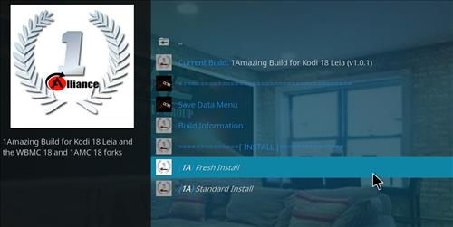  
 

**Step 18)** Click **Continue**  
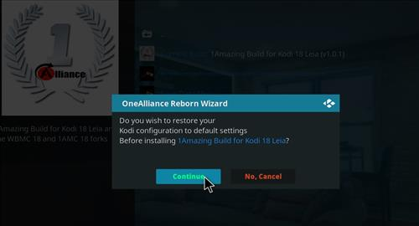  
   
**Step 19)** It will download and install  
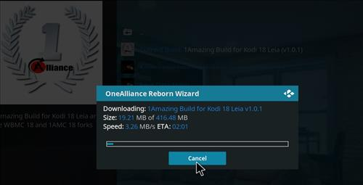  
 

**Step 20)** Click **Force close**  
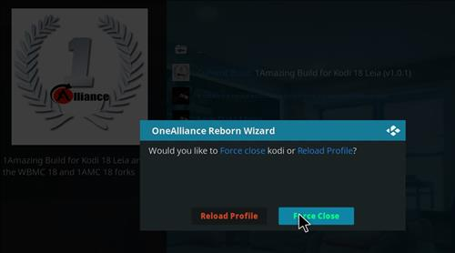  
   
**Step 21)** After it installs restart Kodi and it should come up. Be sure to give it time to build menus and update add-ons.  
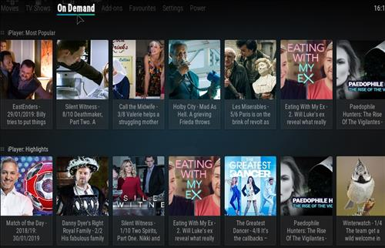  
   
 

If this Build does not work for you here is how to change the Skin back to default Estuary and remove it.  
   
**Step 1)** From home screen go to **Setting**  
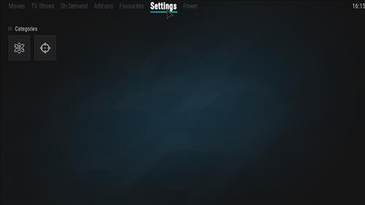  
   
**Step 2)** Click **Interface Settings**  
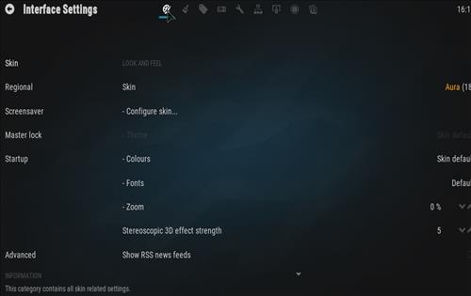

**Step 3)** Click **Skin**   
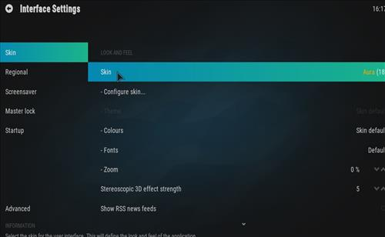

**Step 4)** Click **Estuary**  
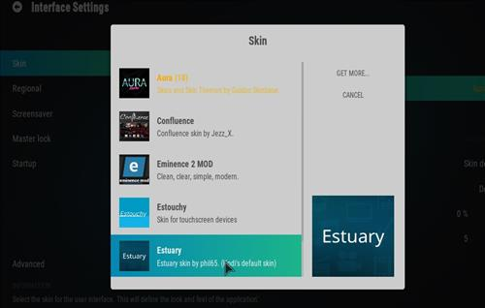   
   
**Step 5)** Click **Yes**  
