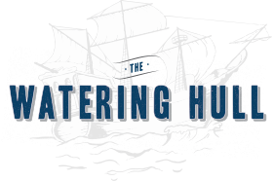***OPEN BARS***

Full-Service Bar ~ **priced per person\***

1 hour **$20**

2 hours **$35**

additional bar service per hour **$10**

Beer, Wine and Soft Drink Bar ~ **priced per person\***

**Domestic, Draft, & Imported Beers, House Wines, Soft Drinks & Bottled Water**

1 hour **$15**

2 hours **$20**

additional bar service per hour **$8**

***$100 Bartender Fee, One Bartender for every 50 Guests***

**\*Price Does Not Include 21% Service Fee and 6.65% NJ Sales Tax**



**CASH BAR**

***$100 Bartender Fee, One Bartender for every 50 Guests***

**\*Price Does Not Include 21% Service Fee and 6.65% NJ Sales Tax**

**If you would like a “Private” Section for your guests, there is a $500 Rental Fee.**

**If you are Interested in a Completely Private Event, we can accommodate for a fee depending on the time of year and day of week.**

**It is NOT available July 4th thru Labor Day**