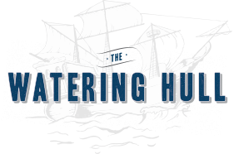

Tier #3
Small Plates:
Choose 3

Bahamian Conch Friters
Bacon Wrapped Shrimp
Mini Crab Cakes
Angus Burger Slliders
Vegetable Spring Rolls
Seared Ahi Tuna on Crispy Won-Ton
Wings Buffalo or BBQ
Chicken Satay w/ Thai Peanut Curry
Scallops wrapped in Bacon
Heiloom Tomato Bruschetta on Garlic Crostini

Salads:
Choose 1

Chopped Romaine (Caesar)
House Salad
Crab & Tomato Stack

Mains:
Choose 2

Jersey Tacos: Mahi, Habanero Shrimp, Pork or Chicken (2 tacos per person)
Bang Bang Chicken & Shrimp
Crab Cakes
Pan Seared Salmon
Hull House Burger
Grilled Portabella
½ Marinated Roated Chicken
8oz. Center Cut Filet

Desserts:
Choose 1

Key Lime Pie
Chocolate Lava Cake
NY Cheesecake
Limencello Marscpone Cake

All items will be priced according to selection
Please add 21% Service Fee and NJ Sales Tax

If you would like a “Private” Section for your guests, there is a $500 Rental Fee.
If you are Interested in a Completely Private Event, we can accommodate for a fee depending on the time of year and day of week.
***It is NOT available July 4th thru Labor Day

