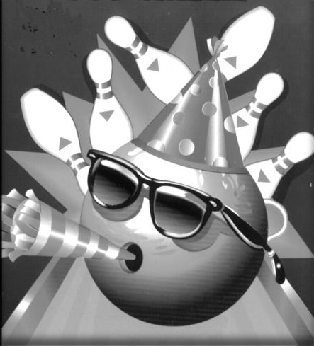
Freeway Lanes Bowling Center
Birthday Party Packages
Birthday Party
- 2 hours of bowling during open play*
- Only $11.25 per bowler
- Shoes included
- “FREE” Autograph Bowling Pin**
*Session includes 2 hours of bowling. You may come in 15 minutes early to decorate. A six foot table will be provided for your convenience. After 2 hours you may choose to continue bowling at the regular price per game per person.
**Receive a “FREE” autograph bowling pin when you reserve in advance with a $50.00 non-refundable deposit and have a minimum of 10 bowlers. (Bowling pin may be purchased separately for $15.00 plus tax)
Rock-N-Glow Bowl Birthday Party
- 3 hours of bowling – Fridays only from 9: P.30M. – 12:30 A.M.
- Session includes: Music and Lights
- Only $15.00 per bowler (8 bowler minimum)
- Shoes included
- You may come in 15 minutes early to decorate. A six foot table will be provided for your convenience.
Food & Beverage
16” Cheese Pizza ............................................................................................................. $12
16” Pepperoni Pizza ........................................................................................................ $13
16” Supreme Pizza……………………………………………………………………………………………………….17.5
Pitcher of Soda.................................................................................................................$6.5
(No Outside Food or Beverages Allowed)

Party Scheduled for Time Deposit Paid
(Date)

 | Date of Party: | Time: |  | A.M. / P.M. | Number of Bowlers:
 |  | Person Responsible for Payment:
 | Phone No. |  | Email:
 | No. of pizzas: | Address:
 | - I understand a $50.00 non-refundable deposit is required for a birthday party reservation and payment in full is required for a Rock-N-Glow Bowl party.
 | Signature |  |  |  | Date
8265 E. Dinuba Avenue Selma, CA 93662 (559) 896-2211 www.freewaylanesselma.com

