Catastrophic Bushfires in Australia.
In pursuit of an Evidence Based Ecological Restoration!
“The question is not what you look at, but what you see.” —Henry David Thoreau
Abstract: I am not a credentialled bushfire expert. However, after living amongst wildfire-threatened areas of Eastern Australia for over 50 years, considerable experience and A little research has moulded a different perspective in my thinking.
A “lightbulb” moment occurred in 2019 when it became obvious that much of the forest areas on the South Coast, New South Wales and adjacent areas were stressed, or dying before the fires raged.
This paper presents evidence that the post-colonial era in Australia has seen a huge impact on Australian forests, forest management and fire risk. Particularly, high-impact periods being the Australian Gold Rush and mining period 1850-1920, the period 1920-1950, (when land without profitable agricultural potential was neglected), the period 1950-present with the “Greening Australia”, tree preservation and National Parks era dominating much of Eastern Australia. During this later period forestry activities became commercialised and restricted in locality. Carbon capture in forests has been elevated to an ecological essential, particularly so, after COP26.
Also, requiring consideration, is the massive impact on land and forest management of displacing the indigenous population and their own management practices.
I strongly believe that forest density in Eastern Australia has been allowed to exceed a sustainable level such that, after shorter periods of below-average rainfall, inferno potential is dangerously high.
Water dynamics with diminishing run-off from forested areas and groundwater changes over many years have been a warning of environmental stress. Forest density may be an important contributing factor to diminishing water flows in many Eastern Australian catchments.
There can be no doubt that Climate Change is real and provides multiple threats, including fire, to ongoing human existence.
The confluence of these factors has produced a forest environment in much of Eastern Australia characterised by forest densities above the carrying capacity of the land. This implies that further catastrophic wildfires are guaranteed and, potentially, will be more frequent.
Without adequate knowledge, research and funding we have lacked a “plan of management” to nurture our forests to a sustainable existence with current forest density excessive. We are unable to adequately control invasive weed species (domestic and foreign) and to maintain and protect sustainable habitat for our priceless native fauna.
We have a duty of care to do better.
In this paper I will discuss many of the causative factors and some potential pathways for progress.

Background:
Australia has been beset with catastrophic fire weather conditions which ultimately threaten to make this continent uninhabitable for humans, together with the long-term survival of much of our flora and fauna. 2019-20 has been a statistical exemplar of this and much of our recorded history provides warning of further threats. 2019 saw much of Australia in drought with many episodes of record or near record high temperature and fire risk. The 2019-20 spring and summer period delivered perfect conditions for the worst recorded bushfire period in Australia’s history.
The July 2020 New South Wales Bushfire Inquiry highlighted:
As an international comparison, analysis by Boer, Resco de Dios and Bradstock (2020) shows that the 2019-20 fires across eastern Australia (including NSW and Victoria) burnt a globally unprecedented percentage of any continental forest vegetation community type (or biome). In this case, it was mainly temperate, broadleaf forest that burned.
Unfortunately, the Australian documentation of detailed fire impacts (current and historical), as highlighted by Bowman et al. https://www.nature.com/articles/d41586-020-02306-4 - is poor.

The October 2020 Royal Commission into the Natural National Disaster Arrangements reports: We heard harrowing personal accounts of devastation and loss. Over 24 million hectares were burnt. Many Australians were impacted, directly or indirectly, by the fires. Tragically, 33 people died and extensive smoke coverage across much of eastern Australia may have caused many more deaths. Over 3,000 homes were destroyed. Estimates of the national financial impacts are over $10 billion. Nearly three billion animals were killed or displaced and many threatened species and other ecological communities were extensively harmed.
The Royal Commission Report accepted that global warming is real and in action. 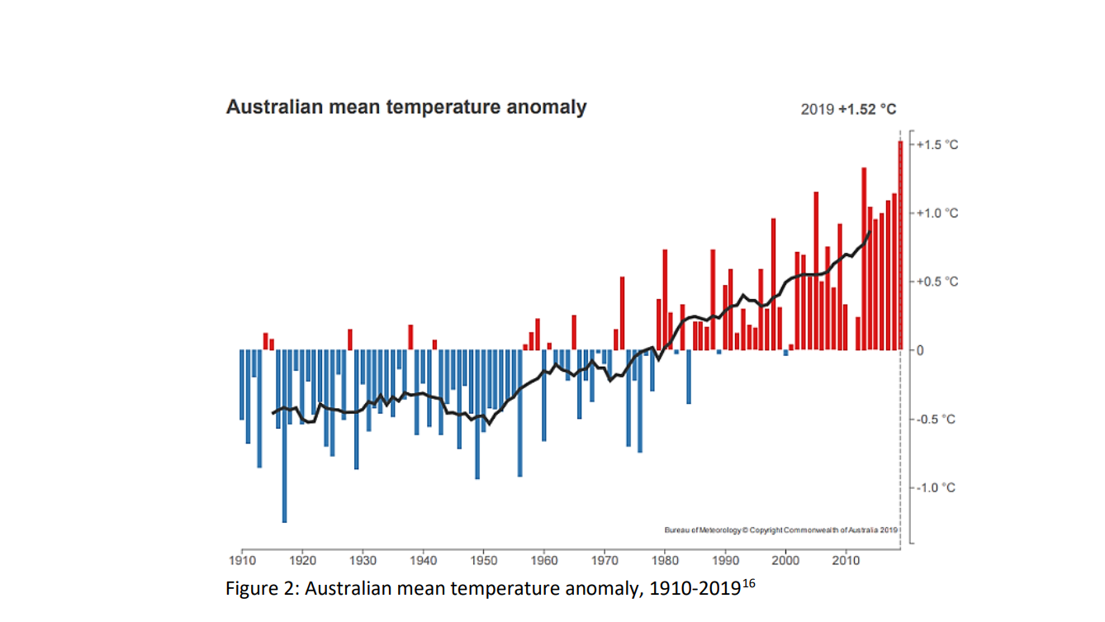
Australian Bureau of Meteorology Data – submission to Royal Commission
Greenhouse gas emissions are agreed to be the driver of global warming. The actual proportion of global warming that humans are responsible for (anthropogenic contribution) is still debated but it is considerable.
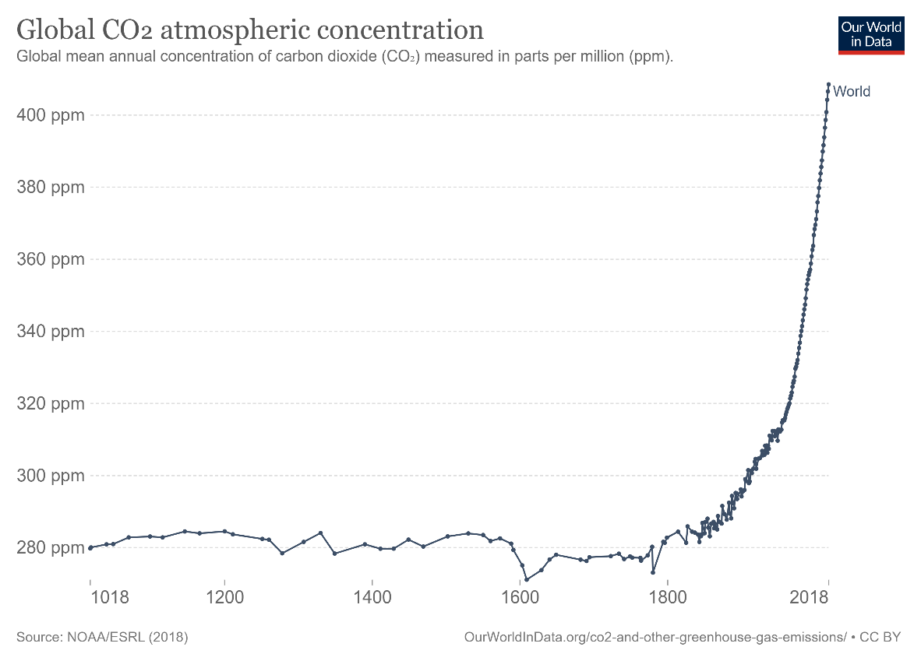

Worldwide action to manage or offset global warming is slow and poorly coordinated. It can be no surprise that, with a warming world, energy levels at the earth’s surface and atmosphere are higher with the capacity to change climate significantly. This may manifest in terms of air temperature, generation of faster air movement, higher surface temperature including sea, higher surface evaporation and increased high-energy weather events without considering the longer-term consequences on polar and glacial ice and CO₂ storage. Increasing bushfire risk is just one secondary effect.
For a thorough analysis, incorporating much of the recent Scientific consensus with evidence, see “The Physics of Climate Change” by Lawrence M Krauss 2021.
It is worth noting the urgency in the argument used by the United Nations Intergovernmental Panel on Climate Change (IPCC) for serious action leading up to the Glasgow meeting in November 2021 (COP26) in the “Code Red” media statements (IPCC report: ‘Code red’ for human driven global heating, warns UN chief | | UN News ).
After the IPCC meeting in Glasgow there has already been much pressure to increase carbon sequestration activity including bulk forest planting. Carbon offsets is now the focus in the absence of immediate real reduction of fossil fuel use. This paper will present powerful evidence that in the absence of science we should not be rushing to pursue this in dry countries.
The World Health Organisation suggests that between 2030 – 2050 there may be 250,000 excess deaths in the world attributable to Climate Change (Climate change and health (who.int))
This is a big, ongoing issue.
One potential mitigating pathway has been supported and pushed in Australia for many decades. Many Australians have actioned this with eventual embedding of the practice across generations. This pathway is “Greening Australia” with widespread tree planting on private land, encouragement of formation of national parks and amalgamation of large areas of state forest with exclusion of forestry practices. More recently the “carbon-sink” or carbon sequestration concept has garnered support.
Indeed, taught in schools, I feel, most Australians have supported and practised this as our Bruce family has. The thought of lowering atmospheric CO₂ and maintaining O₂ as well as maintaining a green habitat coat on the earth’s surface gave momentum to the effort. We actively pursued tree planting and made efforts over decades to establish a small rainforest utilizing native flora.
International scientific acceptance of this principle has been supported and applied. National governments contributing to the Intergovernmental Panel on Climate Change (IPCC) greenhouse gas emissions (GHG) regulation are expected to maintain GHG inventories and can garner credits (offsets) for forestation projects and prevention of forest clearing. (National Greenhouse Gas Inventory: March 2020 | Department of Industry, Science, Energy and Resources) On the other side of the ledger carbon loss from bushfires should be accounted for.
This has become a highly complex (and political) arena (Jackson et al).
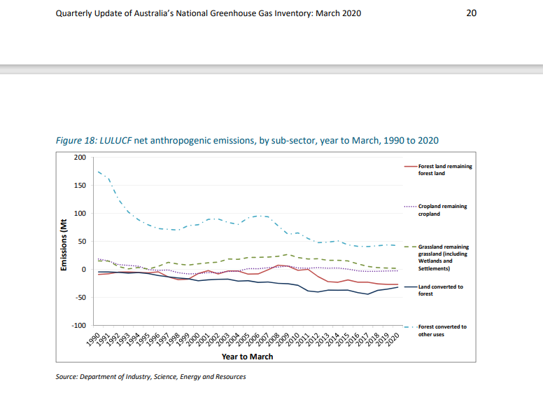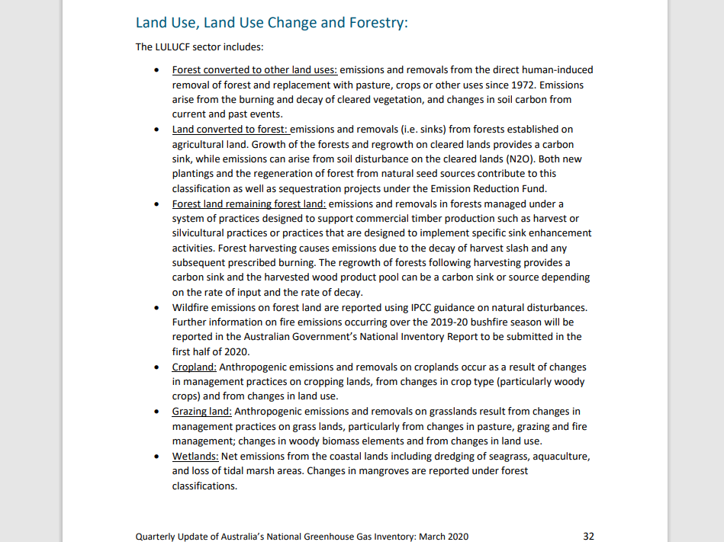
Many Australians will remember Australian Prime Minister Bob Hawke in the 1980s putting foot-to-shovel often in the public campaigns (see photo - a billion trees campaign 1989).
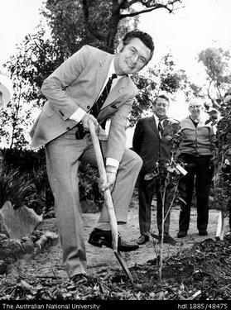
Tree preservation became law.

Australians, speaking generally, slowly became consumed by a push to do “the right thing” and return large sections of Australia to an “old growth” status.
Little did we understand this term!
With no accepted records of historical forest density and poor understanding of tree types within these forests our link to a proper understanding of “old growth” forests is a knowledge gap.
“Old growth” is no longer defined as “untouched” or “as-it was” when the colony was established. “Old growth” is now defined as “ecologically mature forest where the effects of disturbance are now negligible” (Department of Environment and Conservation NSW – Natural Resource Management Advisory series: Note 10 Old Growth Forests (Aug 2004). Relevant knowledge of previous forest or vegetation conditions or sustainability is absent or deficient!
Much of this recent growth is uncontrolled regrowth!
Records of vegetation coverage of Australia at the arrival time of the early white settlers is limited. However, published journals and logs, written by explorers and colonists, (many unpublished records are available in libraries), original drawings and paintings are available.
A sentinel book by academic Bill Gammage “The Biggest Estate on Earth – How Aboriginals made Australia”, as well as sections of “Dark Emu” by Bruce Pascoe, and papers by John Dargavel (Ed 2005) and Lunt (1997) shed some light on vegetation patterns in Australia at the time of Colonisation and the results are surprising.
Most of Australia was not covered by dense forest in 1788.
There is little scientific description of forest types in the early colony years. Terminology was often confusing which may have reflected a lack of botanists or highly educated colonists. Indeed, agreed classification of forest types only became uniform in the 1900s (Diels 1906).
Attempts to assess pre-colonial forest density have found evidence of lower density forest than expected (Lunt 1997, Spooner 2010). Fletcher (2021) presents sub-fossil pollen and charcoal records to indicate that unmaintained wooded Aboriginal land descended into denser, woodier vegetation after dispossession with higher fire risk.
Many explorers wrote of huge areas of mixed grassland and treed areas with little underbrush and often large trees with canopies. This provided little impediment to travel with horses or oxen and carts such as used by Hume and Hovell in 1824 from Appin to Melbourne (04 Jul 1831 - An Extract from the Journal of Mr. Hamilton Hume, written on a Tour through the interior to Bass' Straits, in the Year 1824. - Trove (nla.gov.au)).
Most early settled areas favoured grassland to minimise necessary clearing with numerous examples including Parramatta and Melbourne (see Gammage).
Charles Darwin observed on the 19th Jan. 1836 on an excursion from Sydney to Bathurst NSW: ‘The woodland is so open that a person on horseback can gallop through it. It is traversed by a few flat-bottomed valleys, which are green and free from trees: in such spots the scenery was pretty like that of a park. In the whole country I scarcely saw a place without the marks of a fire; whether these had been more or less recent – whether the stumps were more or less black, was the greatest change which varied the uniformity.’(Gammage)
Wherever there were populations of Aboriginals, fire was used extensively (as also implied by Darwin) to create and nurture grassland for animal feed and yam and grain production as well as controlling underbrush and limiting tree density allowing traffic egress and improved food-hunting. Aboriginal burning practices were frequently written about by the local settler population, often with a degree of scorn. These settlers seemed to misunderstand that the Aboriginal burning practices evolved with accumulated knowledge of flora and fauna so that burning was carried out at times when threat to the burners or neighbours was minimal, when the fire would be extinguished by subsequent night temperature, dew or rain, when there would be little impact on nesting or breeding animals and where the ferocity of the fire could be dampened enough to protect vegetation that was known to be more fire sensitive but worth protecting. Frequency of burning was usually dependent on vegetation type. This forms the basis of the principle of cultural burning, described as “firestick farming” by Jones (1969). See also “Fire Country” by Stephenson 2020.
It is worth noting that coordinated recent analysis has found that humans have manipulated their environment globally for up to 12,000 years (Ellis et al 2021).
Prior to white settlement much of the Australian forest had been exposed to human influence and management.
Fletcher (2021) presents strong evidence of this fact with further evidence of massive overgrowth of woody vegetation in Southeast Australia after Aboriginal dispossession and the associated increase in catastrophic wildfires.
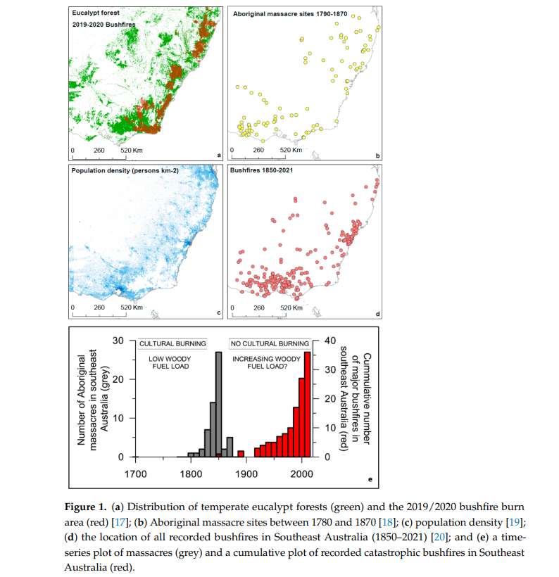
By 1850 the population of Australia was 400,000. By 1881, Australia was 2,250,194 strong with a gold rush dominating the colony (note – regretfully, no accurate census of the Aboriginal population is available). Much of the influx went to goldfield settlements and other diggings where steam power was progressively being introduced to drive machinery (eg. ore crushers, boilers, smelters, dredges and traction engines). In the later half of the 19th century steam-driven machinery, building dwellings, domestic heating and cooking consumed enormous volumes of timber from local supplies. In “Dust and Dreams” author Barry McGowan quotes, from records, that mining activities in Currawang NSW created huge demand for timber. During 1868 7,000 tons of firewood were stockpiled, and by 1871 the monthly consumption was 1,500 tons, with supplies coming from as far away as Mittagong, New South Wales. Exhaustion of the timber supply was a factor in causing the Currawang mine to close. This was a common, widespread problem near mining communities. It was estimated that Ballarat, for instance, in one year, 1860, consumed 180,000 tonnes of fuel wood, 850,000 mining props, 3 million laths and over 3,000 cubic meters of sawn timber. Victoria's goldmines had 1,150 steam engines in 1873 and it was claimed they consumed 1 million tons of fuel wood in that one year. (Frank R Moulds 1993).
In these times Australia lacked highly educated botanists. There was world-wide interest in species and application of post-Linnaean Taxonomy. Australian flora and fauna were of international interest with Joseph Banks (later head of the Royal Society) returning to Britain with many samples and the French quietly raiding. With Banks, Humboldt and Darwin pushing Scientific progress it seemed there was an explosion of Science in Europe. One notable immigrant with a background in Science and Botany migrated to Australia in 1848, Ferdinand von Mueller (Ferdinand Mueller | PlantsPeoplePlanet ), becoming highly regarded and influential in Australian botany. Mueller described and named over 100 eucalypts and was the first Victorian Government Botanist (1853-1896) and Director of Melbournes’ Botanical Gardens and National Herbarium (1857-1873). He authored most of Flora Australiensis in 7 volumes between 1863-1878. He contributed to National and International Exhibitions as well as Forestry Inquiries and Royal Commissions and as a strong advocate for Australian forest product, Mueller pushed bluegum seed export to the Americas, Africa and the Mediterranean as well as trialing imported flora (famously blackberry). He boasted of trekking at least 40,000 km in Australia. Observations (Museum Lecture 1871) recorded during his tenure are now important: Strange as it may appear, an impression seems to be prevailing in these communities, that our forests have to serve no other purposes, but to provide wood for our immediate and present wants, be it fuel or timber. For even after the warning of climatic changes, and after the commencing scarcity of wood, no forest administration - at least, none adequate, or regularly organised has been initiated in any portion of Australia; and thus the forests, even in districts already very populous, remain almost unguarded, become extensively reduced, and in some localities are already annihilated; indeed, the requirements of the current time alone are kept in view. Under such circumstances it cannot be surprising, that neither an universal forest supervision, not a judicious restraint of consumption, nor an ample utilisation of all the various collateral resources of our woodlands, received that serious attention to which such measures became more and more entitled. (Mueller in Gillbank, Dargavel Ed 1993)
Later Inquiries found Mueller recommending that 25% of the land area of Victoria be set aside for forest activity.
It is certain that much of the Australian bush landscape was changed dramatically during this time. As miners struggled in the exhausted gold and mineral areas they spread far and wide in the hope of finding their own “El Dorado”. Secondary diggings began with many of these lasting into the mid-20th century. One local Shoalhaven example being Yalwal.
Most non-mining areas in Australia also relied heavily on local timber for fuel, building material and fencing. Forest clearing for agriculture was common.
Harvesting stress on some forest areas may have lasted for 100 years. There is evidence many of the settlers in these areas tried different land uses, such as cropping or grazing, on land not suited to those purposes. Having failed to produce profit, it would seem much of the “unsuitable” or low-production agricultural land is now in public hands or has been neglected. In many areas land subdivision and development for housing has seen communities develop in non-agricultural areas of degraded or low soil fertility adjacent to or within regrowth forest!
Whilst much of this unprofitable land has moved to public ownership, much of the forest area in Southeast Australia is privately owned (map).
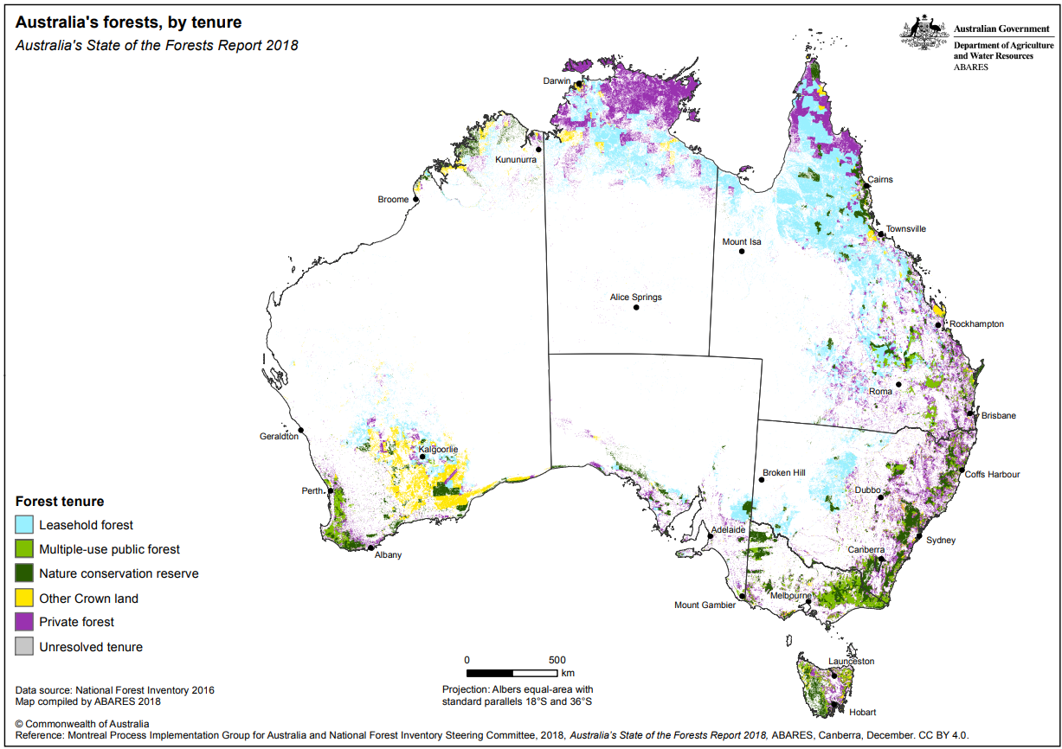
Unfortunately, much of the privately owned forest is not cared for with inadequate forest oversight and regional environmental plans (REPs) and local development control plans (DCPs) restricting many forest uses.
The period during the later gold rushes also saw the introduction of photography into the colony. Many photographs of the Australian landscape taken around these mining areas in the period 1870-1920 show a landscape, often devoid of trees with perhaps a few remnant trees visible. Almost bare hills and wide expanses were the norm.
This dramatic landscape change was noted and commented on by Mueller
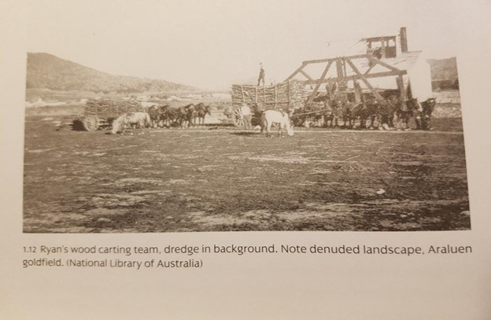
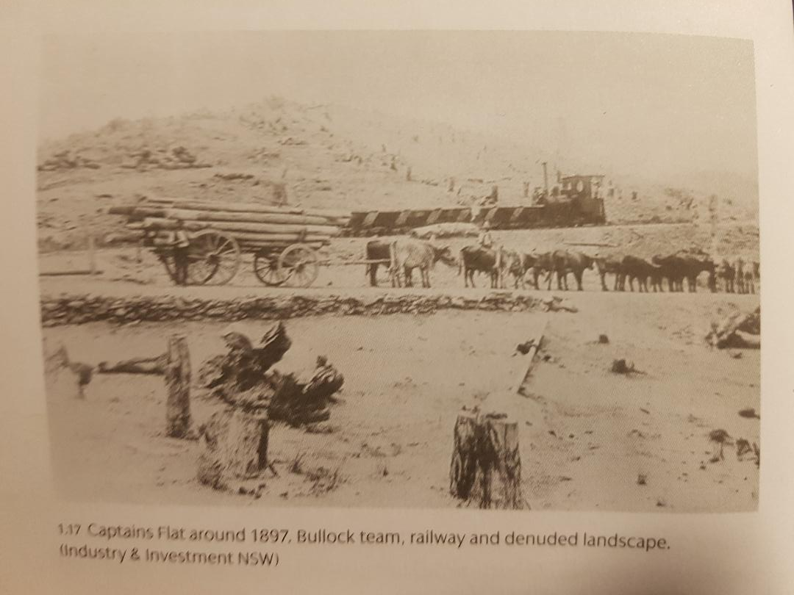
Two examples from Dust and Dreams highlighting the impact of widespread mining activity on local flora.
Subsequent, uncontrolled forest regrowth has since dominated the eastern Australian landscape.
It is becoming increasingly evident that much of what we are seeing as old forest is less than 100 years old, often much less and not necessarily representative of the vegetation from those earlier periods.
There have been many National Parks created in Australia with 516 National Parks covering over 25 million hectares. However, many agree, the system which controls National Parks, Crown land, state forest and council land is cumbersome, poorly conceived, uncoordinated and underfunded. Since the early 1900s Australian State Governments have had their own Forestry responsibility. There is now an expectation that this responsibility is self-funded with plantation timber produced and little activity or forest control in non-profitable areas.
There is recent evidence that forestry plantation activity with dense plantings renders those areas more susceptible to fire effect (Bowman et al).
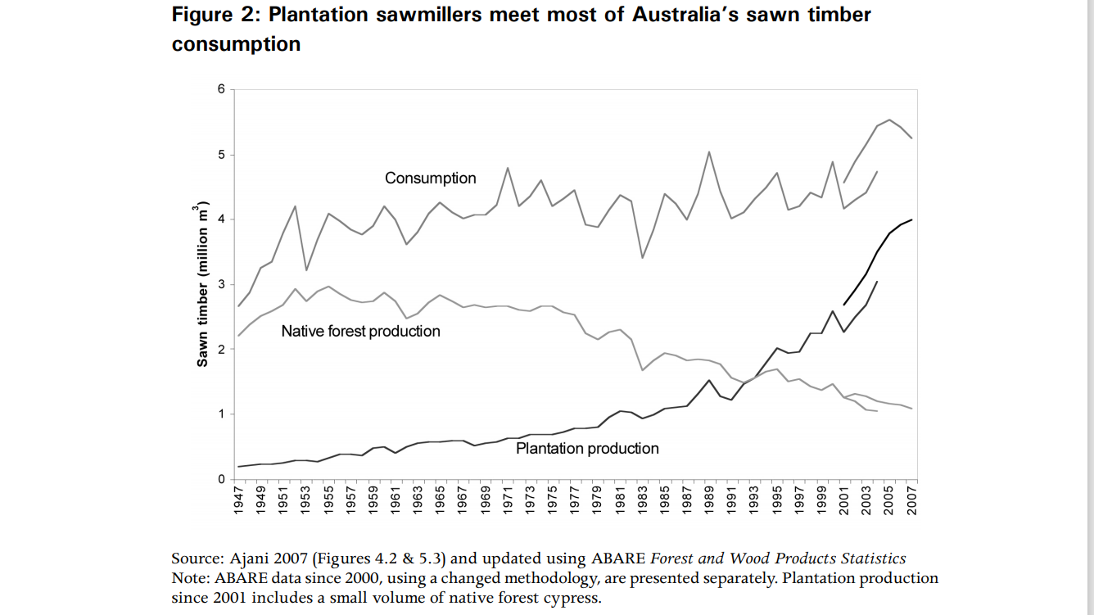
This chart from Ajani (2008) highlights this change without including the plantation production providing for wood panelling and pulp industries.
Previously, most of the eastern states of Australia developed state-based Forestry Commissions with most larger towns with logging activity having office staff and field staff as well as some areas having large nurseries and plantings. Selective logging being the norm. Under this system, local knowledge of landform, land productivity, vegetation species and access were maintained and utilised (see Australian Forest History Kevin J. Frawley in Dargeval ed 2005).
Forest Hydrology
There is a paucity of groundwater and aquifer studies in the hilly and forested areas of Eastern Australia (Harrington 2014) although there is an awareness that bore drilling to access water in these areas is increasingly unreliable. Most water catchment supply dams, for metropolitan water use, are positioned to take advantage of forest catchment rather than farming catchment areas. Despite often imposed water restrictions, reservoir inflow and levels struggle to be maintained, with methods to improve capacity or desalination the only political solution considered. The following schematic (Sun 2016) demonstrates a flow pathway and distribution for rainfall.
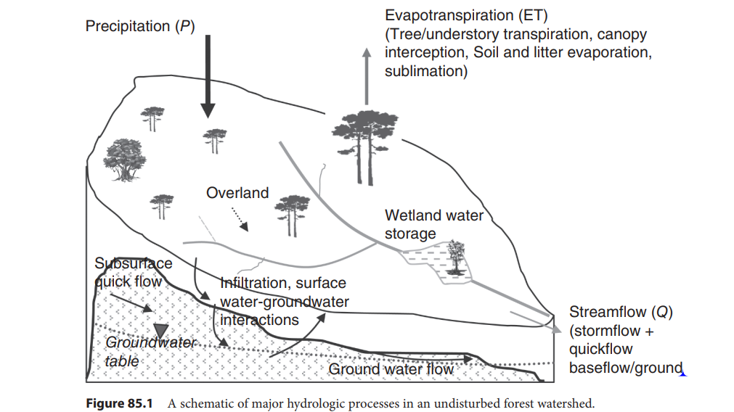
Many Eastern Australian forests have evidence that only high rainfall events penetrate to soil and groundwater because of the forest density and litter accumulation (Jurskis – personal communication).
Reduced forest run-off in watercourses, creeks and rivers has been an indicator of forest overgrowth and poor forest health for decades. In a recent study utilising data over 30 years from river flow gauges in unregulated sections (no dams, water extraction or hydro) Franklin and Davey Rivers of Tasmania Bowman and Williamson (2021) (https://www.mdpi.com/2571-6255/4/2/22) highlighted the link, for the first time in Australia, between forest fire risk and low stream flows. This ground breaking study needs to be applied across the fire risk areas of Australia.
Ongoing predictions for groundwater replenishment in NSW demonstrate a decline over the near future to 2030 followed by steady increase to 2070. In the current forest and bushfire risk arena this is of huge concern (Groundwater recharge and surface runoff (nsw.gov.au)).
Map of telemetry groundwater monitoring sites in NSW. Forest areas are given little attention!
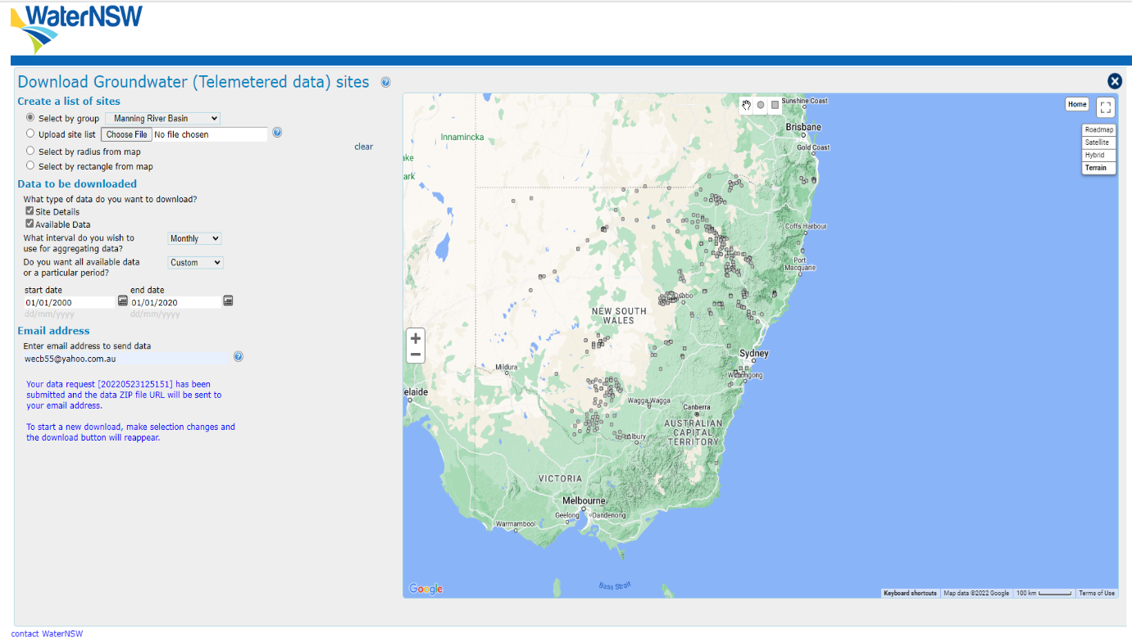
Further stresses occur when native vegetation species compete with other understory competitors and many introduced species. Lantana on the eastern seaboard is just one, particularly big problem.
Drought Stress
With individual large trees within a forest (diameter exceeding 60 cm at breast height above ground) often consuming over 100 litres of groundwater per day for foliage transpiration, photosynthesis and evaporation (Zeppel 2013), logic dictates that drought can easily precipitate water stress. Increasing tree density can only worsen this. Many large trees e.g. Eucalyptus Regnans are capable of extracting up to 800 litres per day (Vertessy et al 1998).
Mechanism of drought injury and drought mortality remains debated but hydraulic failure seems preferred (Adams et al 2017) and a recent report makes hydraulic failure with subsequent xylem embolism and cavitation most likely, particularly under conditions of vapour pressure deficit ( Yael Wagner et al (2022)). Further detailed mechanistic insight is included in the paper by Daniel M Johnson et al (2022).
Nolan et al (2020) https://www.mdpi.com/1999-4907/11/7/779) in another ground breaking paper, propose mechanisms of interaction between drought stress, flammability and fire risk that provide valuable insights into the fire ferocity of the 2019-2020 fires.

Schematic progression in water stress to plant death. Nate G McDowell et al 2022 https://www.nature.com/articles/s43017-022-00272-1
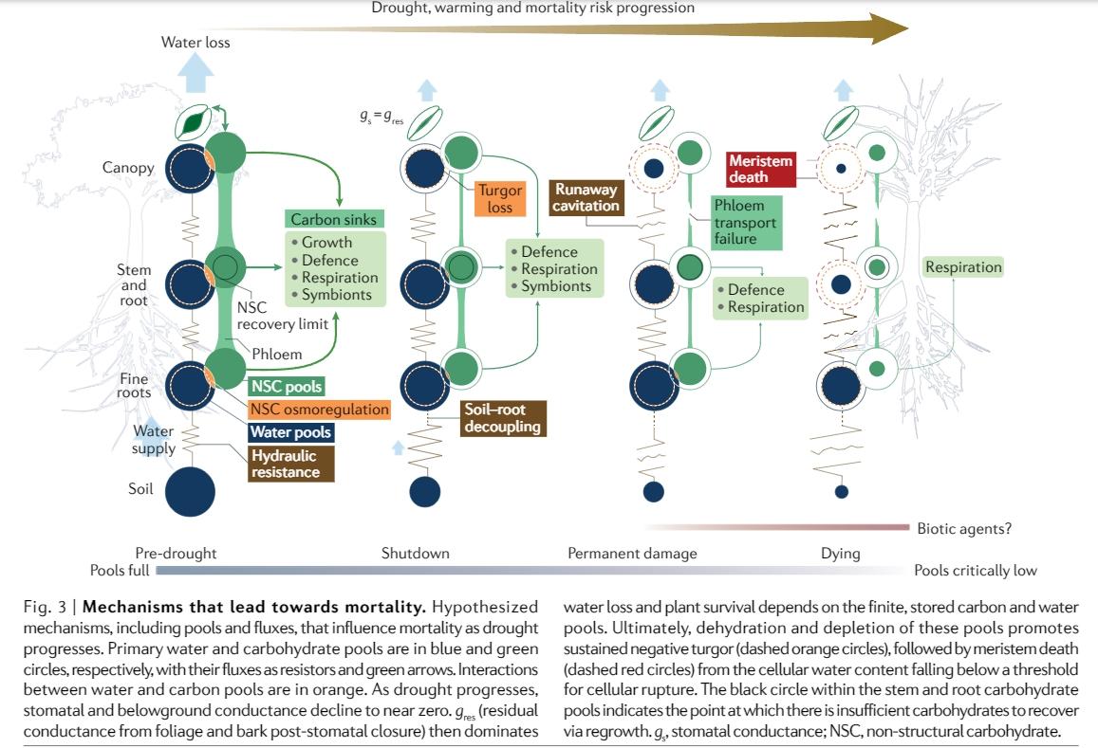
Despite this uncertainty all those living close to large eucalypts will be aware of the effects of water stress with leaf and branch sacrifice.
Droughts do inevitably break and the expectation that forests will recover persist. There is evidence that tree growth and water requirements are entwined and important such that with ongoing forest growth, water and nutrient requirements can be close to survivable limits so features of water stress persist. Steffenson in Fire Country describes stressed, eucalypt forest in southern New South Wales as “sick country”.
I feel that these conditions, combined with significant forest neglect with uncontrolled regrowth have pushed forest density beyond the carrying capacity of the land. A bushfire catastrophe and environmental disaster waiting to happen again and again. It is probable that forest density in much of non-agricultural Australia is now above the forest density present when the colonists arrived, particularly in the fire-impacted areas (see Gammage, Lunt).
The following aerial/satellite photographs I feel are evidence that the imaged large areas of neglected forest with increasing forest density became fuel for the Black Summer fires.

This aerial photo 1981 depicts The Shoalhaven River at the Junction with Yalwal Creek and the peninsular (middle right) that is Coolendel. Dirt tracks easily visible, not so dense vegetation.
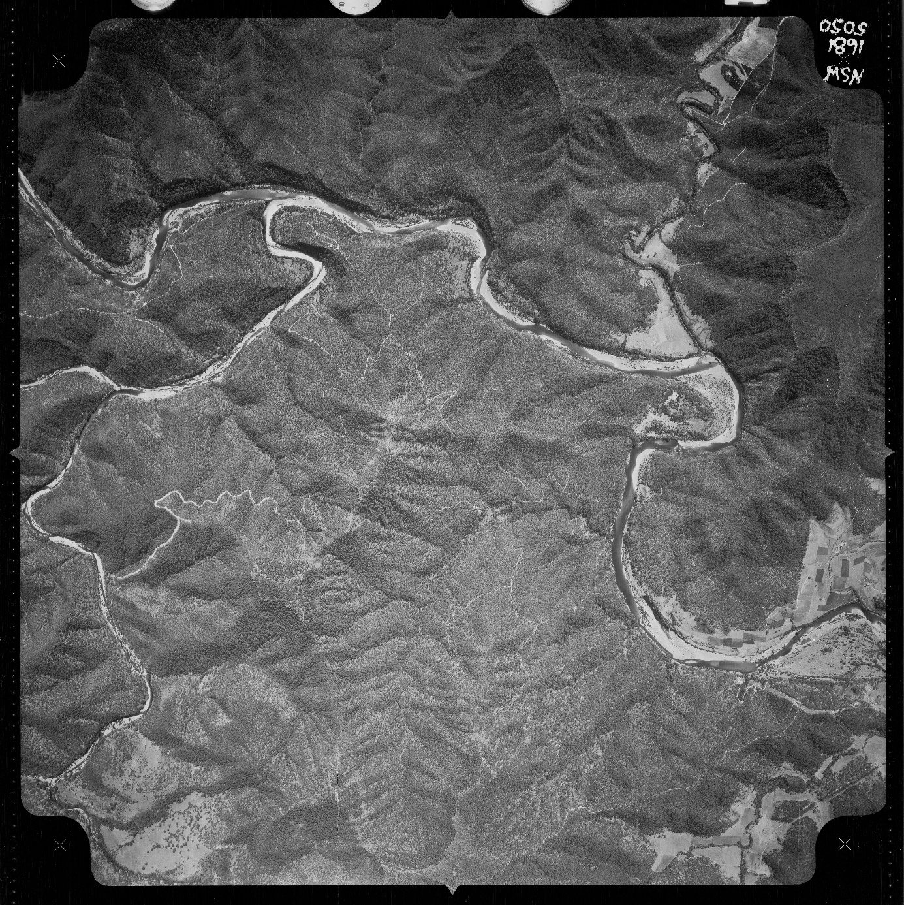

This Google Earth image (same area) 2018 shows increased vegetation.
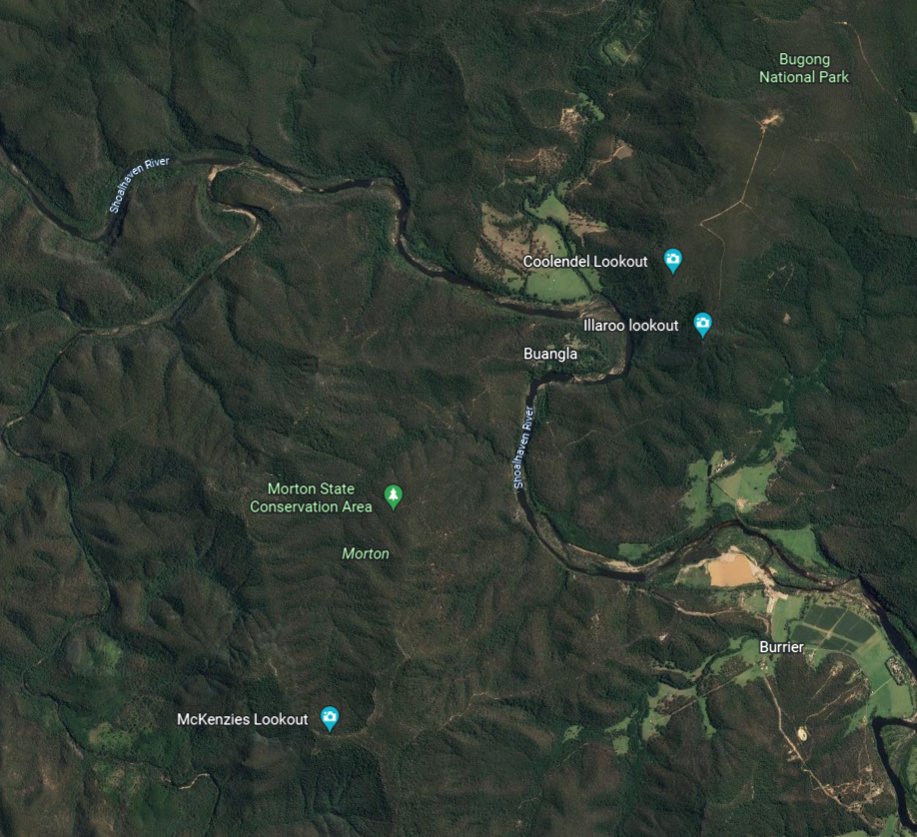

This 2020 Google Earth image of same area after the 2020 fire and flood
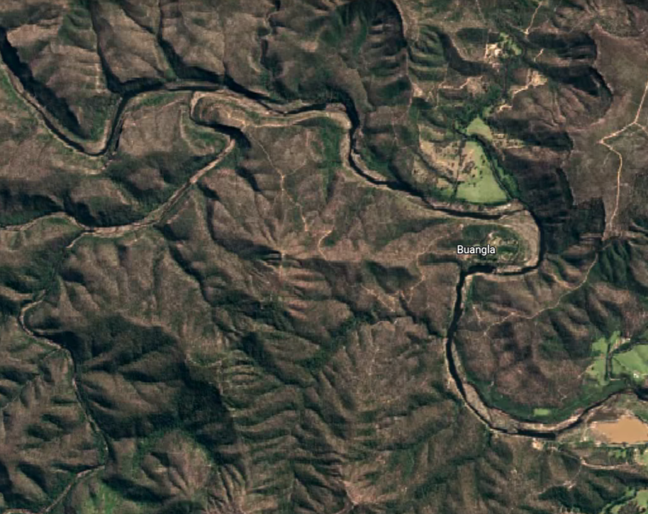
The Black Summer 2019-20 fires season has been well-documented and recorded.
The Rural Fire Service NSW records huge impact to large tracts of forest.
86% of the land area of the Shoalhaven, on the NSW South Coast, was impacted with many of the National Parks of Eastern Australia completely burnt.
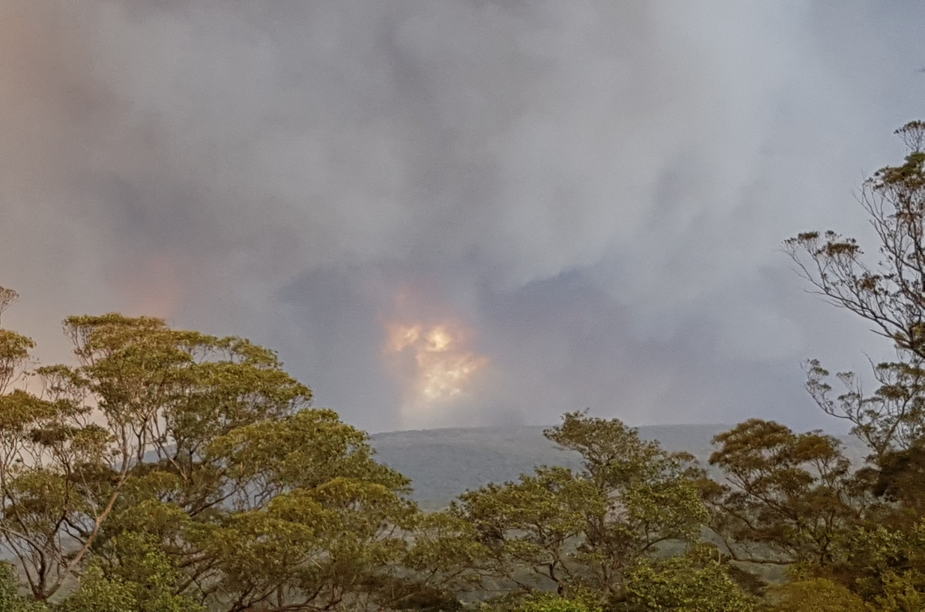
4th January 2020 Fire at Bugong National Park taken from Skyline – Emerys Road, Tapitallee. Note the flame-in-smoke effect up to 100 metres above the forest indicating fire intensity.In the middle of this fire-front is Coolendel Lookout where the “standing fuel” photo had been taken a week earlier.
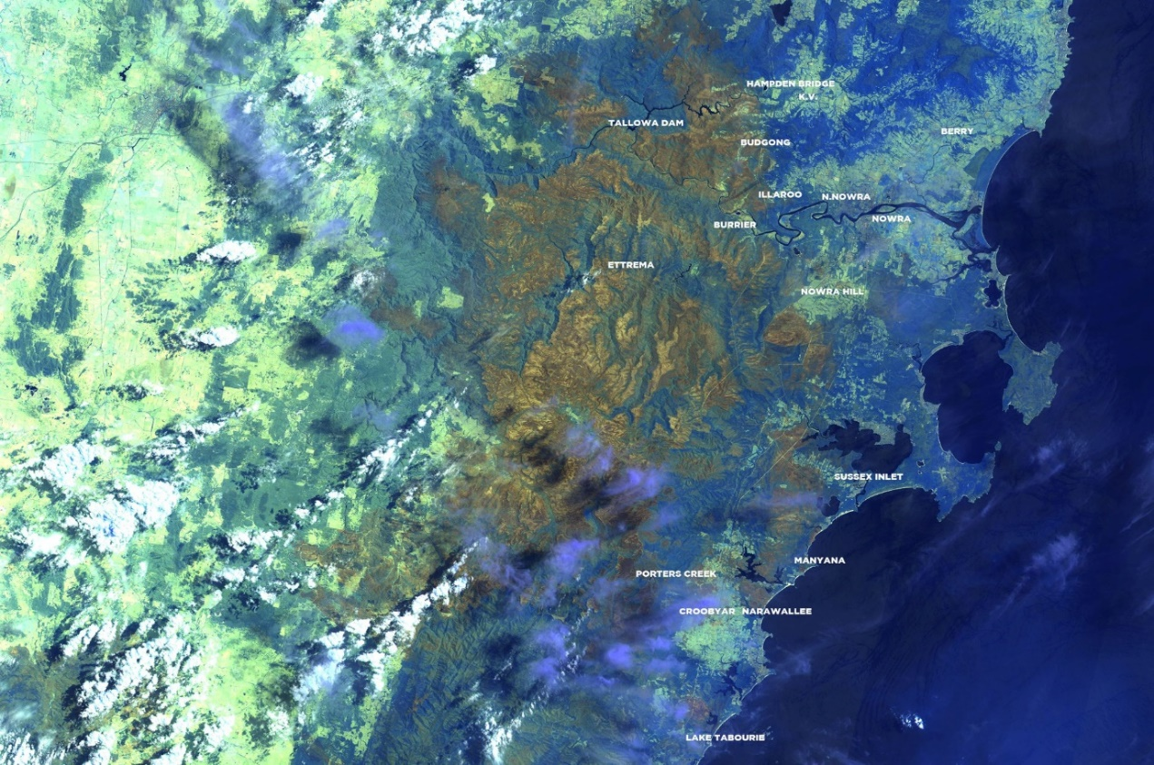’
Satellite view - early January 2020 – Shoalhaven Fire scar
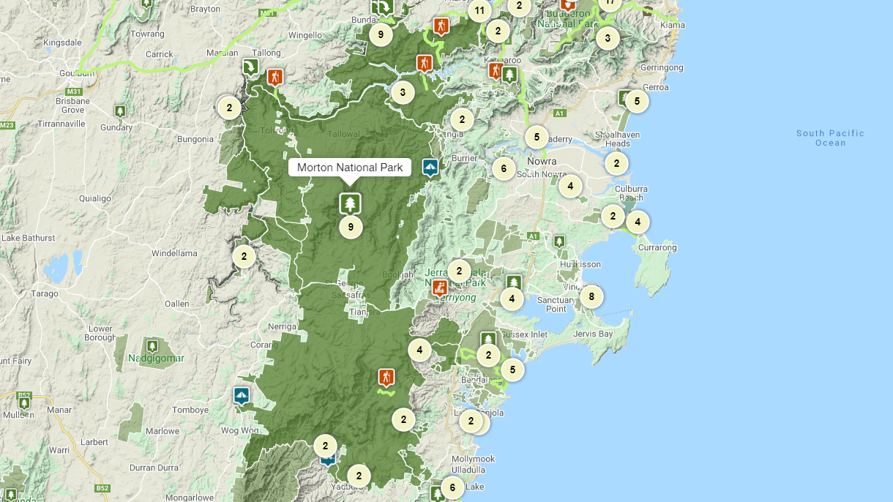
Almost all of Morton National Park NSW was heavily impacted.
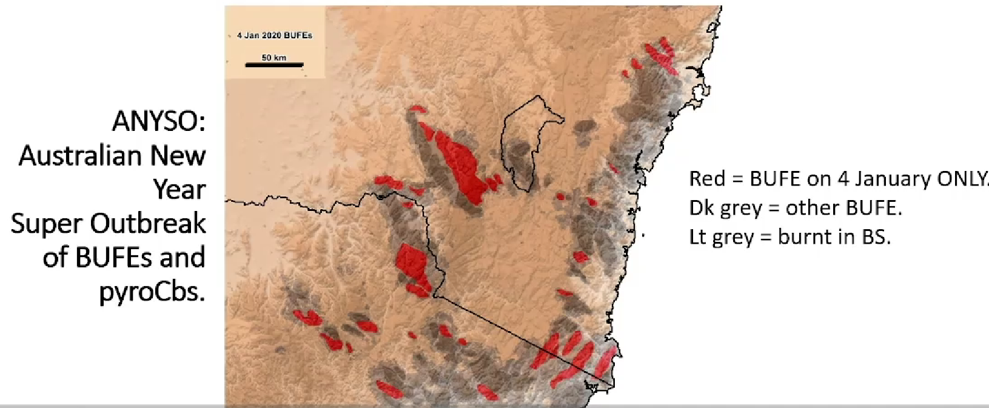
Fire intensity map covering 4th January 2019. BUFE (Blow Up Fire Event) in red represents areas burnt in a 24 hour period. The upper BUFE is the Morton National Park fire with burnt area exceeding 100 square kilometers. Many of the BUFES represented on this map have areas that exceed the agreed terminology of “Megafire” but within 24 hours!
The fires burned so aggressively that on-ground firefighting, particularly in remote areas was considered too dangerous to attempt. There seemed to be very few areas such as moister areas beside streams and gullies that were protected. Much of the riverside vegetation burned on the Shoalhaven River and Mangrove flats burned on the Clyde River.
In the absence of drenching rain, fire impact on residential areas came to be accepted as inevitable.
Many Australians lived for months during this time with elevated smoke levels . public health warnings and considerable health impacts with some estimates of over 400 related deaths (Unprecedented smoke&#x2010;related health burden associated with the 2019&#x2013;20 bushfires in eastern Australia (mja.com.au)).
Citizen Anecdotal research
My family and I have lived in Tapitallee for 30 years and have enjoyed that we’ve been able to observe the bush and nature reasonably closely. As observers we have some observations that may be relevant to this presentation.
A small watercourse runs through our 5 hectare property with a map (from Google maps) designating it as an intermittent watercourse. Anecdotally, prior to our purchase in 1990, the watercourse had been flowing continuously for 15 years although at times only a dribble.
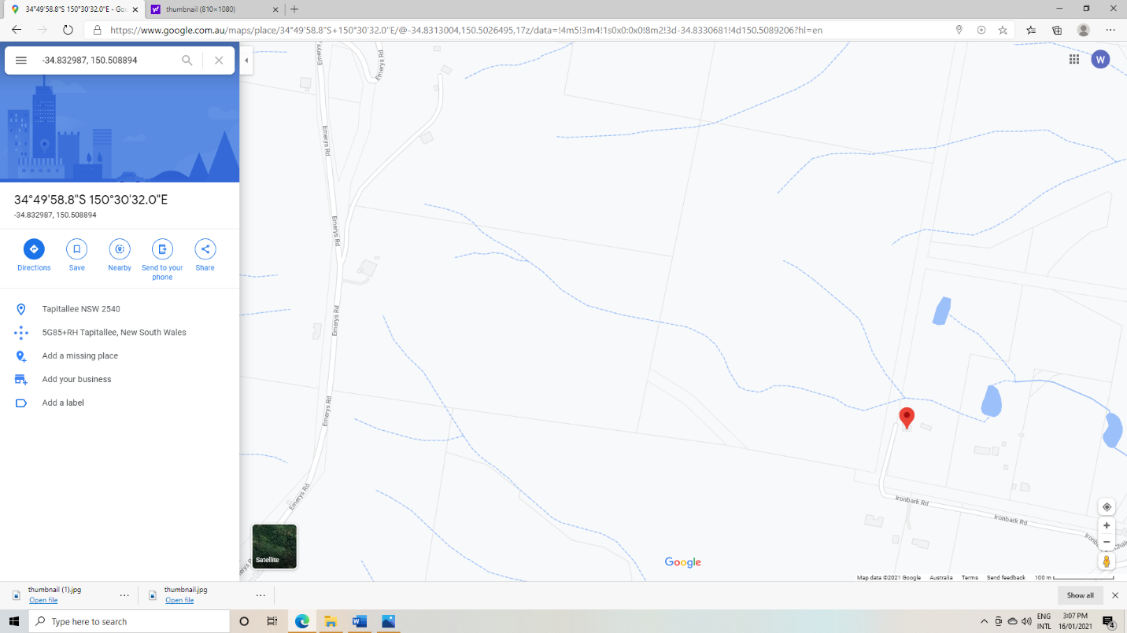
Note: Red pointer highlights our house
For 10 years after purchase (1990-2000), we could always find flow in our watercourse. However, at times, a shovel was needed to define subsurface flow.
For the period 2000-2010 the watercourse would periodically stop without shovel evidence of flow. Additionally, during these times, it became clear that wombats could easily dig in the base of the watercourse to a depth of over a meter and reside in these holes. Episodic consistent rain would collapse and wash away the burrows leaving deep channels. Most wombat burrows could be redug within weeks, indicating rapid watercourse drying.
In the latest period 2010-2020 the watercourse has rarely flowed with wombats occupying burrows, in the base of the watercourse, over 80% of the time. Additionally, over the last 5 years, we have been able to observe severe tree stress with leaning and falling trees and essentially all the eucalypts stressed within the gully of the dry watercourse. This was very noticeable from March 2019 such that, prior to the fires starting in NSW, our small forest was dying and generating more fuel than had ever been noticed in the previous 30 years.
Additionally, it was noticeable that much forest upstream was in trouble as never before.
Many larger areas of forest in the vicinity including much of Morton National Park were also stressed and had an appearance I describe as “standing fuel”!
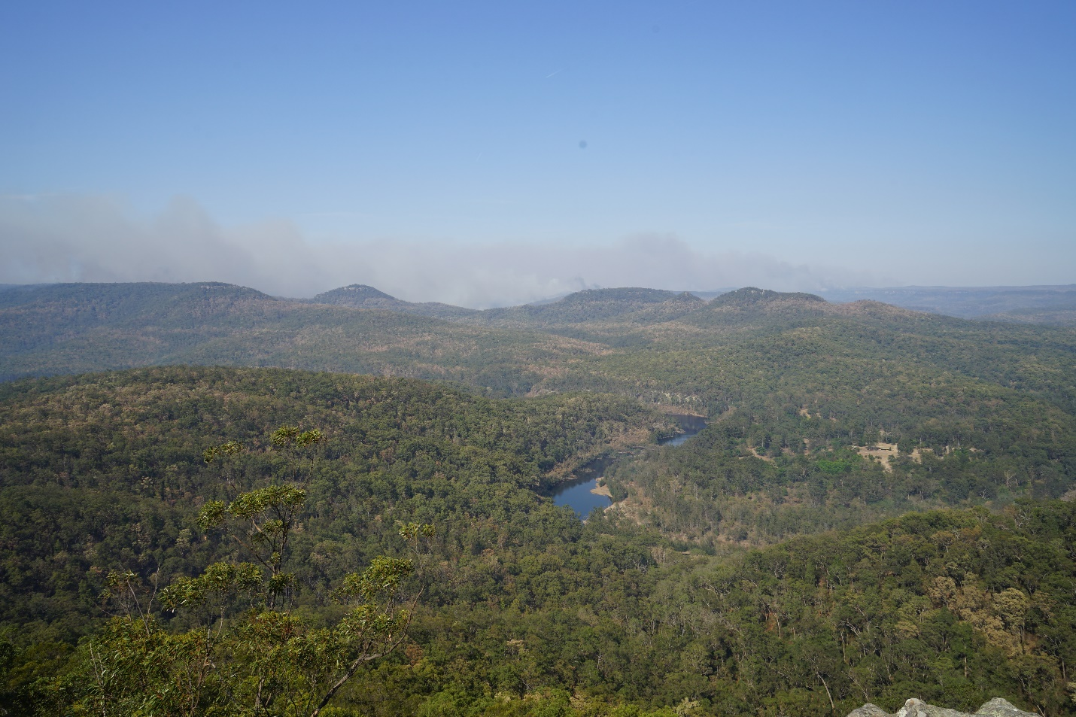
View from Coolendel Lookout in Bugong National Park looking South over Morton National Park on 26th December 2019 with the Morton Fire advancing from South. The brown areas of forest are profoundly water-stressed and dying “Standing Fuel”.
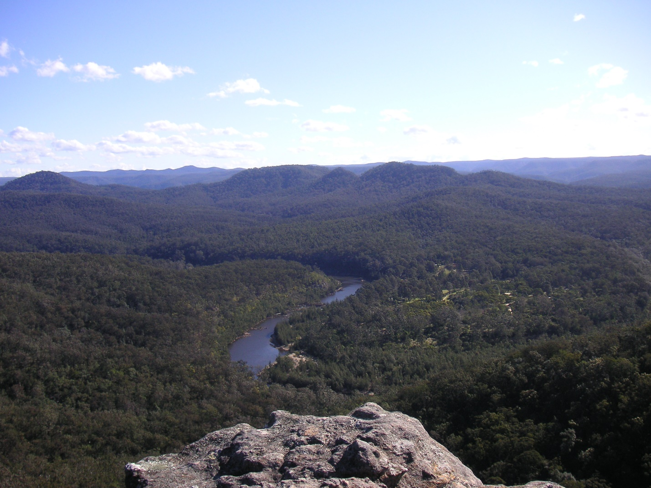View from the same location taken in 2005 during the Millenial Drought. Some stressed areas of forest visible but far less than the 2019 photo.
Our watercourse has a limited catchment of approximately 40 hectares with no changes in land use except noticeably denser and taller forest over many years (some of our eucalypts are over 30 meters in height).
Discussing this change with many other long-term landholders of similar properties with watercourses draining forest or National Park these findings have been widespread. Anecdotal stories of swimming holes of 30 years or more ago in similar watercourses now being dry are common.
Climatic contribution needs to be considered with a slow and steady trend to warmer and drier conditions. 2019 rainfall showed 528 mm after 802 mm in 2018 and 897 mm in 2017. The 20 year average at 1045 mm (see rainfall data). Some noticeably warmer hot spells up to the mid-40s ⁰ Centigrade have been more frequent than previous.
In our local ecosystem little has changed to alter run-off characteristics of the land with a larger forest area and more dense forest normally generating more favourable conditions for water retention, however, water utilization by this additional forest must also be higher.
Below is data representing 20 years of rainfall record for a neighbouring property. Three years (2017-2019) of below average rainfall preceded the 2019-2020 bushfire. Of note is that 2000-2006 with below average rain produced less fire risk and fuel than 2017-2019.

Neighbourhood Rainfall (mm) (with permission John Kubale 45 Ironbark Road)
Yr Jan Feb Mar Apr May Jun Jul Aug Sep Oct Nov Dec
2000 110 115 50 50 8 49 135 49 108 260 5 30
2001 60 125 95 25 15 10 48 51 20 40 60 25
2002 180 290 120 85 15 25 2 10 3 12 25 55
2003 62 91 99 109 201 56 39 25 13 61 148 62
2004 58 116 59 86 7 2 35 29 40 150 69 122
2005 147 173 70 26 72 93 126 5 86 57 148 32
2006 164 56 46 6 35 198 85 38 51 4 37 97
2007 16 373 86 42 23 171 48 49 54 18 196 112
2008 76 319 45 87 15 108 38 40 60 109 44 108
2009 43 148 64 112 57 29 7 15 22 115 51 119
2010 68 202 65 19 72 45 48 32 49 133 219 210
2011 68 101 213 77 36 134 95 53 63 113 96 99
2012 144 236 278 107 15 112 27 9 26 46 48 32
2013 113 235 70 113 65 261 14 24 67 13 127 64
2014 31 48 218 31 20 34 7 240 33 86 37 228
2015 194 45 46 192 97 62 62 259 46 37 77 47
2016 288 111 73 25 18 394 79 53 77 39 23 104
2017 38 211 383 33 20 39 0 40 0 24 57 53
2018 70 170 60 18 9 47 14 29 57 73 180 77
2019 90 29 124 8 5 112 11 34 64 39 11 3

20y Avg 105 189 116 65 43 100 58 65 48 77 90 89
%of YR 11% 19% 12% 7% 4% 10% 6% 7% 5% 8% 9% 9%

YEAR TOTAL(mm) % 20 YR AVE
2000 969 93%
2001 574 55%
2002 822 79%
2003 963 92%
2004 770 74%
2005 1033 99%
2006 815 78%
2007 1185 113%
2008 1047 100%
2009 779 74%
2010 1161 111%
2011 1145 110%
2012 1079 103%
2013 1185 113%
2014 1010 97%
2015 1163 111%
2016 1282 123%
2017 897 86%
2018 802 77%
2019 528 50%
This data is similar to the local recording station that has data from 1900
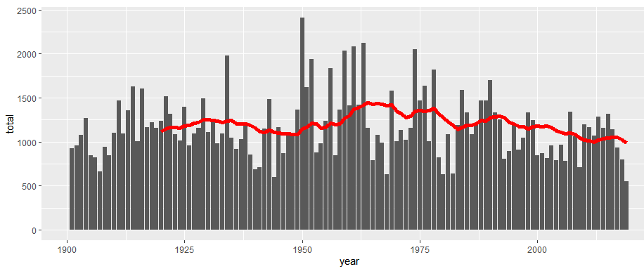

Much of the forest areas of the Shoalhaven are regarded as sclerophyll forests with poorly productive, sandstone-based soil, limited rainfall, and limited potential for forest production.
Despite lacking evidence of optimum tree or forest density we have allowed and encouraged uncontrolled forest growth that is now a real threat to our human-land interface as well as the general flora-fauna habitat relationship.
I feel that further scrutiny for most fire-affected, forest areas of eastern Australia will demonstrate similar mechanisms. Examples include the Mann River in northern NSW (draining large areas of temperate forest of the Clarence River System) and the Mongarlowe River (a Shoalhaven River tributary) which stopped flowing in 2019, with subsequent bushfire affect (see 2019-2020 Bushfires). Somehow, we must work towards a sustainable equilibrium that is safer for all.
In this environment the concept of a carbon sink in uncontrolled Australian forest regrowth becomes impossible, as much of the carbon captured by this method can be re-released in one event.
Keith et al (2014) studied the carbon loss from the 2009 Victorian bushfires affecting a large area of tall eucalypt forests with estimated losses of up to 14% (40-58 tonnes of carbon per hectare) over hours to days.
Using uncontrolled forest regrowth to generate large habitat areas must also be folly as the 2019-20 fires have demonstrated with such destruction from hot fire that many areas have been rendered sterile of fauna. Surely, there must be logic in systems where non-continuous habitat can be encouraged with planning to limit destructive fire impacts with a more mosaic plan and easy access.
It is suggested that certain habitats for endangered species can be enhanced by modified burning (Legge et al with the Gouldian Finch)

The First Australians were good at this!

SUMMARY OF MAJOR POINTS:

- Land and forest management by Australia’s first peoples should be studied, recorded, and credited. Acceptance and integration of Aboriginal input is critical.

- Much of the forests of Eastern Australia represent uncontrolled regrowth. Ceasing and disregarding the broad-scale indigenous application of repeated cold or cultural burning to maintain lower forest density has caused large swathes of “sick country”. Similar outcomes has been evident around the globe.

- The concept of allowing forest density increase in Australia without adequate assessment of the ability of the land to support this forest level is dangerous.

- In all probability, major areas of Eastern Australia now have forest density and intensity above a sustainable level such that repeated years of below-average rainfall will imperil the flora and fauna, as well as. many communities, and towns.

- Watercourse flow from forested areas has been an unrecognised indicator of forest stress for some time. Predictions are for worse to come. Studies of Forest Hydrology in Australia need funding, academic support and implementation.

- The vegetation level across Australia at the time of colonisation needs to be studied and documented further. I feel that this can then be used as an appropriate guide for further sustainable reforestation practices.

- It can be argued that small areas of low-density forest have lower water requirements than dense, continuous forest with resulting higher drought resistance and resilience, with the potential to mitigate a little of the effects of ongoing climate change.

- Vegetation and forest density in large areas of Australia remain at a dangerous level. Unburnt forests are particularly vulnerable now.

- Climate Change with higher incidence of extreme fire weather are driving the urgency to unprecedented and uncertain territory

What can be done?

I don’t pretend to have all the answers, however, Australians should not allow this fire event to pass without action. Reducing future risk will be an enormous job, but inaction or inadequate action carries a potentially huge risk.
Many of the issues and potential contributing factors have polarised communities with diverse, strongly held, personal, philosophical and political ideologies.
We must reconcile and overcome cognitive dissonance.
We need more science – to drive future action plans, not just from those areas being forested for profit. The CSIRO, Universities, Forestry, National Parks and those LGAs controlling public lands need to be funded properly for this purpose.
We need an agreed model of the sustainable forest-grassland mix throughout non-agricultural Australia that will provide better fire safety (Gillson 2019).
The Royal Commission into National Natural Disaster Arrangements – Report 28 October 2020 highlighted the existence of critical knowledge gaps.
23.62 There is a need for Australia-wide agreement on a prioritised research agenda that identifies and targets critical knowledge gaps. Such an agenda would assist in ensuring that finite resources are strategically targeted to critical priorities, while reducing duplication.
The ongoing study and monitoring of water dynamics in forested areas would be one example.
What science we have, often includes references to huge knowledge gaps.
Much of the science is ignored as has the majority of previous Royal Commission recommendations!
Politicised argument abounds.
Scientific study is underfunded.
Armed with more science we need more ongoing consultation with the stakeholders – Federal and State governments indigenous peoples, landowners, those groups above ( CSIRO, Universities, Forestry, National Parks, LGAs controlling public land), political groups, landcare organisations, flora and fauna experts, insurers, as well as firefighters.
Forest access for grazing needs to be considered. This will generate conjecture, however, grazing would potentially enable easier understory management and access but would require a higher proportion of grassland/forest mix than presently exists.

Ownership and oversight of the problem and reform pathways should not be shared. One organisation should be given governance and control.

One extremely important group are the representatives of the First Australians who took this job on by themselves for over 40,000 years in a very effective and sustainable way, driven by ideals of free access, habitat protection and control, grain and yam cultivation, effective wildlife management to sustain hunting practices and reduced threat to themselves. Many of them are willing to help, have a higher level of understanding of the problem and will benefit in terms of involvement/connection with place and land and garnered respect and esteem (see: firesticks.org.au). This practice should evolve into a vital, commercial enterprise.
Australian Aboriginal history and land management needs to be included in the school curriculum.
I feel that the most important aim should be to reduce forest density in fire prone areas. This will be a huge job. However, with the help of stakeholders and a large, subsidised forestry operation, may be achievable.

Forest density reduction to sustainable levels can only be a good outcome.

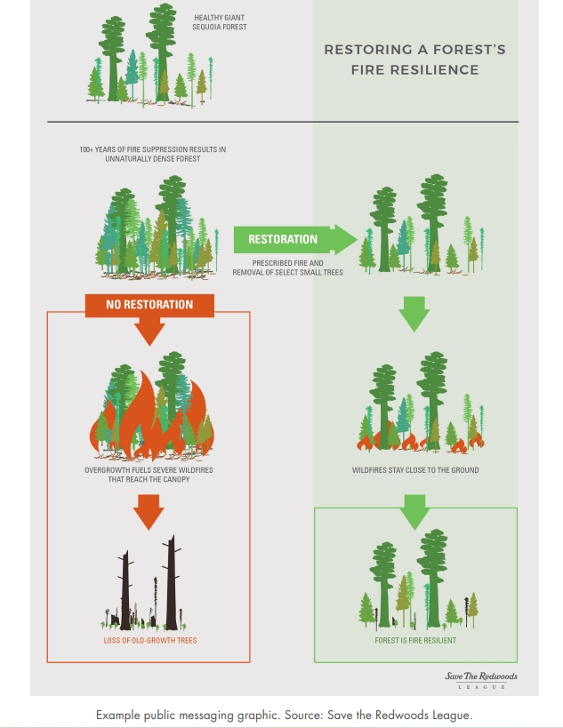
I have included the Save the Redwoods to highlight that this is not just an Australian issue.
Fire has been an increasing threat worldwide as can be seen from the following graph and analysis from Alexandra Tyukavina et al in Frontiers of Remote Sensing (2022).
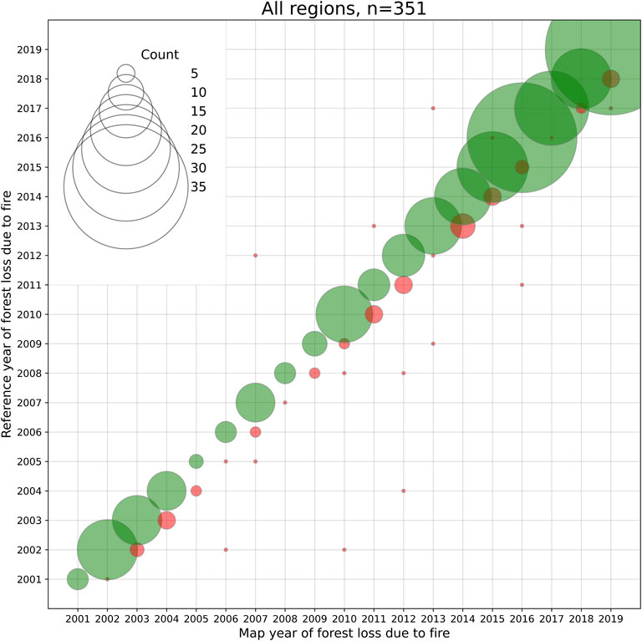

International research is gaining momentum with accelerating research activities and a broadening focus on on-ground forest work, assessing the outcomes of different forest management strategies, as well as remote sensing methods (in particular satellite based sensors).
The United Nations, apart from the global efforts to combat climate change and improve climate change related health impacts, now has a particular focus on indigenous involvement in forest management.
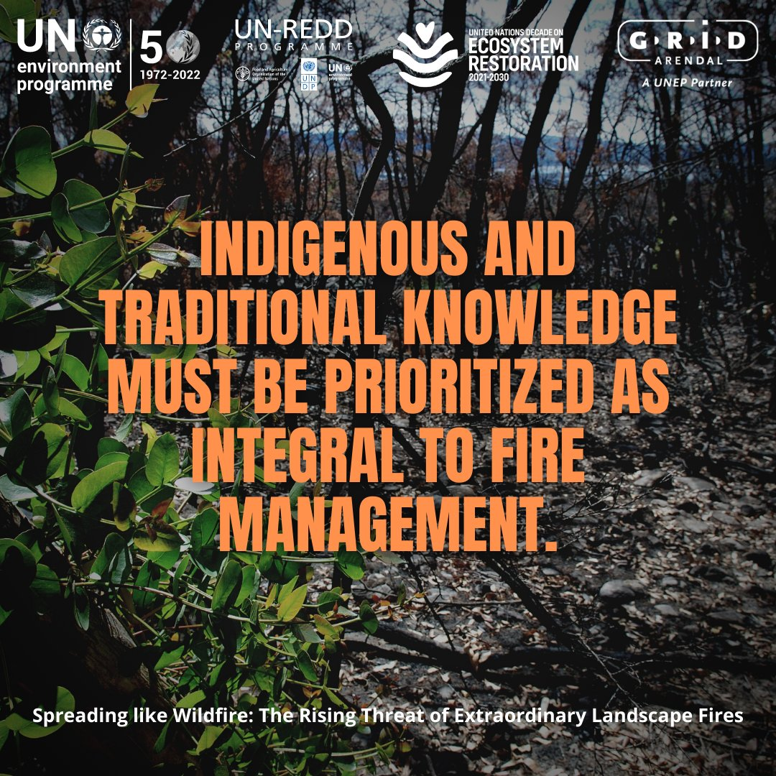

Unfortunately, Australia is lagging behind.

I have included a copy of one Shoalhaven bushfire mitigation example used in the Royal Commission to highlight risk reduction that may have originally been unpopular with locals but has been subsequently applauded. There is little doubt that the thinned, more resilient (less groundwater stress) forest with no undergrowth and lower fuel load provided better access for firefighters and equipment to access the high-intensity fire front generated by the high-density forest with extraordinary fuel loads on the other side of the fence.

Willinga Park, may represent forest density and the mix of forest and grassland described by early explorers in many areas as: resembling English parkland. It was highlighted as a potential model of forest management to reduce bushfire risk during the Royal Commission.
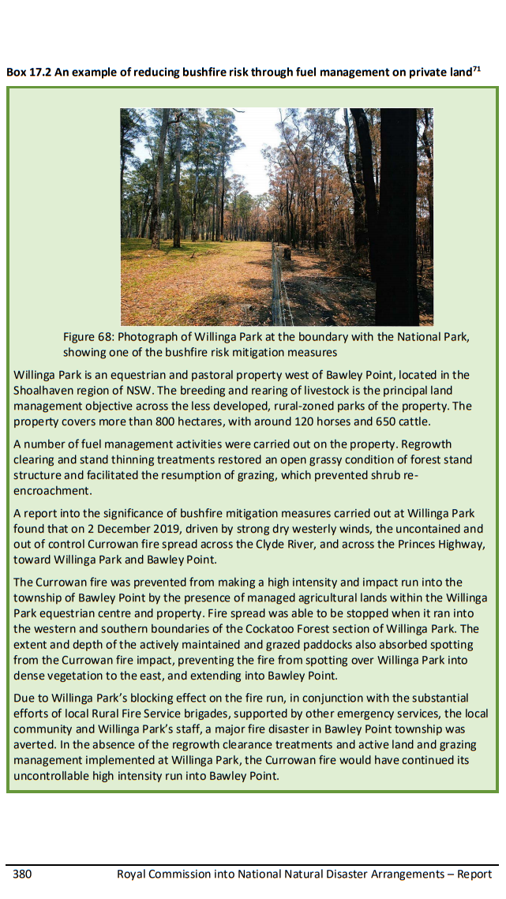
Also included below is the dramatic response on 4th January 2020 that probably saved many properties in our neighbourhood (kind permission from Russell Phelan).
My strong belief is that prevention is paramount and urgent.
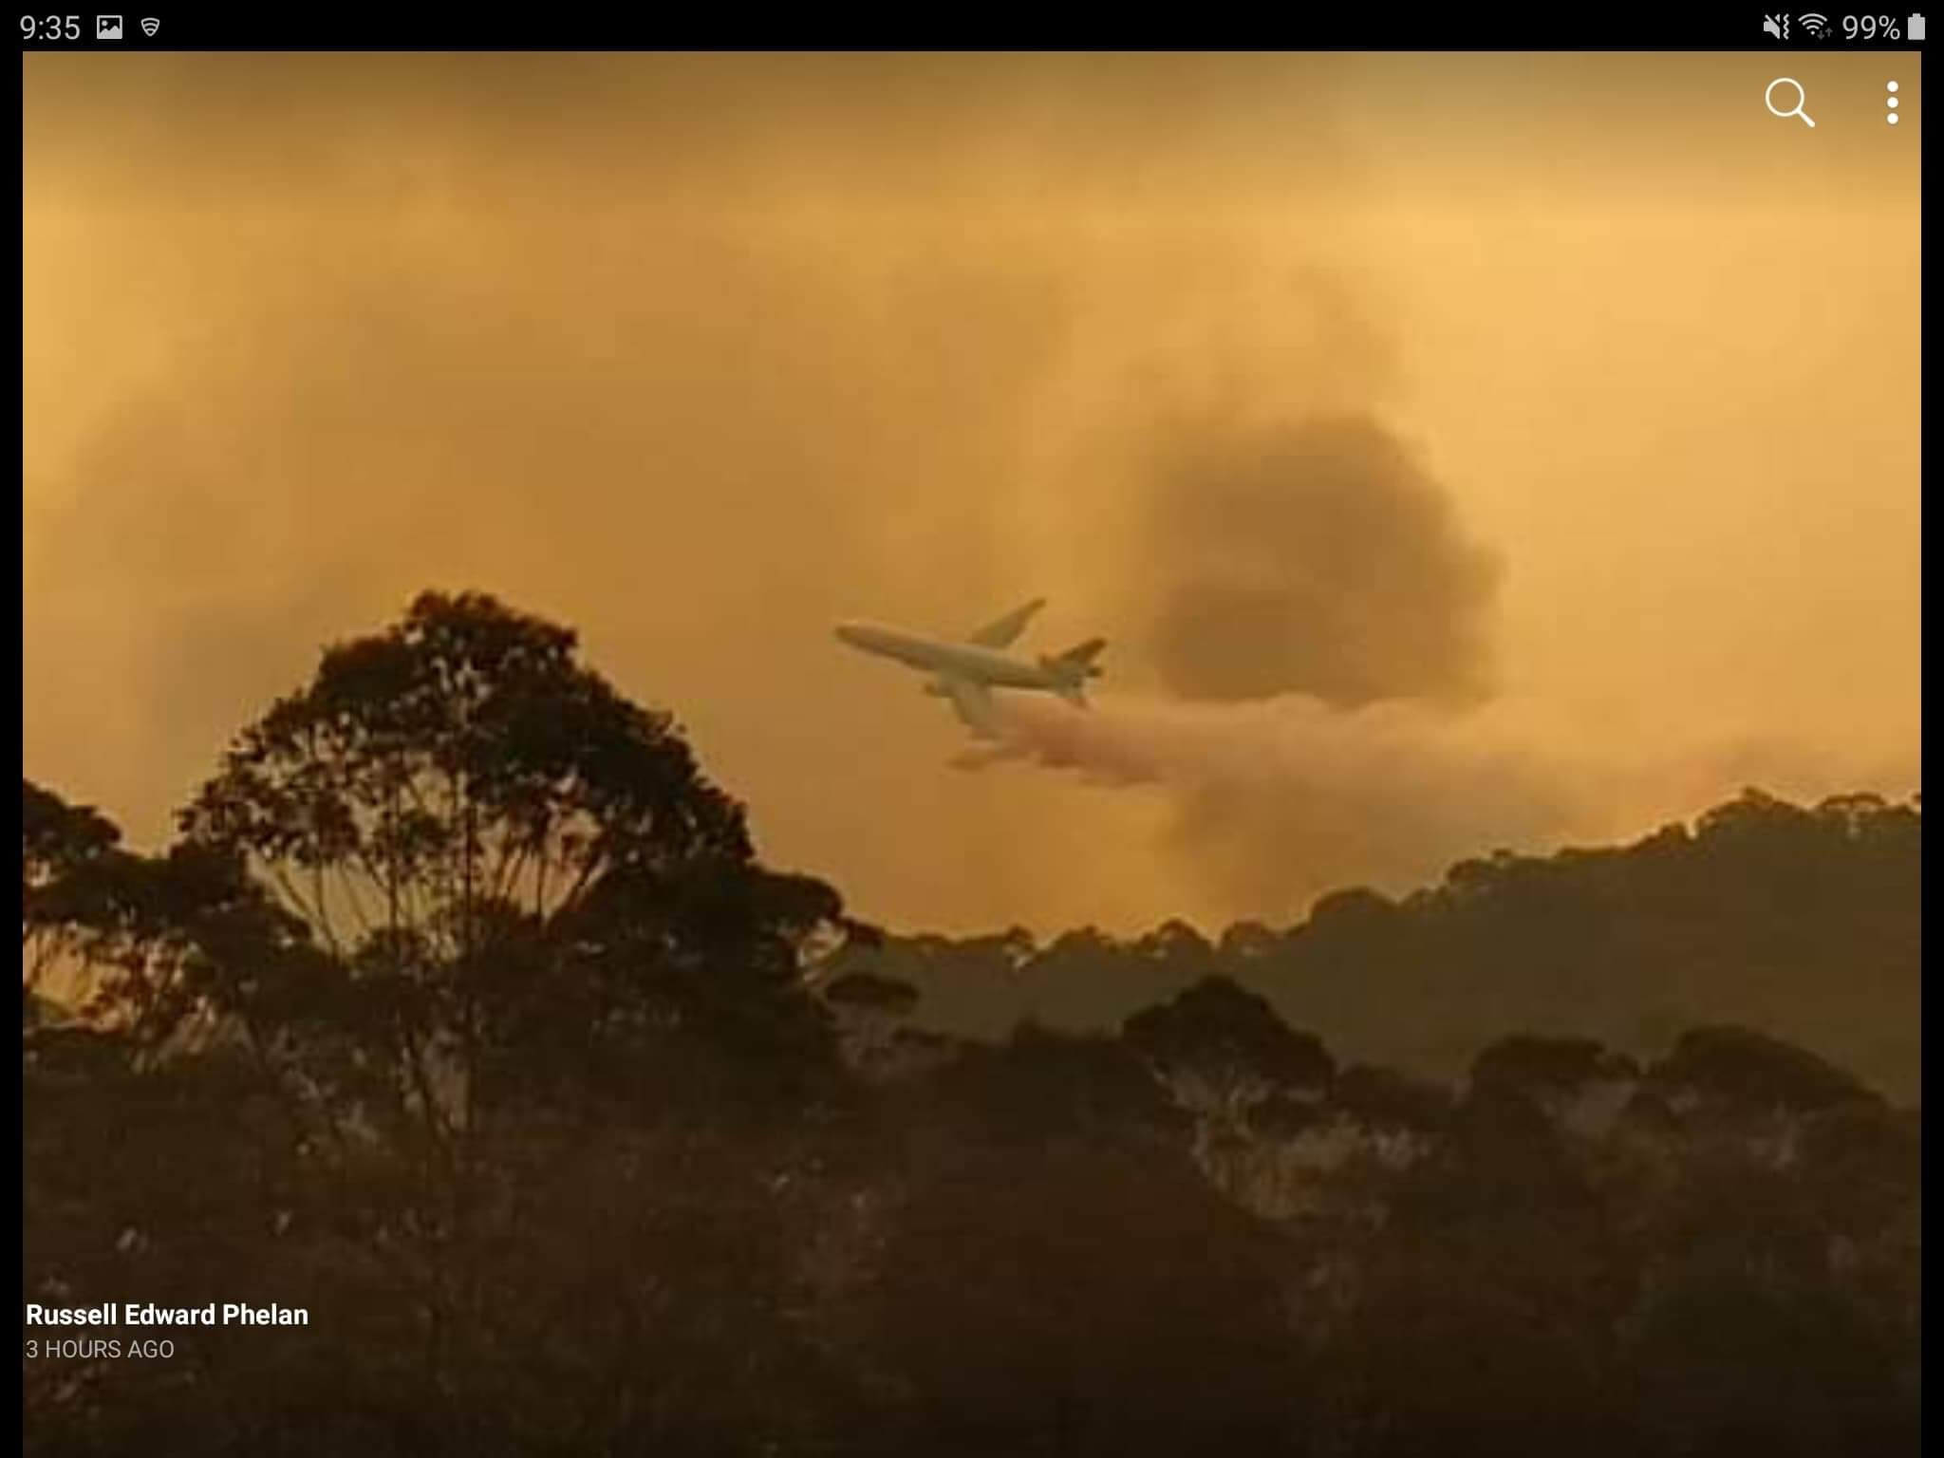

References:
Adams Henry D et al. A multi-species synthesis of physiological mechanisms in drought-induced tree mortality. Nature Ecology & Evolution/ Vol 1/ September 2017/ 1285-1291
Ajani J (2008): Australia’s transition from native forests to plantations; the implications for woodchip, pulpmills, tax breaks and climate change. Agenda 15: 21-38.
Bowman David M J S and Williamson Grant J (2021) (https://www.mdpi.com/2571-6255/4/2/22)
Bowman et al. The severity and extent of the Australia 2019–20 Eucalyptus forest fires are not the legacy of forest management | Nature Ecology & Evolution
Bureau of Meteorology – Climate data presentation to Royal Commission.
Department 0f Environment and Conservation NSW – Natural Resource Management Advisory series: Note 10 Old Growth Forests (Aug 2004)
Dargavel John (Ed): Short Overviews. Australian Forest History Society Inc. Occasional Publication, No 1 (2005)
Diels, L. 1906, Die Pflanzenwelt von West-Australien südlich des Wendenkreises Leipzig: Wilhelm Engelmann.
Ellis et al. https://doi.org/10.1073/pnas.2023483118 People have shaped most of terrestrial nature for at least 12,000 years
https://www.dpc.nsw.gov.au/assets/dpc-nsw-gov-au/publications/NSW-Bushfire-Inquiry-1630/Final-Report-of-the-NSW-Bushfire-Inquiry.pdf
Fletcher, Michael-Shawn et al: Catartrophic Bushfires, Indigenous Fire Knowledge and Reframing Science in Southeast Australia. Fire 2021, 4, 61. https://doi.org/10.3390/fire4030061
Frawley Australian Forest History Kevin J. Frawley in Australian and New Zealand Forest Histories Dargavel ed (2005).
Gammage Bill: “The Biggest Estate on Earth – How Aborigines made Australia”. (2011)
Gillson Lindsey, Whitlock Cathy and Humphrey Glynis: Resilience and fire management in the Anthropocene. Ecology and Society. 24. 3 (Sep 2019)
Groundwater recharge and surface runoff (nsw.gov.au)
Harrington N and Cook P, 2014, Groundwater in Australia, National Centre for Groundwater Research and Training, Australia.
Jackson et al (2021) Reshaping forest management in Australia to provide nature-based solutions to global challenges: Australian Forestry: Vol 84, No 2 (tandfonline.com)
Johnson Daniel M et al, Plant Cell Environment (2022) Catastrophic hydraulic failure and tipping points in plants. DOI: 10.1111/pce.14327
Jones Rhys: Fire-Stick Farming Australian Natural History 16(7): 224-228 (September 1969)
Keith Heather, Lindenmayer David B, Mackey Brendan G, Blair David, Carter Lauren, McBurney Lachlan, Okada Sachiko, Konishi-Nagano Tomoko:- Accounting for Biomass Carbon Stock Change Due to Wildfire in Temperate Forest Landscapes in Australia. PLOS ONE Sept 2014, Vol 9, Issue 9
Krauss Lawrence M “The Physics of Climate Change“ (2021)
Kubale John: 20 Years of rainfall record - 45 Ironbark Road Tapitallee. NSW
Legge S, Garnett S, Maute K, Heathcote J, Murphy s, Wolnarski JCZ, et al. A Landscape-Scale, Applied Fire Management Experiment Promotes Recovery of a Population of the Threatened Gouldian Finch, Erythrura gouldiae, in Australia’s Tropical Savannas. PLoS One. 2015 Oct 7;10(10):e0137997.
Lunt Ian D: Tree Densities Last Century on the Lowland Gippsland Plain, Victoria. Australian Geographical Studies - December 1997, 35(3). 342-348
Moulds Frank R. p 130 in - Australia's Ever-Changing Forests II Proceedings of the Second National Conference on Australian forest history 1993 Edited by John Dargavel and Sue Feary

McDowell Nate G et al 2022 Mechanisms of woody-plant mortality under rising drought, CO₂ and vapour pressure deficit, https://www.nature.com/articles/s43017-022-00272-1
McGowan Barry: Dust and Dreams – Mining Communities in South-East NSW. UNSW Press 2010
McRae Rick (UNSW Canberra) Personal permission to use BUFE image
Nolan Rachel H et al (2020) https://www.mdpi.com/1999-4907/11/7/779)
Pascoe Bruce: Dark Emu – Black seeds: agriculture or accident? (2014) Magabala Books
Royal Commission into National Natural Disaster Arrangements- Report 28 Oct 2020
Spooner P G, Lunt I D and Smallbone L: Using growth form attributes to identify pre-settlement woodland trees in central NSW Australia. Australian Journal of Botany 2010. 58 188-197.
Steffenson Victor: “Fire Country – How Indigenous Fire Management could help save Australia” 2020.
Sun GE, Amatya Devendra M, and Steven G McNulty in FOREST HYDROLOGY Ed Singh Chapter 85 2016

Tyukavina Alexandra et al Fronteirs in Remote Sensing, 2022, Global Trends of Forest Loss Due to Fire From 2001 to 2019 https://doi.org/10.3389/frsen.2022.825190
I. Vertessy, R.A. (Robert Alexander). 1998 II. Cooperative Research Centre for Catchment Hydrology. (Series: Report (Cooperative Research Centre for Catchment Hydrology); 98/4)

Yael Wagner et al New Phytologist (2022) In situ, direct observation of seasonal embolism dynamics in Aleppo pine trees growing on the dry edge of their distribution, doi:10.1111/nph.18208
Zeppel, Melanie. Convergence of tree water use and hydraulic architecture in water-limited regions: a review and synthesis. Ecohydrol. 6. 889-900 (2013)
2019-2020 Bushfires. Extent of impact on old growth forest. A joint report prepared by 2rog Consulting and the Natural Resources Commission–FINAL 3/4/2020
30 years of personal observation 48 Ironbark Road Tapitallee NSW

Acknowledgements:
Most of the ideas within this paper have been generated from our families’ interaction with local nature and discussions within our local community. In particular, assistance has been provided in terms of extra ideas, layout, proofreading and reference checking by Lois Bruce, Rhiannon, Sian, Hamish and Ryan Whittingslow.

Helpful review by Grant Williamson (UOT) appreciated.

Author:
Warren Bruce has been a Shoalhaven anaesthetist and resident for over 30 years. Early years in Coffs Harbour where his ancestors had helped pioneer white settlement of the Upper Orara Valley with farming, timber cutting and gold seeking seeding his interest in the Australian Bush. His experiences and family stories in this area taught him much about the natural bush world.

