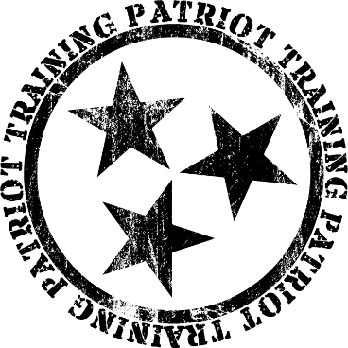

URBAN RIFLEMAN

NAME:: ________________________________________________

NOTES

*** LOGIC ***
The 5-letter word at the top of the handout
URBAN RIFLEMAN

By

PURPOSE
The purpose of this class is to teach practical use of a rifle for self-defense. The purpose of Patriot Training is to help you become Mentally prepared, Physically Prepared, and Legally Prepared to defend yourself.

CLASS CONTENT
Legalities of deadly force Legalities of civilian self-defense with a firearm
Marksmanship & zero the rifle Proper implementation
Fight considerations Malfunction clearing
Shooting from nonstandard positions Use of cover and concealment
Teamwork – leapfrogging and bounding CQB & room entry

INTRODUCTIONS
It is always good to know who your fellow participants are before you go shoot alongside them. Shooting is very fun, but also carries a certain amount of risk. It is far more comfortable for most people to engage in an activity that has risk with people they know, rather than complete strangers. The purpose of introductions is not to make anyone uncomfortable – but, rather, quite the opposite – to make everyone more comfortable. Plus, the camaraderie with fellow shooters is something most Patriot Training classes build and enjoy.

Name?
Where are you from?
What do you do?
What do you hope to get out of class? Write it here:

FOR YOU

HOW TO HAVE A GOOD DAY

- ____________ to instruction (and do it!)
- ________________________________ EXACTLY as instructed
- Focus on ________________________ progress.
- __________________ let me say that again __________________ !
- __________ water.
- Family __________________ coach family.

STUDENT EXPECTATIONS
- Keep a positive attitude and an open mind
- Be _____________ – Arrive on time, stay on task, and follow instructions.
- Be ________ – Follow the Firearms Safety Rules at all times; notify staff of medical concerns.
- Be ____________________ – Treat instructors and peers with respect;
  - family shall not coach family.
- Be ______________________ – Stay engaged with every lesson.

⚠️ Failure to meet these expectations may result in removal from class for safety reasons or not receiving a course completion certificate.

OUR REQUEST TO YOU:

KEEP AN __________________ !

This material is not “The Way.” (no material is!)
This material “A Way.”
Instead of dismissing a tactic or technique out of hand – ours or someone else’s – we request you perform the methods presented and evaluate the entire body of work after the class is complete.
”Absorb what is useful – reject what is useless.” Bruce Lee

SAFETY

GOLDEN RULE: MAINTAIN POSITIVE MUZZLE CONTROL AT ALL TIMES
Always and only point your gun at something you intend to shoot.
Do not point the gun at anything you do not wish to shoot.

In a Patriot Training class, all participants are expected to maintain 110% awareness of muzzle direction and maintain complete control at all times of the direction of the muzzle – REGARDLESS OF CIRCUMSTANCE.

SILVER RULE: MAINTAIN TRIGGER DISCIPLINE AT ALL TIMES
Sights on target and ready to fire = finger on trigger.
Sights not on target OR not ready to fire = finger off trigger, in the high register position.

SILVER RULE: ADDENDUM
For added security, in Expert Rifleman, the safety shall be engaged at all times when the finger is not on the trigger. Likewise, the safety shall be disengaged when the student has a finger on the trigger AND has made the conscious decision to the shot.

BRONZE RULE: Keep guns unloaded when not in use.
In this class, the guns are in use. We run a hot range. Keep guns loaded unless directed otherwise for a specific exercise. Unattended guns should generally be kept unloaded, in case unauthorized individuals access them. This is to make up for the fact that you might not be there and able to enforce the Golden and Silver rules!

HOW OFTEN: ALWAYS!

RANGE & SELF DEFENSE RULE:
Be aware of your target, what is behind it, what is flanking it, and what is between you and your target. Including distance and wind.

ADDITIONAL SAFETY CONSIDERATIONS:
- Hot brass happens – it is NOT a reason to violate a safety rule or quit a drill.
- Finger up – Gun up – then move!
- Rifle: When finger is OFF trigger, safety must be ENGAGED.
- Do not shoot to the left of the yellow markers on the rifle range.
- Take care when bending over and moving.
- No handling guns behind the line.
- If you drop a gun, LET IT GO!
- Keep guns loaded and ready for next drill.

CONSEQUENCES
- Warning
- Ejection

MEDICAL

In the unlikely event of a medical emergency, either due to a range accident, or other unforeseeable circumstance, it is wise to set up a pre-planned course of action. In essence, this requires two parts: first responders, and a call for help.

Patriot Training classes will establish a primary and secondary responder, and primary and secondary phone callers. The purpose for a primary and secondary is self evident: in the event the primary is the one who required medical attention, or in the event the primary is not immediately accessible, the secondary shall take action.

Range Name: _________Mountain Top Gun & Archery Range________

Range Address: _________11564 Harrison Ferry Rd_________________

_________McMinnville, TN 37110__________________

MARKSMANSHIP

FUNDAMENTALS OF MARKSMANSHIP – “GAP”

GRIP
- Hold the ______________________________
- Correct ____________________________ – Proper Standing, Kneeling, Sitting, Prone
- Deploy the __________ .

AIM
- Sight __________________
- Sight Picture – Scope, red dot, irons
- ______________ correctly (so as not to disturb sights when firing)

PRESS
- Touch – slack – ____________________________________ (15 e’s or else you are wrong)
- Keep trigger pinned to rear – this is trigger ____________________________ .
- Experience recoil – sights back on target – __________________________ .

Proper marksmanship should be applied to every shot, without fail.

“Sight – sight – squeeeeeeeeeeeeeeeze”

SIGHT PICTURE TRIGGER
Proper sight alignment Squeeze trigger – smooth rearward pressure
Proper sight picture Follow through (keep trigger to rear)
Focus on front sight Trigger reset

MANIPULATION

THINGS TO DO WITH YOUR RIFLE
- Lock Bolt to the rear.
- Load the Rifle
- Unload the Rifle
- Tap-Rack for a closed bolt “click instead of bang” (Type 1) or a stovepipe (Type 2).
- Unload the gun – reload the gun: double feed (type 3). Use the bolt lock method.
- A bullet over bolt will require a tool such as a screwdriver to relieve pressure on the round so it can fall out or be extracted. DO NOT use a knife!

If you have a sidearm, it is almost always faster to transition than to reload or fix a malfunction. Transition to sidearm if inside of 25 yards. If you must clear your rifle, it is always a good idea to do that behind cover. Almost all of the exercises in this class will be performed from a distance where you can make a hit with the pistol – so transition to pistol!

Keep your rifle pointed UP when loading, unloading, or dealing with a malfunction!!!

RELOADING
Broadly speaking, there are only two times to reload: when you have to, and when you want to. It is better to reload when you want to. Top off.

EMERGENCY RELOADS
When you have to reload, that is most commonly a shooter-induced malfunction!
- Release magazine with shooting hand and bring new mag up with support hand – simultaneously.
- Insert new magazine firmly, with a tap & tug.
- Release bolt.

TACTICAL RELOADS
It is always better to reload when you want to, as opposed to when you have to.
- L-Shaped method
- Finger between method
- Left handed method (emergency reload)

Keep your rifle pointed UP & AWAY (“high port”) when dealing with a malfunction or reloading!!!

CONSIDERATIONS

DEADLY FORCE CONSIDERATIONS
- Deadly Force can be used when a person has a reasonable belief that there is an imminent danger of death or serious bodily injury
- Deadly Force can be used when and to the degree the person reasonably believes is immediately necessary to protect against another’s use of unlawful force
- You can protect someone else “IF” you would be permitted to protect yourself in the same situation

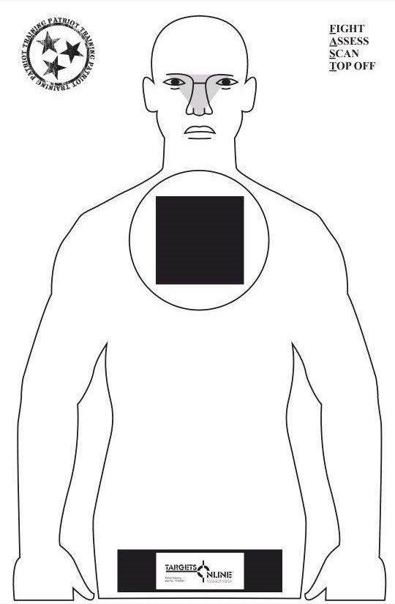
NEUTRALIZING THE HUMAN BODY
We shoot to neutralize. We do not “shoot to kill.”

The most effective way to neutralize the human body is with a shot to the ocular cavity, the triangle represented here in the head area.

The next most effective shot is a fist-sized area in the middle of the upper chest.

Another area of effectiveness is the pelvic girdle.

IMPLEMENTATION

ZERO THE RIFLE
With occasional exceptions:
- AK 47/74 rifles do well with a 50 yard zero.
- AR15 rifles with a red dot or holographic sight tend to do best with a 50-yard zero.
- Many LPVO optics and others have a Ballistic Drop Compensator (BDC) and specify a 100-yard zero.
- For 16-20 inch barreled AR rifles, iron sights might be more effective with a 36/300 yard zero.

To zero your rifle, fire a steady, measured 5 shot group at a target 50 yards away.
Measure how many inches off the center of you group is – how high / low and how far left/right.
Adjust your sighting apparatus the same number of clicks as inches needed to move, and in the same direction. (not foolproof, but a good start for most sighting apparatus!)
Repeat until shots hit where you were aiming.

UP DRILLS (READY-UPS) – “IMPLEMENTATION”
Height over bore considerations & Fighting Stance
Ready – up: Patrol ready (aka “muzzle down”), low ready, high ready

TURNS
Who ever said the bad guy would attack from the front?
It is important to practice turns to the left, to the right, and to the rear.
Just remember the mantra: “Head – Body – Weapon”

UNORTHODOX SHOOTING POSITIONS CARRIES
Supine – Sitting – Kneeling – Back to standing Low Ready
Off shoulder – partial off shoulder High Ready
Patrol Ready
GENERAL SUGGSTIONS Daniel Boone Carry
Square up as best as possible
Drop – Pull – Push – Press

WYATT PROTOCOL
After defending yourself with a rifle, you should engage in the Wyatt protocol (F.A.S.T.):

F = Fight. Always shoot to Neutralize the threat, do not “shoot to kill.”
A = Assess. Always assess the attacker – make sure he is no longer a threat.
S = Scan. Search 360 degrees. You are looking for your friends, his friends, and places to go.
T = Top Off. Bad news typically travels in groups. It is better to face more bad news with a full magazine.

ADVANCED RIF:LE FIGHTING

SHOOTING ON THE MOVE
Shooting on the move is a tricky proposition. Generally speaking, you cannot move at top speed, else you will have virtually no accuracy whatsoever. At the same time, even when moving slowly, accuracy degrades significantly from stationary positions. It is almost like the worst of both worlds – you aren’t moving fast enough to keep from getting shot, and you aren’t shooting accurately enough to make hits. We will practice a little shooting on the move, however, most experts agree that it is better to shoot, then move, then shoot.
Distance will be your friend.
Shoot, and scoot – get away!

USE OF COVER
Cover stops bullets. Concealment stops sight. Cover is very often caliber dependent. Cover works both ways. Cars are generally not cover. Do not hug cover, unless someone is shooting from an elevated position or you have no other choice.
Off Shoulder shooting can help minimize the amount of your body that is exposed when shooting to the non-dominant side from cover.
Partial Off Shoulder shooting can help you be more accurate than Off Shoulder shooting!
Always change sides and elevation if possible. Be unpredictable.

EXFIL
Give a Distance, Description, Direction, then move together. Top Off if time permits.

RTR
Return Rapid fire – 2 shots in the vicinity of the attackers
Take Cover
Return Aimed fire.

TEAM FIGHTING

SHOOTING – MOVING – COMMUNICATING
If you do not shoot and maneuver, you will be maneuvered upon and shot.
There is an art to it. You must request permission to move from your partner.
Request permission: IF no permission granted:
“MOVING!” “NEGATIVE, NEGATIVE, NEGATIVE!”
IF he grants permission: If you run out of ammo:
“MOVE!” “COVER!”

“SILENT” COMMUNICATION – Start moving when partner starts shooting
Leapfrogging (lateral movement from cover to cover)
Bounding (vertical movement from cover to cover)
THE FIGHT

LIMITED ENTRY
Tactical Reload before making entry
Initial entry
Final corners

Congratulations, you are now a Patriot Training Alumni!
You may take any live fire class in the future at a discounted price.
Use code “ptalum” to activate the savings!

