Contents
PURPOSE 2
HOW TO HAVE A GOOD DAY 2
STUDENT EXPECTATIONS 2
OUR REQUEST TO YOU: 2
SAFETY 3
MEDICAL 3
MARKSMANSHIP 4
MANIPULATION 4
HOLD OVERS 5
WIND HOLDS 5
(ON THE RANGE) ZERO THE RIFLE 6
WYATT PROTOCOL – “F.A.S.T.” 6
RELOADING 6
MALFUNCTIONS 7
UNSUPPORTED PRONE 7
BRACED POSITIONS 8
BRACED POSITIONS – STAIR STEP DRILL 8
SHOOT STEEL AT 300 YARDS 9
THE HEZEKIAH WYMANN 9
The Fundamental Marksmanship Evaluation 10
First Shot Drill 10
Range Estimation Using the Reticle 11
THE DM LED AMBUSH 11
TACTICS 12
SOLO TACTICS 12
TEAM TACTICS 13
HIT & RUN 13
BOUNDING EXFIL – LEAPFROGGING 14
BOUNDING EXFIL – BOUNDING 14

PURPOSE
PATRIOT TRAINING
To help you be:
- Physically Prepared
- Mentally Prepared
- Legally Prepared
To defend yourself and your loved ones.

EXPERT RIFLEMAN
To build Riflemen

HOW TO HAVE A GOOD DAY
- Listen to Instruction… and do it!
- Perform the task EXACTLY as instructed.
(“CREATING” YOUR OWN VARIATION INVARIABLY LEADS TO FRUSTRATION)
- Focus on you and your progress.
- Slow down! let me say that again SLOW DOWN!
- Drink water.
- FAMILY SHALL NOT COACH FAMILY

STUDENT EXPECTATIONS
- Keep a positive attitude and an open mind
- Be Ready – Arrive on time, stay on task, and follow instructions.
- Be Safe – Follow the Firearms Safety Rules at all times; notify staff of medical concerns.
- Be Respectful – Treat instructors and peers with respect; family shall not coach family.
- Be Accountable – Stay engaged with every lesson.

OUR REQUEST TO YOU:
This material is not “The Way.”
This material “A Way.”
Instead of dismissing a tactic or technique out of hand – ours or someone else’s – we request you perform the methods presented and evaluate the entire body of work after the class is complete.
”Absorb what is useful – reject what is useless.” Bruce Lee

SAFETY

GOLDEN RULE: MAINTAIN POSITIVE MUZZLE CONTROL AT ALL TIMES
Always and only point your gun at something you intend to shoot.
Do not point the gun at anything you do not wish to shoot.

SILVER RULE: MAINTAIN TRIGGER DISCIPLINE AT ALL TIMES
Sights on target and ready to fire = finger on trigger.
Sights not on target OR not ready to fire = finger in the high register position.

BRONZE RULE: Keep guns unloaded when not in use.
In this class, the guns are in use. We run a hot range. Keep guns loaded unless directed otherwise for a specific exercise.

HOW OFTEN: ALWAYS!

RANGE & SELF DEFENSE REMINDER:
Be aware of your target, what is behind it, what is flanking it, and what is between you and your target. Including distance and wind.

MEDICAL

In the unlikely event of a medical emergency, either due to a range accident, or other unforeseeable circumstance, it is wise to set up a pre-planned course of action. In essence, this requires two parts: first responders, and a call for help.

Patriot Training classes will establish a primary and secondary responder. The purpose for a primary and secondary is self-evident: in the event the primary responder is the one who required medical attention, or in the event the primary responder is not immediately accessible, the secondary responder shall take action. Participants who have active or past careers as first responders: Paramedics, EMTs, etc. will be asked if they are willing to assume this responsibility.

In a similar manner, two persons shall be designated as primary and secondary phone callers. The reason for two is the same as with the medical responders – just in case the primary phone caller is the one who needs medical assistance. The call shall go this way: “hello, there has been a range accident. Please send an ambulance!” Give the name of the range and address.

MARKSMANSHIP

FUNDAMENTALS OF MARKSMANSHIP: “GAP”
GRIP
- Hold the rifle correctly
- Stand / kneel / prone correctly
- Deploy the rifle
AIM
- Sight alignment
- Sight Picture – scope, red dot, irons
- Breathe correctly (so as not to disturb sights when firing)
PRESS
- Touch – slack – squeeeeeeeeeeeeeeeze (15 e’s or else you are wrong)
- Keep trigger pinned to rear.
- Experience recoil – sights back on target – trigger reset (follow through)
Proper marksmanship should be applied to every shot, without fail

MANIPULATION

THINGS TO DO WITH YOUR RIFLE
- Lock Bolt to the rear.
- Load the Rifle
- Unload the Rifle
- Tap-Rack for a closed bolt “click instead of bang” (Type 1) or a stovepipe (Type 2).
- Unload the gun – reload the gun: double feed (type 3). Use the bolt lock method.
- A bullet over bolt will require a tool such as a screwdriver to relieve pressure on the round so it can fall out or be extracted. DO NOT use a knife!

If you have a sidearm, it is almost always faster to transition than to reload or fix a malfunction. Transition to sidearm if inside of 25 yards. If you must clear your rifle, it is always a good idea to do that behind cover. Almost all of the exercises in this class will be performed from a distance where you can make a hit with the pistol – so transition to pistol!

Keep your rifle pointed UP when loading, unloading, or dealing with a malfunction!!!

HOLD OVERS
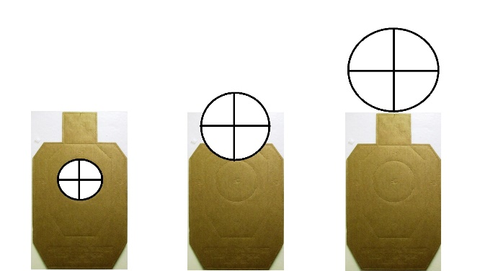
HOLD OVER
Which applies to your sighting apparatus?
Go with the method you have.
HOLD OVER – BDC
Zero at 100 (or per manual)
Use 200 / 300 / 400 hash marks accordingly.

HOLD OVER – RED DOT OR SCOPE

Standard crosshair or red dot
Chest – Head – Hat
≤ 200 300 400

Range – drop MOA Reticle MIL Reticle
100 – Zero
200 – 2.6” drop 1.3 MOA 0.4 MIL
300 – 12.1” drop 3.8 MOA 1.1 MIL
400 – 30.9” drop 7.4 MOA 2.1 MIL
500 – 62.5” drop 11.9 MOA 3.5 MIL

WIND HOLDS

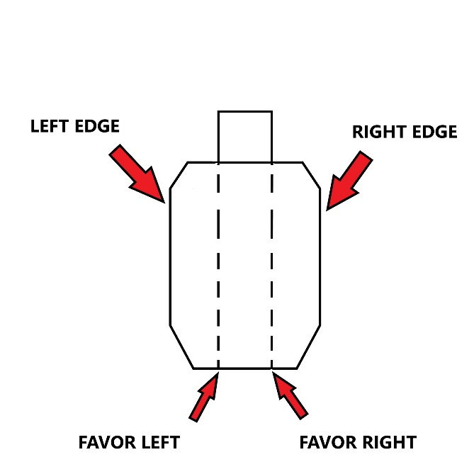

(ON THE RANGE) ZERO THE RIFLE
WHAT: Apply marksmanship fundamentals to align point of aim with point of impact.
WHY: Without a zero, you cannot guarantee hitting where you intend.
HOW:
- Zero distances: 50-yards to start – ALL optics, aim dead center
- Setup: Show how to make a training magazine (remove bottom, spring, follower). Adjust stock fully out, or one click in if needed for shorter shooters—remind this is for marksmanship, not combat.
- DPOA (Disciplined Point of Aim): Rifle squared to target. Demonstrate proper prone—body behind rifle, feet apart and “live,” rifle rested on rucksack/stock in shoulder, roll shoulder, support hand “coke can grip,” proper eye relief/NTCH. Load the mag like a bipod. Explain supported vs unsupported prone.
- Fundamentals (GAP – Grip, Aim, Press): Stress sight alignment and trigger control. Finger placement is less important than correct manipulation. Teach “touch–slack–squeeze,” reset, and “sight–sight–squeeze.”
- Breathing: Demonstrate steady breathing with controlled break.
- Dry fire: Watch muzzle for movement. Students repeat until stable.
- Live fire: Students fire best 5-shot group. Walk downrange, inspect, adjust. Repeat as needed (no more than 3 repetitions). 4” groups at maximum.
- Fine Tune: Take targets to 100 yards. DEAD CENTER HOLD. 5-shot groups. 6” groups at maximum.
  - RED DOTS – Use top center of dot for aiming point.

WYATT PROTOCOL – “F.A.S.T.”
WHAT: Teach the Wyatt Protocol to guide shooter actions after firing.
WHY: Provides a structured routine for maintaining awareness and control after engaging a target.
HOW:
- Fight: Engage the target as directed.
- Assess: Ensure the target is neutralized; gun at low or high ready, finger up, safety on.
- Scan: Look 360° for friends, foes, and possible movement routes.
- Top Off: Reload as necessary.

RELOADING
WHAT: Ensure the rifle has ammunition ready for continued engagement.
WHY: Prevents running dry at a critical moment; keeps the shooter prepared.
HOW:
- Reload proactively (“when you want”) or reactively (“when you have to”).
- Bring the new magazine up to the gun before dropping the old one to ensure you have a replacement.
- Left-handers drop old mag while inserting new.
- If a magazine is dropped, pick it up and use the Daniel Boone carry for storage.
- For tactical reload issues, ensure magazines are loaded properly (avoid overstuffing—31 rounds) or instruct students to load fully, then remove two rounds to ease insertion.

MALFUNCTIONS
WHAT: Teaching immediate action drills to clear rifle malfunctions.
WHY: So the student can quickly identify and correct malfunctions to continue engaging the target.
HOW:
- Observation: On a “click” or mushy trigger, pause ~½ second and check ejection port. Identify:
  - Bolt locked back → Reload the rifle.
  - Closed bolt / stovepipe → Tap and tug magazine, reciprocate charging handle with support hand.
  - Double feed →
    - Keep rifle pointed downrange.
    - Lock bolt to rear.
    - Remove magazine (may require force).
    - Clear rounds/brass through magwell (“finger-fornicate”) and/or charging handle.
    - Reload rifle.
- Exercise:
  - Use full magazine with three dummy rounds loaded alternately (top, 3rd, 5th).
  - Fire → click → tap/rack → fire → repeat for all dummy rounds.

UNSUPPORTED PRONE
WHAT: Shooting from prone without using any support device.
WHY: Sometimes a solid support position isn’t available in a dynamic environment.
HOW:
- Rest the AR-15 on the magazine; apply all standard marksmanship principles (sight alignment, trigger control, breathing, stock placement, etc.).
- Do not use a backpack or rear bag.
- Fire 10 rounds at center mass of a paper target at 100 yards.

BRACED POSITIONS
WHAT: Shooting from various positions while using a brace or support.
WHY: Different positions provide tactical advantages and allow accurate hits at longer distances (up to 300 yards) when properly braced.
HOW:
- Body setup: Triangulate shoulders and hips to the bracing object, roll shoulder.
- Stock adjustment: Typically 1–2 clicks out for proper eye relief.
- Support hand: Can stabilize the rifle on forearm or shoulder depending on position and stability.
- Maintain DPOA (Disciplined Point of Aim).
Execution:
- Standing: 5 hits per steel target (100 / 150 / 200 yds), braced, then FAST.
- Kneeling: Repeat 5 hits per target, braced, then FAST.
- Sitting: Repeat 5 hits per target, braced, then FAST.

WHAT – Teach different shooting positions with the body.
WHY – Different positions have different advantages and disadvantages. Use them according to the situation.
HOW – follow up lesson from previous

Do this:
- Shoot a string of 2 hits on the 200 yard steel target, braced on object for support, using each stair step of the bracing object. Then FAST

BRACED POSITIONS – STAIR STEP DRILL
WHAT: Shooting from different heights using a bracing object.
WHY: Teaches adaptability and stability from uneven surfaces; different positions have tactical advantages depending on the situation.
HOW:
- Use each “stair step” of the bracing object for support.
- Shoot 2 hits on the 200-yard steel target from each step while braced.
- Repeat FAST after each string.

SHOOT STEEL AT 300 YARDS
WHAT: Shooting targets at 300 yards to demonstrate rifle capability.
WHY: Shows that a rack-grade rifle, standard optic, and bulk ammo are sufficient for accurate hits at extended distance.
HOW:
- Preparation:
  - Use stuffed magazines; count rounds carefully.
  - Shooters bring rucksack for support. Bring Water – we will be out in the field for an hour or more.
  - Split into two teams with walkie-talkies: one in the “pit” to count hits, one shooting.
  - Dot + magnifier shooters: hold at target’s head. LPVO shooters: use 300-yard mark in scope.
- Execution:
  - Supported prone: 5 rounds, then FAST.
  - Switch teams and repeat.
Additional Concepts (on the way out there):
- SLLS (Stop – Look – Listen – Smell): Environmental awareness techniques.
- Patrol Formations (2-man):
  - Ranger file (vertical)
  - Echelon (diagonal)
  - Line (horizontal)
  - Dispersion varies 1–30+ meters depending on circumstances.

THE HEZEKIAH WYMANN
WHAT – shooting, moving to cover, and re-establishing position to shoot again.
WHY – Builds confidence in the braced standing position, reinforces both NPOA (Natural Point of Aim) and DPOA (Disciplined Point of Aim), and conditions students to reset under movement and stress.
HOW – Three bracing objects are staged: one at 50 yards (right side of range), one at 25 yards (center), and one at the firing line (left side). Student begins at the forward brace.
Drill Steps:
- At the signal, brace and fire 2 rounds at the far target from the 50-yard brace.
- Move to the 25-yard brace using the Daniel Boone carry. Brace, then fire 2 rounds at the medium target.
- Move to the firing line brace (left side), again using the Daniel Boone carry. Brace, then fire 2 rounds at the near target.

The Fundamental Marksmanship Evaluation
WHAT – A structured marksmanship evaluation.
WHY – To measure student progress in applying fundamental rifle marksmanship skills.
HOW –
- Mags: One magazine loaded with 10 rounds.
- Starting Condition: Rifle loaded, magazine inserted, round chambered.
- Target: Steel at 300 yards.
- Course of Fire: Fire 10 rounds, unsupported prone, within 90 seconds.
STANDARDS –
- 9/10 hits = “Expert Rifleman” Patch awarded.
- 10/10 hits = “Expert Rifleman” Hat awarded.

First Shot Drill
WHAT – Cold bore shot at distance.
WHY – The very first shot of the day is the truest measure of skill under real conditions. It forces the shooter to apply fundamentals without warm-up.
HOW –
- Distance: 300 yards.
- Timing: Day 2, first event.
- Action: Each shooter fires one cold shot, applying holdover and a steady hold.
- Coaching: Instructors provide remedial coaching as needed.

Follow-on: Drill is immediately followed by another run of the Fundamental Marksmanship Evaluation.

Range Estimation Using the Reticle
WHAT – Measuring target distance with optic reticle.
WHY – Builds familiarity with using the reticle for range estimation. Reinforces how target size appears at different distances, sharpening the shooter’s ability to judge range under field conditions.
HOW –
- Setup: Steel target placed at 365 yards.
- Action:
  - Students move to the 265 yard line, with their rucksacks.
  - Students will observe target through their own optic.
  - They sketch in their handout how the target appears relative to their reticle at each distance.
  - Special focus: relative size of the target vs. reticle subtensions.
- Repetition: Exercise is repeated at 100, 200, and 300 yards.

THE DM LED AMBUSH
WHAT – A tactical live-fire drill where a Designated Marksman (DM) initiates fire, and the Riflemen follow immediately.
WHY – Individual skill is powerful, but synchronized team tactics amplify effectiveness.
HOW –
- Riflemen have 15 seconds to build positions and take up slack on triggers.
- Instructor designates the DM for each run.
- DM fires first; the rest fire immediately after.
- Rotate DM after each iteration so every shooter fills that role.
- Drill conducted at 100, 200, and 300 yards.

DM Led Ambush Partners well with Range Estimation Drill.

TACTICS
WHAT – Basic tactical framework for a pair of civilian Expert Riflemen.
WHY – Shooting skill is powerful, but proper tactics multiply its effectiveness.
HOW –
- Draw from US Army Guerrilla Warfare Handbook, Ch. 8, Sec. II: Offensive Combat Operations.
- Key point: “Raids and ambushes are the principal offensive techniques of the guerrilla force… When directed against enemy lines of communication, key areas, military installations, and industrial facilities, the total result is interdiction.”
- Break down every tactical operation into three phases:
  - Movement to the site (INFIL)
  - Actions at the site (ACTION)
  - Exit from the site (EXFIL)
- Apply this INFIL–ACTION–EXFIL model to understand both historical and modern small-unit tactics.

SOLO TACTICS
WHAT – A drill for a single civilian Expert Rifleman: move to cover, engage a designated target, then exfiltrate.
WHY – Builds the habit of linking marksmanship with tactics. Shooting skill by itself is limited; adding INFIL–ACTION–EXFIL reinforces survivability and teaches that every shot must fit inside a tactical plan.
HOW –
- Movement to the site (INFIL): Rifleman advances to the braced position with stealth and awareness, treating all terrain as potentially hostile.
- Actions at the site (ACTION): From cover, engage the designated steel target with one precise shot. Emphasize economy—fast, decisive, no wasted exposure.
- Exit the site (EXFIL): Immediately break contact, move away from the firing position, and complete a clean exfiltration. Priority is survival and denial of enemy counteraction.

TEAM TACTICS
WHAT – A paired drill: one Rifleman engages a designated target while a partner covers their “6,” then both exfiltrate.
WHY – Reinforces the value of teamwork and mutual security. Having a partner expands situational awareness and reduces exposure risk compared to solo operations.
HOW –
- Rifleman (ACTION): Moves to the braced position, engages the designated steel target with a precise shot. Focus on fast, decisive execution while minimizing exposure.
- Partner (SECURITY): Covers the Rifleman’s rear (“6”) and immediate surroundings, observing for threats and preventing surprise attacks.
- EXFIL: Once the shot is taken, both Rifleman and Partner move away from the firing position together, maintaining coverage and control throughout the exit.
- Rotation: Repeat the exercise multiple times so each participant has the opportunity to serve as Rifleman and Partner, ensuring experience in both roles.

HIT & RUN
WHAT – A coordinated ambush drill where two partnered Riflemen engage targets from braced positions, then exfil together.
WHY – Builds teamwork under fire, reinforces coordinated movement, and demonstrates how skill combined with proper tactics increases lethality and survivability.
HOW –
- Setup: Both Riflemen take braced positions on assigned cover points. Decide which Rifleman is the Designated Marksman (DM) for the first iteration.
- Engagement (AMBUSH):
  - At the DM’s signal shot, both Riflemen engage their designated steel targets, applying proper marksmanship principles.
  - Focus on timing, coordination, and maintaining proper trigger control and sight picture.
- Exfil (EXIT):
  - Once targets are engaged, Riflemen coordinate their movement off the firing line together.
  - Practice silent communication and movement synchronization during the exfil.
- Rotation & Repetition: Swap DM role so each participant leads an ambush, ensuring both experience firing and covering roles.

BOUNDING EXFIL – LEAPFROGGING
WHAT – A bounding exfil drill where two Riflemen alternate moving forward to successive cover points while the other provides covering fire.
WHY – Teaches coordinated movement under fire, maintaining suppressive fire while advancing, and minimizing exposure to threats.
HOW –
- Setup: Riflemen begin behind two designated cover points on the range, facing steel targets. Assign initial shooter roles.
- Execution:
  - Rifleman A provides suppressive fire while Rifleman B moves laterally (horizontally) to the next cover point.
  - Once at cover, Rifleman B establishes a braced position and provides covering fire.
  - Rifleman A then moves to the next cover point past Rifleman B.
  - Repeat the sequence until the designated end point is reached.
- Communication: Utilize verbal commands (“MOVING!” / “MOVE!” / “COVER!”) or silent cues as appropriate.
- Rotation & Repetition: Swap starting roles so each participant experiences moving first and providing cover.

BOUNDING EXFIL – BOUNDING
WHAT – A bounding exfil drill where Riflemen advance to the rear along alternating sides of the range while covering each other.
WHY – Teaches tactical withdrawal or approach using cover, moving in a coordinated manner while minimizing risk of exposure.
HOW –
- Setup: Riflemen begin at the starting line with two points of cover on opposite sides of the range. Assign initial roles (cover / mover).
- Execution:
  - Rifleman on one side provides covering fire while the partner moves rearward to the next designated cover on the opposite side.
  - Upon reaching cover, the moving Rifleman assumes a braced position and covers the partner.
  - Continue alternating sides, maintaining suppressive fire and movement rhythm until reaching the final exfil point.
- Communication: Use standard verbal commands or silent cues to coordinate movement.
- Rotation & Repetition: Swap initial roles to ensure each Rifleman practices both moving and covering.

