*** LOGIC ***
5-letter word at the top of the handout
AMERICAN RIFLEMAN
By

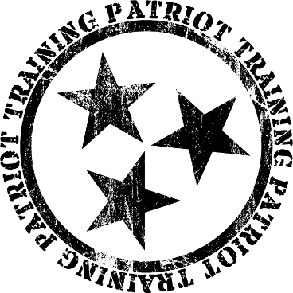

PURPOSE
The purpose of American Rifleman is to teach marksmanship with your rifle. The purpose of Patriot Training is to help you become Mentally prepared, Physically Prepared, and Legally Prepared to defend yourself.

CLASS CONTENT
- Fundamentals of marksmanship
- Zero the rifle
- Shooting positions:
  - Supported prone
  - Unsupported prone
  - Sitting
  - Kneeling
  - Standing
- Shooting at 100 – 200 – 300 yards effectively.

INTRODUCTIONS
It is always good to know who your fellow participants are before you go shoot alongside them. Shooting is very fun, but also carries a certain amount of risk. It is far more comfortable for most people to engage in an activity that has risk with people they know, rather than complete strangers. The purpose of introductions is not to make anyone uncomfortable – but, rather, quite the opposite – to make everyone more comfortable. Plus, the camaraderie with fellow shooters is something most Patriot Training classes build and enjoy.

Name?
Where are you from?
What do you do?
What do you hope to get out of class? Write it here:

HOW TO HAVE A GOOD DAY

- ________________________________ 4. ________________________________

- ________________________________ 5. ________________________________

- ________________________________

SAFETY
The “Col. Cooper Rules” of gun safety apply to the range and the “2-way range” as well.

- All guns are always loaded. Treat them as such.
How do you do that?
- Never let the muzzle cover anything you are not willing to destroy.
Always point your gun in a safe direction
- Keep your finger off the trigger till your sights are on the target.
Sights on target, finger on trigger.
- Identify your target, and what is behind it, beside it, in front of it, and around it.
Where are innocent bystanders in relation to your attacker?
- If you drop a gun – LET IT GO!!!

Range Specific Safety Rules
- Do not shoot to the left of the yellow markers!
- Hot brass happens… and is NOT a reason to stop the drill, nor is it a reason to ignore safety rules.

In a Patriot Training class, all participants are expected to maintain 110% awareness of muzzle direction and maintain complete control at all times of the direction of the muzzle – REGARDLESS OF CIRCUMSTANCE. Additionally, fingers shall be kept off the trigger until sights are on target and the shooter is ready to fire. Violations of these are unacceptable and will result in punitive action, up to and including ejection from the class and the range.

MEDICAL
In the unlikely event of a medical emergency, either due to a range accident, or other unforeseeable circumstance, it is wise to set up a pre-planned course of action. In essence, this requires two parts: first responders, and a call for help.

Patriot Training classes will establish a primary and secondary responder. The purpose for a primary and secondary is self-evident: in the event the primary responder is the one who required medical attention, or in the event the primary responder is not immediately accessible, the secondary responder shall take action. Participants who have active or past careers as first responders: Paramedics, EMTs, etc. will be asked if they are willing to assume this responsibility.

In a similar manner, two persons shall be designated as primary and secondary phone callers. The reason for two is the same as with the medical responders. The call shall go this way: “hello, there has been a range accident. Please send an ambulance!” Give the name of the range and address.

FUNDAMENTALS OF MARKSMANSHIP
AIMING
- Sight alignment
- Sight Picture – scope, red dot, irons
- Breathe correctly (so as not to disturb sights when firing)

BRING THE GUN TO BEAR
- Hold the gun correctly – standard / marksmanship
- Deploy the rifle

CONTROL THE TRIGGER
- Touch – slack – squeeeeeeeeeeeeze (15 e’s or else you are wrong)
- Keep trigger pinned to rear.
- Experience recoil – sights back on target – trigger reset (follow through)

Proper marksmanship should be applied to every shot, without fail.
sight-sight – squeeze-squeeze – sight-sight – squeeze-squeeze

SIGHT PICTURE TRIGGER
Proper sight alignment Squeeze trigger – smooth rearward pressure
Proper sight picture Follow through (keep trigger to rear)
Focus on front sight Trigger reset

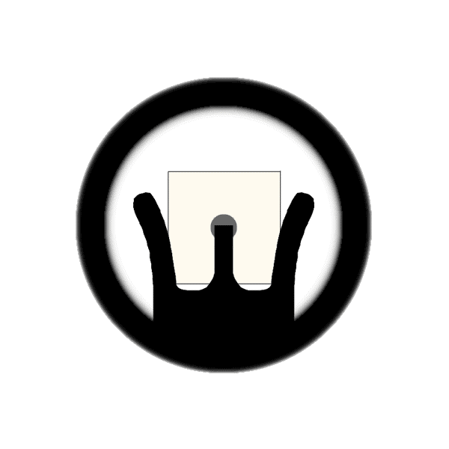
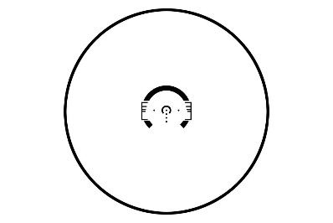

WHY 300 YARDS?
Your typical grocery store parking lot can be 300 yards.
98% of military and police sniper shots are taken at under 200 yards.
Rack grade military spec rifle & “ball” ammo = 4 MOA = 12” at 300 yards.
Your iron sights / optics can easily make the shot.

5 THINGS YOU WILL DO WITH A GUN HOW TO DO IT
- Load Address magazine / Address bolt
- Unload Address magazine / Address bolt
- Type 1 Malfunction Address magazine / Address bolt
- Type 2 Malfunction Address magazine / Address bolt
- Type 3 Malfunction Unload gun / Load gun

MALFUNCTIONS
Machines do two things – function and fail to function. This is not bad luck, or “God hates me” or any such nonsense. It is an eventuality that a machine will fail to function. A smart person prepares for such a failure.

TYPE 1 – Fail to fire “FTF”
This is a “click” instead of a “bang.”
This is the second-loudest sound you will hear in a gunfight.
Solution: Tap-Rack

TYPE 2 – Fail to eject “FTE”
This is sometimes called a stovepipe.
Might be a piece of brass, or another round.
Solution: Tap-Rack

TYPE 3 – Double feed
Two objects try to occupy the same space.
Solution: When the “Tap-Rack” doesn’t work, reload the gun.
You may have to forcefully pull the magazine out.
On an AR pattern rifle, you may have to lock the bolt to the rear and insert fingers up the magwell.

Keep your rifle pointed UP when dealing with a malfunction!!!

SUPPORTED PRONE
The supported prone position is a very stable position. For most shooters, this position can approach or equal the bench rested position in terms of precision. The shooter will use a support under the rifle to steady the hold. The support can be placed under the AR15 magazine (as shown in the picture) or under the forearm. DO NOT rest the rifle on the barrel.

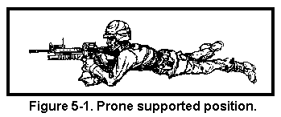

Where the military teaches to flatten the heels on the ground for stability, Patriot Training instructors have found that using the jiu-jitsu concept of “live feet” is more useful. Live feet allow the shooter to make micro adjustments for elevation, without having to shift the whole position, and without having to introduce muscle trembles and errors.

Elbows are used to stabilize. Stock should be solidly into shoulder. Shooter should push into the rifle. Firing hand has a firm, but not tight grip on the pistol grip. Off hand can be around the magwell, over the top, or under the forearm. Cheek should form a good stock weld. Nose to charging handle for consistency of sight picture.

UNSUPPORTED PRONE
Unsupported prone is a name that sometimes leads to confusion. It can mean shooting in a prone position with the rifle rested on nothing but the hands. However, it is perfectly acceptable to rest the magazine on the ground for more stability. If obstacles prevent a clear line of sight when the magazine is rested on the ground, then bring elbows under the rifle to raise it up off the ground. This will result in less stability, but a competent shooter will still be able to engage targets at up to 300 yards, even without a rested magazine.

For some reason, the myth still persists that resting a magazine on the ground will induce malfunctions.

Army TC 3-22.9 Rifle Marksmanship, 2016 edition:
The magazine can be used rested on the ground while using the prone unsupported position. Firing with the magazine on the ground will NOT induce a malfunction.

Rest that magazine on the ground! Otherwise, the position is very similar to Prone Supported. A skilled Rifleman can engage targets to 500 yards and even beyond with a prone unsupported position where the rifle is rested on the magazine.

KNEELING & SITTING
Kneeling is easy and natural to use. One can kneel behind cover, or to simply become a smaller target. With some tweaks, the kneeling position can become substantially steadier than a standing position.

In the kneeling position, it is important to observe these positional details: The knee that is up is the support side knee. Place the elbow in front of the knee. The foot of the strong side leg should have the heel place between the buttocks, or under a buttock.

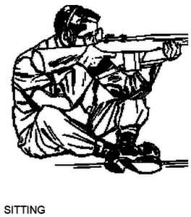
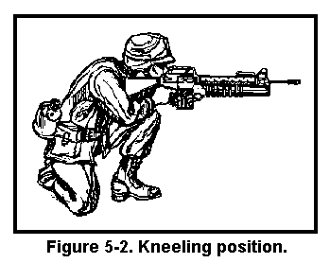

Sitting is very stable, and undeniably useful. There are three different ways to shoot sitting: cross-legged, cross-ankles, and open leg. Your body

STANDING
Standing is the most common shooting position. It is also the least steady. While experts compete in standing position at 200 yards, this takes a lot of practice. There are two major variations of standing: tactical for combat, and precision for marksmanship.
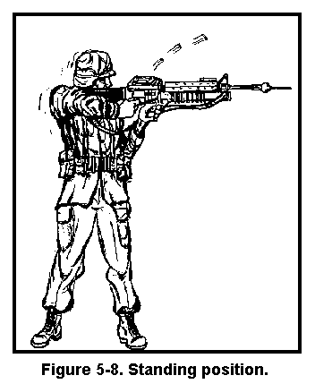
Keep the strong side elbow tucked as much as possible to present the smallest target possible. Off side elbow can be tucked into body for more stability. Grip farther forward with off hand if more maneuverability is needed. Grip closer to magwell if more stability is needed.

