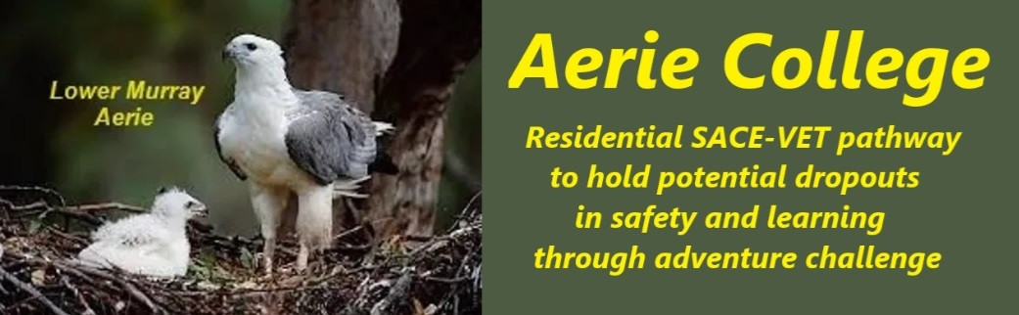

**Policies**

|  |  |
| --- | --- |
| Title | Resident SACE College |
| Category | SACE Student Learning and Assessment |
| Document ID | 2.1 |
| Version | 1.0 |
| Date | 10/1/25 |
| Purpose | A special assistance residential school designed for at-risk senior students. Our SACE curriculum emphasizes active learning for all students, through adventure-based experiences and practical skills training. We aim to keep students engaged and motivated by providing supportive environments that fosters shared personal growth and development.  **Key features of our program include:**   * **Adventure-based learning:** Engaging students through outdoor activities and challenges. * **Practical skills training:** Equipping students with valuable skills for future employment and life. * **Supportive environment:** Providing safe accommodation, nutritious meals, and ongoing support. * **Swag camping lifestyle:** Encouraging students to embrace a self-sufficient, low cost and resilient backpacker lifestyle.   By combining these elements, Aerie College offers a unique and effective approach to helping at-risk youth succeed. |
| Audience | ESB  Parents/Carers of potential students  ANCOM Community members |
| Registration requirement | To satisfy the requirements of the ESB for registration as a school and to secure Special Assistance Funding for students who need assistance. |
| Responsible person | Principal |
| Sign off by | Charity Board Chair, Capt Arthur Jones |
| Next review date | Sept 2027 |
| URL |  |