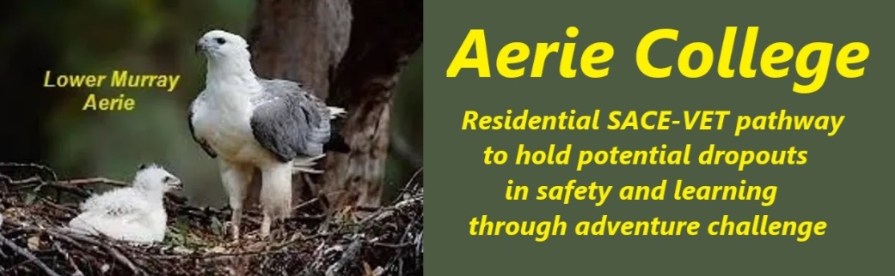
Policies
Title | Quality Control
Category | School Governance
Document ID | 1.5
Version | 1.0
Date | 10/1/25
Purpose | Education Method:  Remote wilderness adventure challenge, non-urban environment  Building supportive partnerships and teams – non-binary  Practical Home skills for peer service low cost living & lifestyle  Key Goals:  Achieve wellness and happiness  Achieve the SA SACE certificate.  Progress to VET competencies
Audience | ESB, Parents of potential students, Community of campus locations.
Registration requirement | To satisfy the requirements of the ESB for registration as a school
Responsible person | Principal
Sign off by | Charity Board Chair, Capt Arthur Jones  
Next review date | Sept 2027
URL

