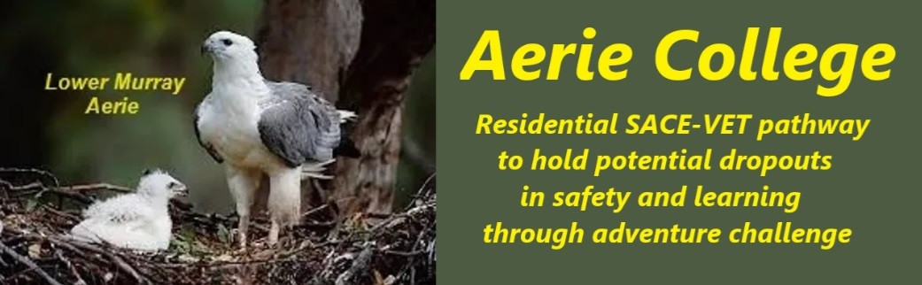

**Procedures**

|  |  |
| --- | --- |
| Title | Other Staff |
| Category | Non-teaching staff & Contractors |
| Document ID | 2.9 |
| Version | 1.0 |
| Date | ***10/01/25*** |
| Audience | ESB  Other support staff |
| Registration requirement | To satisfy the requirements of the ESB for registration as a school |
| About | **Aerie College** is hosted within a private collegiate community sharing gated holiday resort properties and riverboats. As such, the college's facilities may be used by community members for various activities  The school, as part of a community, has appropriate non-teaching staff, contractors and volunteers to support the achievement of its educational outcomes and the school supports their performance through the provision of professional development as appropriate.  To ensure a harmonious coexistence of Aerie students and community members, both younger and older, we will emphasize appropriate student behavior when interacting with community members.  All community members and visiting workers will receive information about our expectations regarding student conduct and interaction with visitors and other community members.  To address self-defense needs of our older student cohort within community, we will regularly discuss community childcare obligations, legally required for their age group, as part of our community life programs engaging both older and younger members. |
| Responsible person | Principal |
| Sign off by | Charity Board Chair, Capt Arthur Jones |
| Next review date | Sept 2027 |
| URL |  |