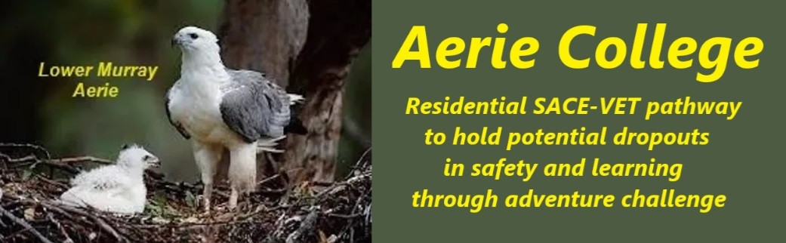

**Procedures**

|  |  |
| --- | --- |
| Title | Resources to Support Program. |
| Category | Learning and assessment resources |
| Document ID | 2.4 |
| Version | 1.0 |
| Date | ***10/01/25*** |
| Purpose | **Aerie SACE Curricula: A Personalized Approach** **At Aerie, we believe in empowering students to take ownership of their learning journey.** Our SACE curricula are designed to provide a flexible and supportive environment where students can explore their interests and achieve their goals. We use SACE guidelines for assessment and assign progress as C (Complete at acceptable level) or NYC (Not yet complete at acceptable level) This has no intent of comparative grading. It refers to the teacher’s assessment of appropriate result for each child.  **Key Features of Our Approach involves access to the Internet:**   * **Student-Centered Learning:** Students will have the freedom to choose a curriculum, possibly from Open Access College that aligns with your passions and aspirations. * **Personalized Support:** Our experienced teachers will work closely with students to create a tailored learning plan that meets your individual needs. * **Collaborative Learning:** We encourage teamwork and partnership between students and teachers. Working together, we can achieve more. * **Structured Approach:** We'll provide sample learning plan formats to help you stay organized and on track. * **Continuous Reflection:** Daily reflection logs will allow students to monitor your progress and identify areas for improvement.   **How it Works:**   1. **Curriculum Selection:** Choose a SACE curriculum that interests the student 2. **Personalized Planning:** Work with your teacher to develop a personalized learning plan. 3. **Learning and Reflection:** Engage in your chosen curriculum and maintain a daily reflection log. 4. **Continuous Support:** Receive ongoing guidance and support from your teacher.   **Our program is designed for students who need to restart their learning journey.** |
| Audience | Education Standards Board |
| Registration requirement | To satisfy the requirements of the ESB for registration as a school |
| Responsible person | Principal |
| Sign off by | Charity Board Chair, Capt Arthur Jones |
| Next review date | Sept 2027 |
| URL |  |