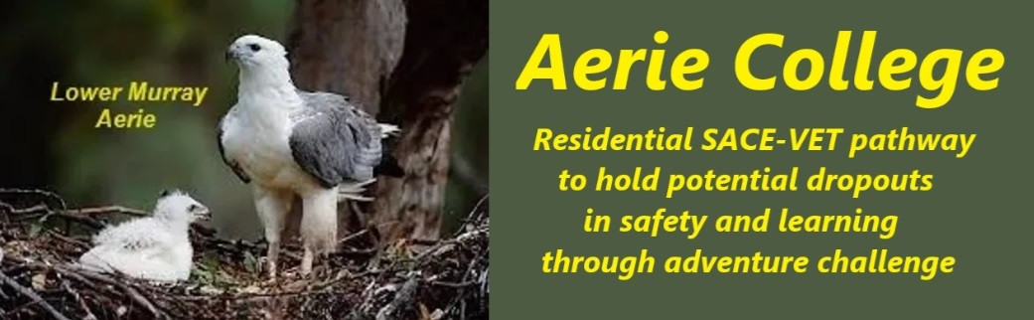

**Policies**

|  |  |
| --- | --- |
| Title | Injury Medical Support |
| Category | Risk & Safety implementation |
| Document ID | 3.3 |
| Version | 1.0 |
| Date | 10/1/25 |
| Purpose | **Our mission is to foster a supportive environment where our students can thrive, both physically and emotionally.** During this pivotal stage of adolescence, characterized by experimentation, adventure and personal growth, we prioritize **wellness and happiness** above all else.  We require all staff working with students to maintain advanced first aid training and we regularly provide skills learning input to our students whenever possible in where the skills are needed.  As water activities are a major part of our adventure activities, we always have emergency oxygen and defibrillator available nearby as part of first aid kit.  We always do an incident review with all students present in the event of an injury after the urgency has calmed. This is essential learning. |
| Education SA link | We follow these guidelines and add our own extra safety requirement of working in buddy pairs in all adventures.  <https://www.education.sa.gov.au/policies/shared/sporting-and-adventure-activities-standard.pdf> |
| Audience | ESB  Parents/Carers of potential students  ANCOM Community members |
| Registration requirement | To satisfy the requirements of the ESB for registration as a school |
| Responsible person | Principal |
| Sign off by | Charity Board Chair, Capt Arthur Jones |
| Next review date | Sept 2027 |
| URL |  |