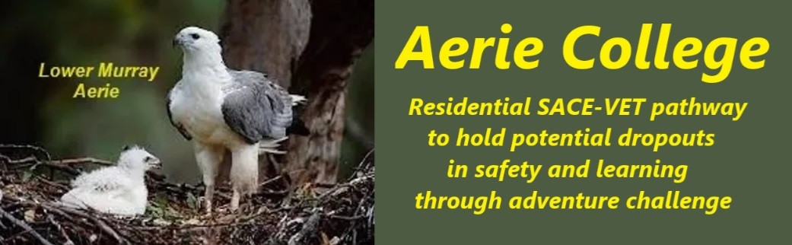

**Procedures**

|  |  |
| --- | --- |
| Title | Curriculum Review. |
| Category | Reviews Curriculum, Teaching & Assessment to improve |
| Document ID | 2.7 |
| Version | 1.0 |
| Date | ***10/01/25*** |
| Purpose | **Reviewing the curriculum based on criteria**   * **Promoting Wellness**    + **The majority of our students have arrived with Aerie because they have not found wellness and happiness in their previous school.**   + **Aerie Curriculum from within the SACE options has focus on home skills, good living skills and adventure challenge.**   + **Our learning mode is mostly a practical application of the skills to be learned.** * **Student Success**   + **The majority of our teaching mode is working with partners and teams. We expect that the partners will help each other and the teams will help other people within their group who are struggling with a problem.**   + **If a particular task becomes too difficult we direct the student to leave that task for a time, attend to something else, and then come back with another try at a later time.** * **Collaboration**   + **We encourage our students to work in partnerships and teams. “Together, we can move mountains.”** * **Student Self-Assessment**   + **We encourage our students to work in partnerships, discuss their projects with others, and encourage them to discover ways they can improve their work without teachers being over-critical.** * **Avoiding Harmful Comparisons**   + **We use the VET method of assessment, competent C or not yet competent NC in a task, and make suggestions where we find fault.**   **VET v Uni**  Aerie college focus Is on a VET future progression. We make sure our students understand that if they seek a university future, there is the opportunity to switch at a later stage from advanced VET to university study.  **Emphasizing Care and Support**  Our teaching philosophy emphasizes caring, helping, and fostering a positive learning environment. Participation and effort will be noted with teacher comments in the Student Logbook, reflecting the importance of these qualities in student development.  Teaching staff will meet regularly to review the progress of all Aerie students within their influence and maintain notes of the meetings for future reference and planning. |
| Audience | Education Standards Board |
| Registration requirement | To satisfy the requirements of the Education Standards Board for registration as a school |
| Responsible person | Principal |
| Sign off by | Charity Board Chair, Capt Arthur Jones |
| Next review date | Sept 2027 |
| URL |  |