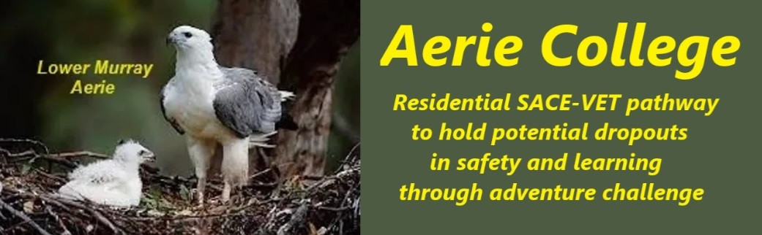

**Procedures**

|  |  |
| --- | --- |
| Title | Health & Injury Management |
| Category | Risk & Safety implementation |
| Document ID | 3.3 |
| Version | 1.0 |
| Date | 10/01/25 |
| Purpose | We encourage students to **form strong partnerships** and **work together as a team.** The foundations for this policy are set during the entry term **"Together, we can move mountains." SEE** “Time Out” **Chat list**  **A cornerstone of our curriculum is adventure, first aid and risk assessment**, including both physical and mental health. Given our focus on water activities, and remote natural environments we emphasize partner and teams support, water safety and rescue techniques.  To address the complex social and emotional landscape of puberty, we dedicate **significant time to open discussions** about **friendships, partnerships, close contact, sexuality, and consent.** Our goal is to empower students to make informed decisions and build healthy relationships.  **Aerie staff is committed to creating a safe and supportive community** where everyone feels valued, safe and included. |
| Education SA link | <https://www.education.sa.gov.au/policies/shared/sporting-and-adventure-activities-standard.pdf> |
| Audience | ESB  Community members |
| Registration requirement | To satisfy the requirements of the ESB for registration as a school |
| Responsible person | Principal |
| Sign off by | Charity Board Chair, Capt Arthur Jones |
| Next review date | Sept 2027 |
| URL |  |