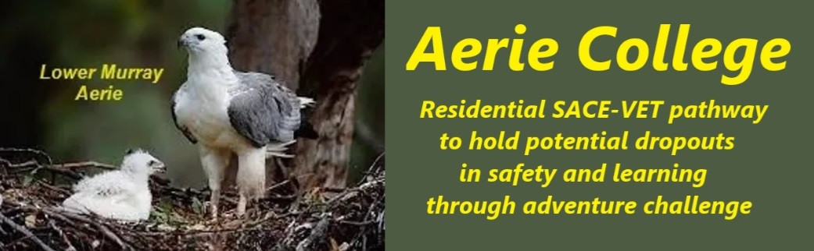

**Procedures**

|  |  |
| --- | --- |
| Title | Safe Facilities and Equipment |
| Category | Property, Facilities & Equipment |
| Document ID | 2.11 |
| Version | 1.0 |
| Date | 10/01/25 |
| Purpose | **Aerie College: Requires a Unique Learning Environment**  Aerie College offers a distinctive learning environment tailored to the Adventure Challenge learning needs of SACE Years (Ages 15-18). Our campuses, resemble a community resort and tourist facilities, featuring renovated buildings adapted for various educational and community activities, and a Commercial River Passenger school ship.  **Adventure-Based Learning**  Our school's infrastructure and equipment are specifically designed to support Adventure-Based Learning, a highly effective approach for our student cohort. This approach fosters resilience, problem-solving, and teamwork in a challenging yet supportive setting.  **Community-Focused Campus**  We envision Aerie College as a resort-style precinct where students and community members of all ages interact and learn together. This emphasis on care and service encourages empathy and a sense of responsibility including care assistance between age groups.  **Safety and Risk Assessment**  Safety is paramount at Aerie College. Regular risk assessments, conducted by both staff and students, ensure that our facilities and activities are safe and appropriate. Students are actively involved in identifying potential risks and making informed decisions.  **A Balanced Approach to Risk**  While we strive to create a safe environment, we also recognize the importance of exposing students to calculated risks. This approach helps them develop resilience and decision-making skills.  We teach a formal process for risk assessment for all planned student activities.  **VET and Student Businesses**  Risk analysis extends to student businesses, ensuring that entrepreneurial endeavors are conducted safely and responsibly.  **Support and Well-being**  The well-being of our students is a top priority. Designated staff members are available to provide support and guidance, including confidential discussions about sensitive matters.  **Key Points:**   * **Tailored Campus:** Aerie College offers a unique learning environment suited to SACE Years. * **Adventure-Based Learning:** Our approach fosters resilience and problem-solving skills. * **School ships:** Both River Murray and potential SA Gulf waters. * **Community-Focused:** Students interact with community members of all ages. * **Safety First:** Regular risk assessments ensure a safe and supportive environment. * **Balanced Risk:** Students are exposed to calculated risks to develop resilience. * **VET and Student Businesses:** Entrepreneurial endeavors are supported and monitored. * **Well-being Support:** Dedicated staff members are available for guidance and support. |
| Education SA | <https://www.education.sa.gov.au/policies/shared/asset-management-policy.pdf> |
| Audience | Education Standards Board  All community membership |
| Registration requirement | To satisfy the requirements of the Education Standards Board for registration as a school |
| Responsible person | Principal |
| Sign off by | Charity Board Chair, Capt Arthur Jones |
| Next review date | Sept 2027 |
| URL |  |