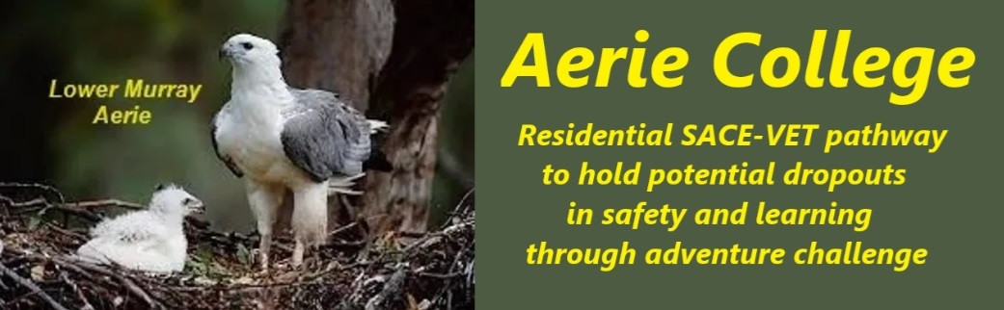

**Procedures**

|  |  |
| --- | --- |
| Title | Child Protection, Mandatory Reporting |
| Category | Mandatory Reporting |
| Document ID | 2.10 |
| Version | 1.0 |
| Date | ***10/01/25*** |
| Purpose | **Mandated reporters** in Aerie College and the larger resort communityare individuals who, by virtue of their profession or position, are legally obligated to report suspected child abuse or neglect to the relevant authorities. In a resort community hosting a residential senior high school, the following professionals would typically be considered mandated reporters:  All members of ANCOM Community will be briefed on these requirements on entry to membership. Any person who has concern about childcare within the ANCOM Community and its school **should discuss their concerns with the principal for advice on procedures.** **Within the School**  * **Teachers:** Including subject teachers, team teachers, and specialized educators. * **School administrators:** Principals, vice-principals, and other administrative staff. * **Counselors:** School counselors, psychologists, and social workers. * **Resident staff:** Including property, plant and equipment managers, gardeners and boat crew. * **Medical staff:** If the school community has on-site medical personnel, such as nurses or doctors.  **In the Community or visiting**  * **Teachers visiting with a school camp group** * **Medical professionals:** Doctors, nurses, midwives, and dentists. * **Allied health professionals:** Psychologists, social workers, speech therapists, occupational therapists, and physiotherapists. * **Childcare workers:** Including those in resort day care centers, * **Youth workers:** Those working in youth centers, community programs, or other visiting youth-focused organizations. * **Police officers:** All police officers in the area. * **Legal professionals:** Lawyers and judges who become aware of suspected child abuse in their professional capacity. |
| Audience | ESB |
| Registration requirement | To satisfy the requirements of the Education Standards Board for registration as a school |
| Responsible person | Principal |
| Sign off by | Charity Board Chair, Capt Arthur Jones |
| Next review date | Sept 2027 |
| URL |  |