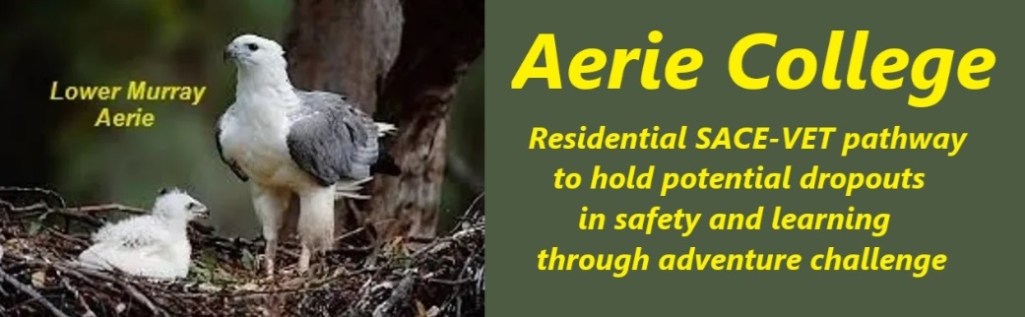
Procedures
Title | Documented Teaching Program
Category | Curricular and planning
Document ID | 2.3
Version | 1.0
Date | 10/01/25
Purpose | Aerie SACE Curricula  At Aerie, we believe in student-centered learning. We assist students to select their studies from the SACE options with particular focus on our preferred selection. Each SACE curriculum selected by a student is supported by clear guidelines for completion. Aerie teachers collaborate closely with students to tailor requirements to their individual needs. Online learning resources are provided to aid in planning and study.  For outlier subjects we will contract with OPEN ACCESS COLLEGE.  We encourage teamwork and partnership between students and teachers. This collaborative approach is essential for achieving success. It's not cheating; it's working together to reach shared goals. Teamwork is a cornerstone of everything we do at Aerie.  - Personalized Learning Plans: Teaching and learning plans will be developed in partnership with each student.  - Structured Learning: Sample learning plan formats will be provided once the school is officially registered.  - Continuous Reflection: Students will maintain daily reflection logs to track their progress and learning.  Key Points:  - Student-Centered: Emphasizes the student's role in choosing and completing their curriculum.  - Collaborative Learning: Highlights the importance of teamwork between students and teachers.  - Personalized Support: Assures students of individualized guidance and resources.  - Structured Approach: Provides a framework for learning through sample plans.  - Continuous Assessment: Uses reflection logs for ongoing evaluation
Audience | ESB
Registration requirement | To satisfy the requirements of the ESB for registration as a school
Responsible person | Principal
Sign off by | Charity Board Chair, Capt Arthur Jones  
Next review date | Sept 2027
URL

