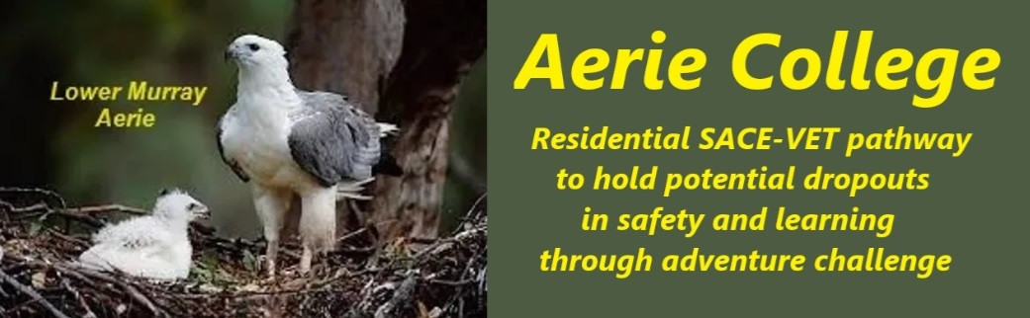

**Policies**

|  |  |
| --- | --- |
| Title | Professional Dev. Non-teaching |
| Category | Non-teaching Staff & Contractors |
| Document ID | 2.9 |
| Version | 1.0 |
| Date | 10/1/25 |
| Purpose | To ensure a harmonious coexistence of Aerie students and community members, both younger and older, our teaching staff will emphasize appropriate student behavior when interacting with other community members.  All community members will receive information about our expectations regarding student conduct.  To address the self-protection needs and behaviors of our older student cohort, we will regularly discuss community childcare obligations, legally required for their age group, as part of our community life programs engaging both older and younger community members. |
| Audience | ESB  Parents/Carers of potential students  ANCOM Community members |
| Registration requirement | To satisfy the requirements of the ESB for registration as a school |
| About | **Aerie College** is hosted within a private collegiate community sharing gated holiday resort properties. As such, the college's facilities may be used by community members for various activities.  The school, as part of a community, has appropriate non-teaching staff, contractors and volunteers to support the achievement of its educational outcomes and the school supports their performance  through the provision of professional development as appropriate.  The school student specific areas of the property will not be available to public visitors. |
| Responsible person | Principal |
| Sign off by | Charity Board Chair, Capt Arthur Jones |
| Next review date | Sept 2027 |
| URL |  |