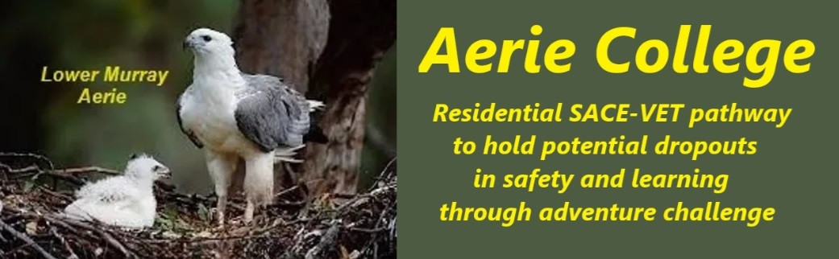

**Procedures**

|  |  |
| --- | --- |
| Title | Pastoral Care |
| Category | School Governance |
| Document ID | 3.4 |
| Version | 1.0 |
| Date | 10/01/25 |
| Purpose | **Aerie College: Fostering Wellness and Identity**  Our student cohort is at a critical developmental stage, characterized by exploration, experimentation, and the formation of personal identity. During this time, lifestyle choices, values, and ethics are solidified. Our primary educational goal is to foster wellness, happiness, and a strong sense of self.  **"Time Out": A Reset for the Mind and Soul**  The first entry term at Aerie College is "Time Out," a remote Murray wilderness river cruise that includes visits to local schools along the river. Designed as a mental reboot, "Time Out" aims to clear out old, damaging thoughts and improve mental functionality for a brighter future.  **Building Strong Partnerships and Teams**  Creating safe partnerships and strong teams is a vital part of "Time Out." We've prepared a discussion guide for the voyage (see Entry Term Chat List file). Essential SACE Units will continue during the cruise, along with establishing the student log system that will be used throughout their time at Aerie College.  **Open and Honest Discussions**  During "Time Out," we prioritize open and honest discussions about a range of topics, including:   * **Relationships:** Friendships, partnerships, and close contact * **Sexuality:** Understanding and navigating personal desires and boundaries * **Consent:** The importance of clear messages and mutual agreement * **Belief:** Religious leaders are invited to participate in these discussions to share their perspectives and beliefs, fostering a respectful and inclusive learning environment supporting diverse family religious backgrounds and tolerance.   **Care and Support for All**  Care and support for all members of our community are paramount. We encourage open dialogue and conflict resolution to address issues constructively. Mandatory reporting procedures are in place for all staff working with underage students to protect students and ensure their safety. Students are also introduced to the concept of reporting and encouraged to use this process with trusted teachers if necessary.  **Anonymous Reports and a Culture of Safety**  Anonymous reports will be used in student partnerships and team discussions to identify areas for improvement in relationships and enhance our support systems. This approach promotes a culture of safety and well-being for all.  **Benefits of Anonymous Reporting:**   * **Increased reporting:** Students and staff feel more comfortable reporting incidents of bullying, harassment, or other concerning behaviours when they can do so anonymously. This can lead to earlier intervention and prevention of more serious problems. * **Early identification of issues:** Anonymous reports can help identify potential problems early on, allowing schools to address them before they escalate. * **Reduced fear of retaliation:** Knowing that their identity is protected can encourage individuals to come forward without fear of reprisal. * **Data-driven decision making:** Anonymous reports can provide valuable data to help schools understand the nature and extent of problems, enabling them to develop targeted interventions.   **Benefits of a Culture of Safety:**   * **Improved student well-being:** A safe and supportive school environment promotes positive mental health, reduces stress, and improves academic performance. * **Enhanced learning environment:** When students feel safe and respected, they are more likely to be engaged in learning and achieve their full potential. * **Stronger relationships:** A culture of safety fosters positive relationships between students, teachers, and staff, creating a sense of community. * **Reduced bullying and harassment:** A culture of safety discourages bullying and harassment by creating a climate where such behaviours are not tolerated. * **Increased trust:** When students and staff feel safe and supported, they are more likely to trust school authorities and report concerns.   **Combined Benefits:**   * **Proactive problem-solving:** Anonymous reporting systems can help schools identify and address problems before they become serious, while a culture of safety creates an environment where students and staff feel empowered to report concerns. * **Effective intervention:** A combination of anonymous reporting and a culture of safety allows schools to respond effectively to incidents, provide support to victims, and hold perpetrators accountable. * **Long-term positive impact:** By fostering a safe and supportive school environment, schools can create a lasting positive impact on the lives of their students.   It is important to note that anonymous reporting systems should be implemented in conjunction with a comprehensive school safety plan and a strong culture of safety. This includes training staff on how to respond to reports, providing support to victims, and taking appropriate disciplinary action against perpetrators |
| Education SA | <https://www.education.sa.gov.au/policies/shared/supporting-gender-diverse-intersex-sexually-diverse-children-young-people-policy.pdf> |
| Audience | ESB  Community Membership |
| Registration requirement | To satisfy the requirements of the Education Standards Board for registration as a school |
| Responsible person | Principal |
| Sign off by | Charity Board Chair, Capt Arthur Jones |
| Next review date | Sept 2027 |
| URL |  |