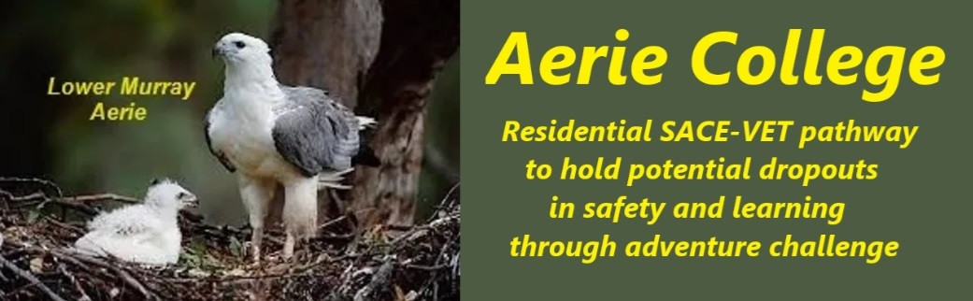

**Policies**

|  |  |
| --- | --- |
| Title | Financial Viability. |
| Category | School Governance |
| Document ID | 1.3 |
| Version | 1.0 |
| Date | 10/1/25 |
| Audience | Education Standards Board, Parents of potential students, Members of the ANCOM Collegiate Community charity sponsoring the school. Government financial support agencies |
| About | **EDUCATION FEES**:- As a special assistance school, Aerie College is required to deliver education fee-free. Aerie will receive both state and federal funding on day one for each student entry, for the provision of education.  It is expected some of the Aerie students may require extra special assistance. In this event, the education and support fees will be negotiated with the Government authorities.  **RESIDENTIAL FEES**:- Students and their families will have access to youth allowance, and student living away from home allowance.  Aerie College will operate its residential campus in lower cost rural areas and provide Full Board student backpacker style residence at minimum cost, based on the World Youth Hostels Assn YHA model. There is no student travel cost in time or money as students are resident in their school.  The food costs will be minimal as all food services are part of the school curriculum. Students will all participate in peer service hospitality and cookery education and training. Food materials costs are an education costs, and Aerie will approach major food suppliers and supermarkets for access to shelf products destined for garbage disposal.  **As the startup phase necessitates both initial working capital and ongoing government funding to support low-income, at-risk youth, we will request all possible financial assistance and further advice for funding.**  ANCOM BANK HISTORY:-   1. The charity ANCOM, will approach its long term bank, CBA, for operating overdraft after registration of the school. ANCOM has never requested bank overdraft or loan finance. 2. ANCOM will approach SAFA for loan capital finance to establish the Aerie college property and facilities.    1. **See Capital requirements below** |
| School card assistance | Aerie staff will assist parents and students to access all sources of support finance for both tuition and residence  <https://www.education.sa.gov.au/docs/finance/school-card/school-card-scheme-procedure-for-non-government-schools.pdf> |
| Responsible person | Principal |
| Sign off by | Charity Board Chair, Capt Arthur Jones |
| Next review date | Sept 2027 |
| URL |  |

[](http://www.aeriecollege.au)

**New Special Assistance school** [**https://www.aeriecollege.au**](https://www.aeriecollege.au)

**Capital requirements – Request total SAFA loan $4,000,000**

**For: Property, staff, teaching materials, marketing**

As an Independent Special Assistance school, it is understood that schooling for these children is required to be fee-free. This means both the Federal and State governments pay all recurrent operational expenses for the school.

Aerie College students will require special assistance in some way for education, and the costs of this assistance will vary according to their assessed need.

* It is expected that existing schools, through their student counselors, are likely to advise parents of the availability of Aerie College Special assistance.
* It is expected that on student enrolment, there will be asessment of the specific needs of the student. Some needs will require extra funding.
* It is understood tuition fees are paid in advance to the school on student admission.

**PROPERTY AND WORKING CAPITAL AT START=UP:**

* **Property. $3,600,000** will purchase sufficient property resourses for approximately 64 student enrolments over the first two years
* **Working capital and incidentals $400,000 - The charity has no capital reserves.**

**STUDENT NUMBERS – Planned intake for the first two years**

* We plan for an intake of 16 students each term at Senior high level
* The college will provide ongoing residence for all students including those who progress with VETIS in to VET training. We provide ongoing community residence.
* We provide Home base residence, and ”Parental” help
* Our Community, built from families and inerested Community Service groups, may be able to assist with seed capital for fledgling student businesses.

**WE NEED TO KNOW:**

* Will the State Government school's student counselors be in a position to advised of the Aerie College program option?
* Who will assess the potential Aerie Students Special Assistance needs and costs?
* Who pays for the assessment to determine the Government fee contribution?
* Do the Aerie Student come to us with their fees already determined?
* We understand tuition fees are payable by the Government in advance at the time of enrolment.

**OUR PLANNED PROPERTY PURHASE**

**All the Properties below are required on startup to provide Aerie College special assistance education and training programs.**

As an Independent Special Assistance school, we have found a variety of unique property assets suitable for the provision of special assistance education. The charity will need immediate access to Capital to complete purchase.

* Current research indicates a current high school dropout rate of 24% before completion of year 12.
* Different property styles, based on effective learning models, are required for special assistance to hold this potential dropout cohort within education. This is the child’s right under our state laws, to be held in education to age 17 (12 years of schooling at Government expense).
* School camping and adventure challenge learning are well recognized as a high-value experience in education, especially for the underachievers.
* Underachievers are the students at risk of dropping out. They find no happiness in existing schools.
* **These childen are our student cohort target.**

1. **The current South Australian property requirement for a “School” is a 9B class building located on land. (A Box shape building and some “Play Space” with dunnies out the back.)**
   1. This is very restrictive concept of a learning place (School) and relies on many complicated State planning regulations when considering existing buildings as suitable for a school. **OLD THINKING**
   2. **The cost of planning approval** to use a suitable existing house building as a residential school home is **very high, and a waste of money.** Our proposed “School” is an approved building constructed to strict “House” design standards.
   3. Large “House” Buildings are ideal as modern shelter place for students to rest up between learning adventures and for administrative functions. They do not need to be a “School Building” for use **FOR OLDER TEENS**. (Perhaps needed for little people) Teens “Hang out” anywhere, usually quite safely in many homes. with friends. **The closeted “Boarding House” is a shadow of the past**, **designed to keep pretty senior girls clean and tallented for a good rich husband.**
2. **The best learning space (School) for disrupted teens is found in the wilderness.**
   1. South Australia has part of one of the world’s most remarkable wilderness features, the Murray River. This offers a unique learning experience environment.
   2. **Yes. We all need shelter** for rest and consolidation of learning **BUT NOT IN A SCHOOL BUILDING.**
   3. Aerie home base is an existing safe house, 5 star standard, of all poured concrete structure, totally fire proof and indestructible. It faces a government reserve that provides “Play Space”.
3. **Other Different “Buildings” are used elsewhere for “Schools” and shelter,** 
   1. **“School Ships”, used throughout the world to motivate youth, are buildings supported by water not dirt.**
   2. South Australia has a school ship, “One and All”, built as a school ship for youth training, capable of world cruising, she did a round-world cruise when first launched, expensive to operate, but still used substantially by schools.
   3. “Failie”, an older SA Coastal trader was also a “Schol ship” managed by an Education Department-employed teacher (now one of our Board members). “Falie” is beyond safe use as a school ship but is open for school visitation at berth in Port Adelaide.
   4. **AERIE COLLEGE proposes to use commercial Murray River based “School ships”** as a safe shelter (Food, sleep, and foul weather) for adventue challenge learning in the Muray wilderness, The reality learning environment.

**Home base, Full-time Aerie House, River Port Mannum.**

**NB:** Subject to enrolment demand for the first two years of operation, (16 student intake each term planned. No specific age except to start or continue SACE.) The properties below are adequite for the first two years of operation.

A better intake projection can be provides after 1st year of operation

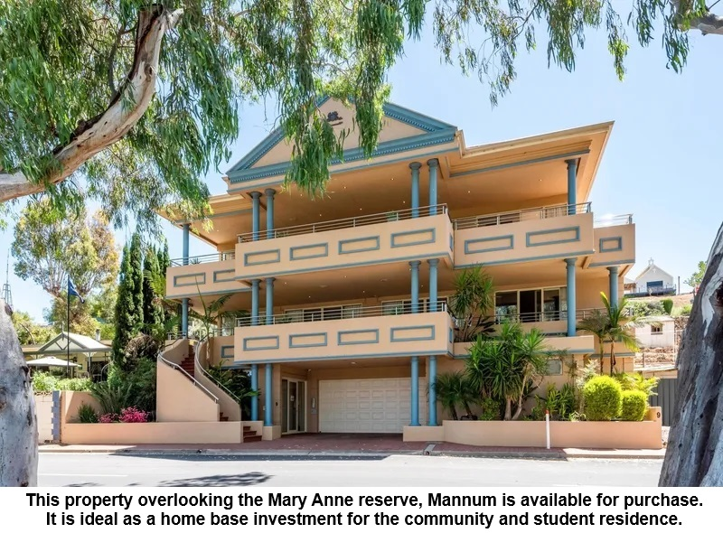

**Aerie House, Mannum. College Home base. Purchase and fitout $2,400,000**

* Aerie House will be set up as a world-standard YHA style for Aerie youth residents.
  + Shared dorms with shared showers and toilets.
  + 4 separate dorms each with shared showers and toilets on the first floor, a total of 64 student bunks.
  + housemaster’s suite, common lounge, and dining on the top floor.
  + Internal stairs between the first and top floors.
* Access to the top secure floors is by lift from the ground floor guarded by the reception Office. All external doors are locked from outside at night. Excape is open from inside.
* There will be 2 resident teachers supervising the house, provide house maintenance and catering skills training as part of the SACE curriculum.
* Each student team of 16 will have a care teacher cople with them at all times.
* There is a gated outside stairs from ground to the first floor balcony, with doors from each student dormitory. The balcony exit gate to the ground floor can be opened from the inside, for fire escape.
* The ground floor lift foyer has a college admin reception office, staffed daily.
* There is a large open space behind a secure garage door that opens to Mary Anne Reserve with an internal secure access door from the reception porch. This large open indoor space, including access to a bathroom and toilet, will be used for various school functions and public events, a “school Hall”.

**School ship Mundoo**

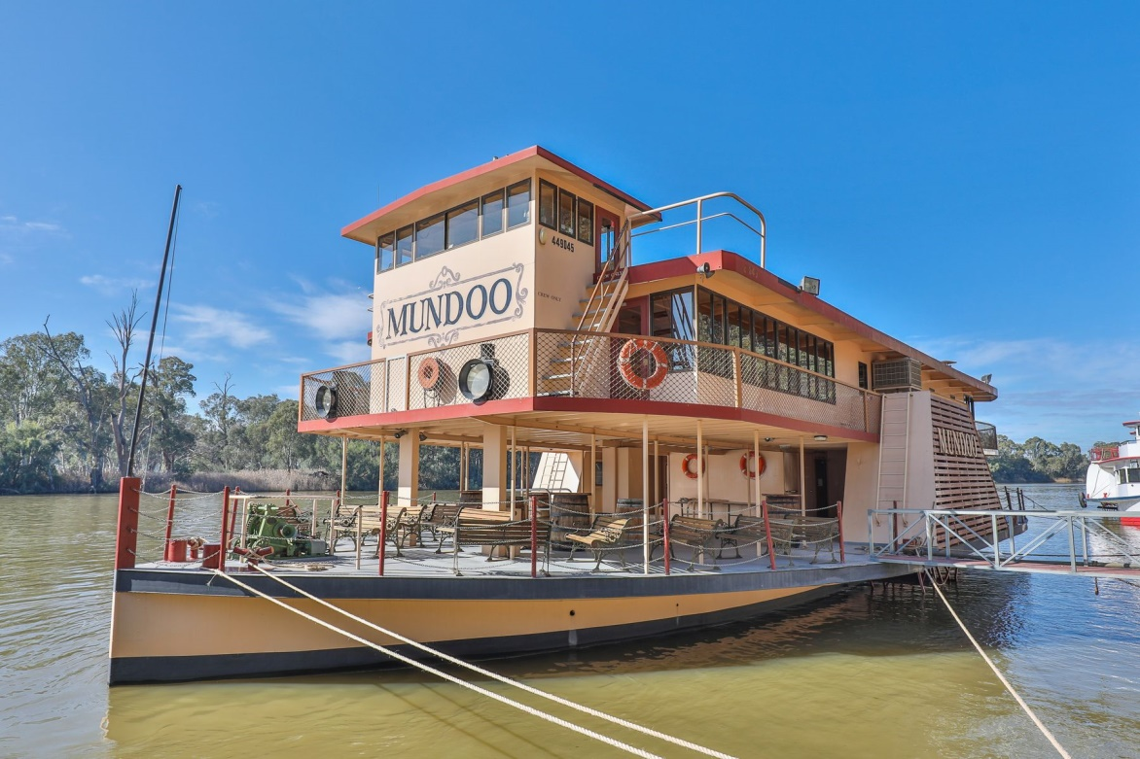

**School Ship “Mundoo”. Purchase and refit for School work $600,000**

**“**Mundoo” with a catering capacity of 300 people, is a commercial day cruise restaurant ship. It must work with a maritime Qualified Master/engineer in charge. Aerie students can be trained to assist operations as qualified deck crew with Cxo3NC tickets.

* **The top deck** is all carpeted for restaurant dining with a dance floorand licensed bar.
* **On the main deck**, there is a full-function catering galley, crew quarters, and ablution facilities.
* **In the hull,** there are large unused void spaces with main deck access
  + Stairs down aft from the kitchen to stores and open space
  + Stairs down forward to engine room (now a modern diesel) and void spaces.
  + Both aft anf forward hull spaces can be fitted out for full-time student crew bunks.
* Aerie students will study maritime operations, tour guiding adventure challenge, and catering skills onboard “Mundoo”.

**Proposed continuing use as real experience training ship with visiting school camp clients**

Aerie students will be trained to crew “Mundoo” and provide their skills under our teacher's supervision, for visiting school camp groups.

* Tour Guiding and Catering skills VETIS training
* Outdoor recreation leadership skills VETIS training
* Maritime operations skills VETIS training
* The visiting camp program will include kayaking and other river adventures, SACE Outdoor Education.

**School ship “Time Out”**

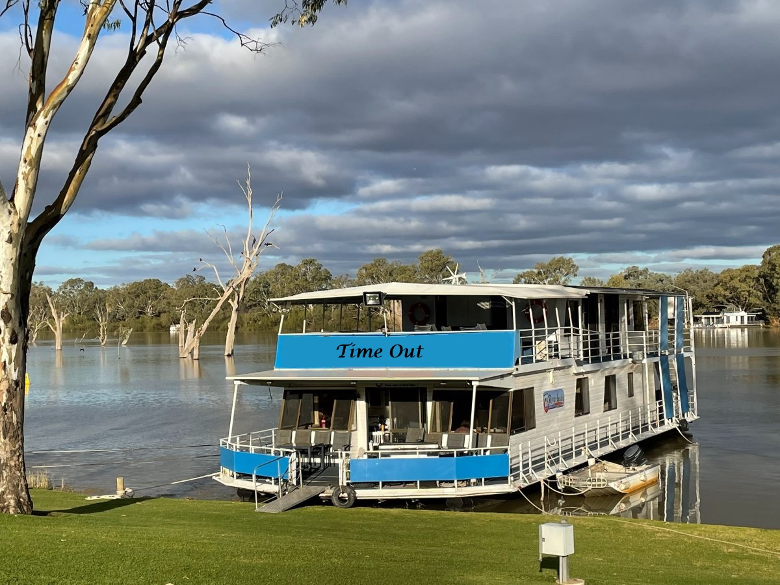

**School ship “Time Out”. Purchase and refit for school work $500,000**

* This schoolship, home ported in Mannum, will work continously on the river,
  + As Aerie entry term Time out program
  + As weekly “Come and try” marketing cruises during school vaation
* It has been working as a backpacker cruise boat with 40 day passengers or 16 ovenight for some years in the Riverland. Now for sale in Mannum.
* “Time Out” is best suited for the entry-term 10-week cruise program working between Mannum and Renmark. It contains:
  + Student backpacker bunk capacity = 16 on main deck
  + Permanent home suite for teacher crew Master/Cook couple, top deck
  + 4 Visiting teacher/guest cabins, top deck
  + It is a smaller, more comfortable full-time liveaboard home-style houseboat.
* The main deck has 4 student’s cabins with double bunks for 16 students, a forwad dining space, kitchen and M/F shower/toilet rooms aft.
* Top deck has master’s suite with ensuite and 4 visitor cabins with ensuite.

**NB:**

1. While identifying Aerie College as a special assistance school, this should not be interpreted as a school for disabled children.
2. Aerie College will enrol any child that seeks our style of education. There is stong evidence that all young people within the older teen cohort will benefit from our style of learning support.
3. Part of tolerance and good living is recognition and provision of the help needed by some who are different.