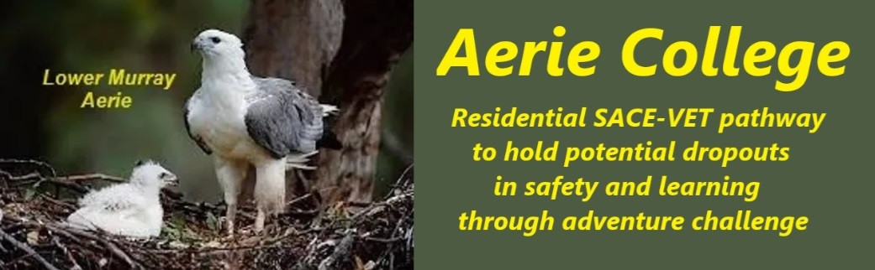

**Procedures**

|  |  |
| --- | --- |
| Title | Student safety at all learning locations |
| Category | Safety health & Welfare off school sites |
| Document ID | 3.2 |
| Version | 1.0 |
| Date | 10/01/25 |
| Purpose | As part of Aerie education and training, all students and teachers are required to prepare and document a standard format risk analysis sheet (RAS) for each planned activity. Standard RAS template is provided online from website.  **Risk Assessment Training:** Provide training to students and staff on how to conduct effective risk assessments, including techniques for identifying and evaluating hazards.  **Risk Management Framework:** Develop a comprehensive risk management framework that includes policies, procedures, and guidelines for risk identification, assessment, mitigation, and monitoring.  **Risk Communication:** Establish clear communication channels for reporting and discussing risks, ensuring that all stakeholders are informed and involved.  **Continuous Improvement:** Regularly review and update risk analysis documents and processes to reflect changes in activities, regulations, and best practices.  **Risk-Based Decision Making:** Use risk assessments to inform decision-making regarding activity planning, resource allocation, and safety measures. |
| Audience | Education Standards Board |
| Registration requirement | Government Requirements |
| Responsible person | Principal |
| Sign off by | Charity Board Chair, Capt Arthur Jones |
| Next review date | Sept 2027 |
| URL |  |