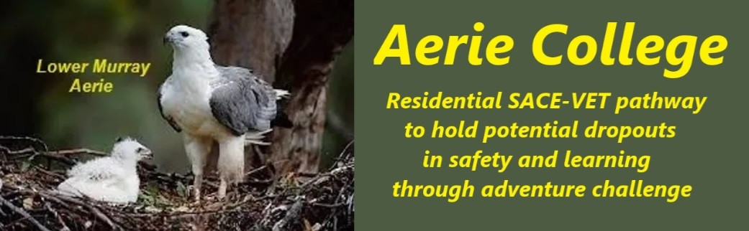

**Policies**

|  |  |
| --- | --- |
| Title | Care and Reporting |
| Category | School Governance |
| Document ID | 3.4 |
| Version | 1.0 |
| Date | 10/1/25 |
| Purpose | Our students are at a pivotal developmental stage, characterized by exploration, experimentation, and the formation of personal identity. During this time, lifestyle choices, values, and ethics are solidified. Our primary educational goal is to foster wellness, happiness, and a strong sense of self with community responsibilities.  The Aerie College Term one “Time Out” program has dominant focus on discussions round all these matters. We have many discussions on right and wrong on many matters. We reset the student focus onto a happy future.  The Essential SACE requirements and Personal Log as a permanent task within Arie are maintained during this introductory program. |
| Education SA | We are aware of these matters and have open discussion with students.  <https://www.education.sa.gov.au/policies/shared/supporting-gender-diverse-intersex-sexually-diverse-children-young-people-policy.pdf> |
| Audience | ESB  Parents/Carers of potential students  ANCOM Community members |
| Registration requirement | To satisfy the requirements of the ESB for registration as a school |
| Responsible person | Principal |
| Sign off by | Charity Board Chair, Capt Arthur Jones |
| Next review date | Sept 2027 |
| URL |  |