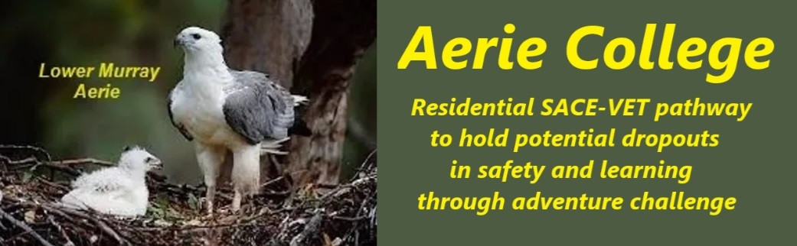

**Procedures**

|  |  |
| --- | --- |
| Title | Skills & Management Knowledge |
| Category | School Governance |
| Document ID | 1.4 |
| Version | 1.0 |
| Date | ***10/01/25*** |
| Board management skills | The Aerie College Board has substantial management skills in a wide variety of enterprise including all levels of education. **Capt. Arthur Jones: Dip. PE., Dip. Bus. Admin., TAE.IV, Ship Master Inland Waters, JP****Establishing Principal – Teaching**Teacher registration remains current **Teaching experience – SA Education Dept.**   * Upper primary & Lower secondary including tech studies * Advisory teacher, School camping including management of in-service training * Seconded to Police Greys to prepare guidelines for riding school camps * Member outdoor education Project team – including developing SA aquatics centers throughout SA.   **Teaching experience - After education department.**   * Trainer assessor First aid with Royal Life saving society & RLSSSA Board member. * Yachting Australia Sailing Master and rescue boat master * Commercial Coxswain and Master Inland waters (Large riverboats) crew training * Established and operated Residential Outdoor Pursuits Centre in Goolwa with escorted canoe expeditions into the Coorong National Park. (Managed Average of 1,000+ students each year) * The site was a registered school for 1995, but not enough enrolments (16) for viability. * 2004+ Delivering State accredited Rec. Boat License Certificate courses (3,000+ certificates issued to date)   **Home Stay Parent,** past 16 years - International senior high school students. One student is onboard now.   * Over the past 18 years, ESDA Homestay Parent for 50+ senior high school children, boys and girls.  **David Dewar PHF, B.A., Dip.Ed., TAE IV, M.A.C.E.L.** **Assistant Principal -  Teaching**  Teacher registration remains current  Teaching experience – SA Education Dept.   * Primary school Teacher, Principal, * Lecturer in Education (18 years part-time Uni SA), * Manager, Home Education for EDSA. * Team leader Teachers Union campaign for merit selection and helped design the Merit Selection procedures for the Education Department, SA. * Team Leader JESIFA project, a joint union-education department project which informed all teachers in SA about the problems with teacher mobility and promotion and led to the 4-year compulsory transfer system. * Team member English Course review for the Education Department and chaired the implementation committee for ELIC (Early Literacy Inservice Course) and LLIMY (Language and Literacy in the Middle Years) teacher in-service courses. * Director of ACEL (Excellence in education) since its inception in 1978 * Member Education Department's Change Review Team for Volunteer Support. * I have supported various school leadership teams for the past 21 years, specializing in change management processes. * Introduced Royal Life saving courses to the SACE Community study options   Community experience   * Chair of the Royal Lifesaving Society SA & Federal Board member for 14 years. * Planned & implemented DEET Lifeguards course in 2001 and ran the course for 4 years. * Rotary Club President several times  **Emily Melgar** **VET specialist Board member - VET to Diploma – VETIS Teaching**  Managing director **RTO 4849**  W**:**[enablecollege.edu.au](https://urldefense.proofpoint.com/v2/url?u=http-3A__www.enablecollege.com.au_&d=DwMGaQ&c=euGZstcaTDllvimEN8b7jXrwqOf-v5A_CdpgnVfiiMM&r=vMpuVVKKKf6OWCpoNc81RXxWPzVOsYB6PHxU1JKLOgM&m=rDfTk6JdT41sQy8bjXunHKhq0yE3Ujf7sw7ntwN5-_q64ZKysJ94TG18s1xb0yAi&s=-XbyAGkoIo-8miUPIktlOios-VLhZ1z8PQ8sU3MUQMk&e=)  **SCOPE:**CHILD CARE | AGED CARE | DISABILITY SUPPORT | SHORT COURSES |  A:**Level 2, 47 South Terrace ADELAIDE 5000**  T: **1300 157 750** | M: **0413 896 905** **Dr Terence Blackburn BIT, BCIS, PhD, MAICD** **Board member  - Post Secondary Education & Commercial industry experience – Admin and documentation**   * **Administrator** and **coordinator**- 15 years in total, various institutions and domains. * Designed, built and maintained my own **databases, financial analysis models** and **spreadsheets**. * Well-practiced people skills include **listening**, **negotiation, questioning** and **seeking resolutions**. * Ability to **lead, supervise and motivate** small to medium size project teams. * Proven and demonstrated **high level of verbal and written communication skills, published over 12 scientific papers**.   Managed 3,000 onshore and offshore students per annum in a large University environment |
| Background | 1980 The charity was incorporated in South Australia on 20th November as Encounter Coast Outdoor School Inc. to operate school camps in association with a resort property.  1995 it was registered as a Senior High school located in Grahams Castle Conference Centre, Goolwa, offering a specific senior school curriculum related to the lower Murray and Coorong region.  The charity has always remained financially viable and has no debts.  It maintains a vehicle term purchase contact. |
| Audience | Education Standards Board |
| Registration requirement | To satisfy the requirements of the Education Standards Board for registration as a school |
| Responsible person | Principal |
| Sign off by | Charity Board Chair, Capt Arthur Jones |
| Next review date | Sept 2027 |