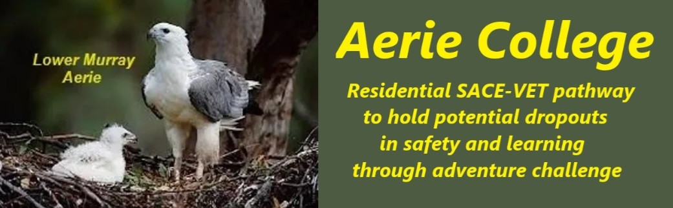

**Procedures**

|  |  |
| --- | --- |
| Title | Education Philosophy Our Guide. |
| Category | Student Leaning and Assessment |
| Document ID | 2.1 |
| Version | 1.0 |
| Date | ***10/01/25*** |
| Purpose | **Key features of our program include:**   * **Adventure-based learning:** Engaging students through outdoor activities and challenges.   + The majority of our learning adventures are based on water activities on the river Murray.   + An essential part of our skills learning has focus on healthy living, food safety and preparation, first aid, physical skills and water safety.   + We also introduced the first level of vocational training VET in maritime, cookery, care services and tourism adventure leadership. * **Practical skills training:** Equipping students with valuable skills for future employment and life.   + Practical skills for a happy life with home skills, cookery, care services, cleaning and maintenance of property.   + Risk assessment training and documentation is an essential part of our training * **Supportive environment:** Providing safe accommodation, nutritious meals, and ongoing care and support.   + In all our activities students work in partnerships and teams making sure that everybody keeps watch and good care of each other.   + We have particular focus on wellness and good health. * **Swag camping lifestyle:** Encouraging students to embrace a self-sufficient and resilient lifestyle.   + We use the swag camping and backpack lifestyle as an example of low cost, comfortable living.   + We encourage the use of cycling and kayaking for extended journeys.   + The International Youth Hostels Association Rules are applied in all our campuses as an example of how to safely travel throughout the world at minimum cost.   + We insist on our students working in partnerships and travelling in teams while taking great care of each other.   By combining these elements, Aerie College offers a unique and effective approach to helping at-risk youth succeed. |
| Audience | Education Standards Board |
| Registration requirement | To satisfy the requirements of the Education Standards Board for registration as a school |
| Background | Current research indicates a 24% dropout rate at senior school level.  We believe schools have been cuckooed by universities.  We believe we can provide a more balanced approach to essential learning and living skills. |
| Responsible person | Principal |
| Sign off by | Charity Board Chair, Capt Arthur Jones |
| Next review date | Sept 2027 |
| URL |  |