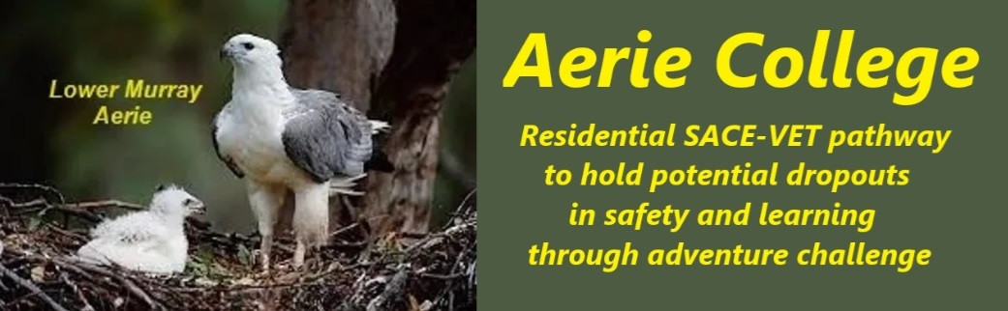

**Policies**

|  |  |
| --- | --- |
| Title | Child Protection, Mandatory Reporting |
| Category | Mandatory Reporting |
| Document ID | 2.10 |
| Version | 1.0 |
| Date | 10/1/25 |
| Purpose | **A Unique Learning Environment**  As Aerie College will be working with young adults aged 15+, many being well experienced in the adult world. It is expected they can learn well within an adult environment. The Aerie resort-style environment offers a unique learning experience, together with a commercial Murray Riverboat serving as a campus. The school's facilities, grounds, and infrastructure are designed to cater to the needs of students aged 15-18 and, at times, will be shared with Community members.  **Safety and Well-being** Student safety is paramount. The student residential section of campus is secure from external visitors, with all School staff undergoing security checks before being granted access. While other community members may be present on the school spaces, they are considered visitors. Only school staff are required to participate in mandatory reporting procedures.  **Physical Environment** The school buildings are structured to provide a distinctive learning atmosphere. The curriculum is tailored to suit the unique setting and the needs of older students.  **Support and Guidance** Aerie College is committed to supporting student well-being. Designated staff members are available to provide guidance and support to students who need to discuss sensitive matters. |
| Audience | ESB  Parents/Carers of potential students  ANCOM Community members |
| Registration requirement | To satisfy the requirements of the ESB for registration as a school |
| Responsible person | Principal |
| Sign off by | Charity Board Chair, Capt Arthur Jones |
| Next review date | Sept 2027 |
| URL |  |