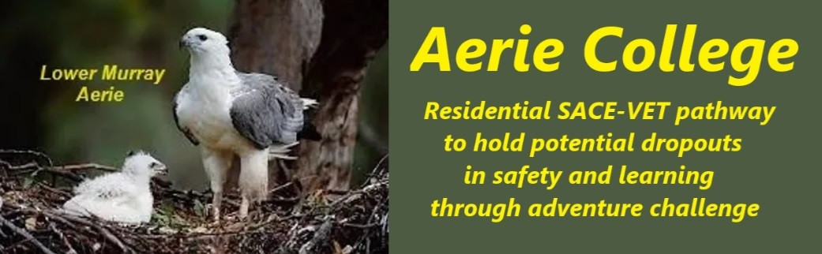

**“Time Out” Proposed chat list – will vary with experience**

**Entry term Aerie College Introduction discussion Program**

1. **Introduction to Aerie College lifestyle**
   1. Orientation to the College local area
   2. Risk Assessment template and regular use
   3. Establishing the Arie Student Log
   4. Duty rosters daily tasks partnerships and teams
   5. Kitchen skills
   6. Housekeeping skills
   7. Kayaking – Boat escorted
2. **Understanding Self–Body**
   1. Sleep
   2. Nutrition
   3. Exercise
   4. Grooming & Physical Care (Skin, Hair, Teeth)
   5. Sexual Health
   6. Kayaking – Boat escorted
3. **Water Challenge #1**
   1. Risk Assessment (Water focus) Use template
   2. Bronze Medallion Training (pool, river and surf)
   3. RLSSSA Swim-Teacher Instructor certificate
4. **Understanding Self–Mind**
   1. Character & Identity
   2. Mental Health Hygiene
   3. Cognitive Distortions & How to Correct Them
   4. Kayaking – Boat escorted
5. **Understanding Self–Soul**
   1. Values
   2. Spirituality
   3. Mindfulness
   4. Gratitude, Compassion, Humility, Philanthropy
   5. Kayaking – Boat escorted
6. **Staying Safe**
   1. Health & Safety at all ANCOM Campuses & Excursions
   2. Advanced First Aid Training including Oxygen
   3. Cyber Safety and media
   4. Kayaking – Boat escorted
7. **Understanding Others**
   1. Healthy Relationships
   2. Issues of Respect and Consent
   3. Importance of Teamwork
   4. Conflict resolution
   5. Caring for others
   6. Kayaking – Boat escorted
8. **Water Challenge #2**
   1. Boating & Risk Assessment
   2. Boat License, Coxswain 3NC Certificate
   3. Kayaking – Boat escorted
   4. Boat Launch and recovery at boat ramp
9. **Getting Around**
   1. Bike safety & maintenance
   2. Overnight Swag Camp - individual swag tents
   3. Camp fire cooking & food safety
10. **Water Challenge #3**
    1. RLSSSA Pool lifeguard certificate
    2. Lifeguarding from a boat
    3. Party time catering & Planning

**Celebration– Invite Parents & Friends – accept your eagle feathers**

1. **Vacation reflection Unlocking the Future – Head, Hand, Heart**
   1. What sort of person do I want to be?
   2. What sort of life do I want?
   3. What sort of work (paid/unpaid) would I find rewarding?
2. **OPTIONAL 1 or 2 weeks Vac.School Aeie River Cruise with reflection time.**
   1. This will be a marketing opportunity to attract other students.