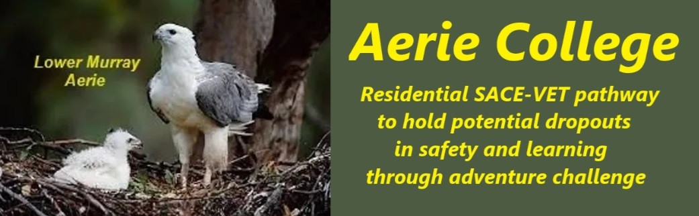

**Procedures**

|  |  |
| --- | --- |
| Title | Financially Viable |
| Procedure ID | Procedure 1.3 |
| Version | 1.0 |
| Date | ***10/01/25*** |
| Campus Description | **Aerie College proposes two styles of campuses to hold students in education.**   1. ***Aerie* School ships for one entry term “Time Out”** to reset student expectations and assess for admission usingwater-based adventure challenge skills learning    1. *School ship* *Aerie* cruise mode is Swag camping,    2. Aerie **“Time Out”** 10 weekstudy requirements are       1. Student Log,       2. maintenance of SACE Essentials,       3. much kayaking,       4. much group discussion on specific topics, [(See List),](https://aeriecollege.au/entry-term-%22time-out%22)       5. day time cruising,       6. river bank mooring overnight       7. on the Murray between Goolwa and Renmark.    3. As the school grows, *School-ship Mundoo* will cruise continuously as both school camp service for visiting schools and for the new students “Time Out” term working with a “Time Out” specialist teacher.    4. *School-ship Mundoo* will be crewed by older Aerie students working on their SACE-VET study programs under the ship’s supervising teacher, the Master, Mate, and Cook.   ***Aerie School-ships* will be financially viable** because of the short course income from the visiting schools Camp programs fees – a proven profitable market.   1. **9 River Lane, Mannum** A large quality residence suitable for home skills education, hospitality, care services, backpacker and administration base for the College. A safe home, remote from city distractions and transport. Facing water and a grassed park, adventure challenge skills learning areas on the river.   **Both styles of Aerie campus present financially viable education options**   1. A different learning and living style are required to reactivate youth in need of special assistance to hold them in education. 2. The lowest possible cost to Government is needed to provide Residential School support for youth who are on the verge of, or already at dropout.   **By implication of SA Education Law,**   1. **The cost to hold youth in schools to age 17 is a State Government responsibility.** 2. **State also has a moral responsibility** to care for under-age youth at risk of homelessness, but not yet in the care of the Minister or in detention. 3. **We suggest Aerie College Special Assistance Residential Backpacker College will be less expensive that the government provided options.**   **Aerie College Proposal can provide both** safe home and education at best possible cost to State Government.  **The target student group is rejecting the traditional “School”** both physically and mentally and require different learning facilities to motivate the young people to achieve the necessary learning. The SACE subject lists offer sufficient curriculum options for Aerie to offer a different backpacker style approach to achieve the desired SACE result and hold them in school. |
| Viable student numbers | **The financial viability** of Aerie College Special Assistance Residential Senior College **relies on attracting viable student enrolments.**  **Potential enrolment indicators:**   1. The current state high school 24% dropout 2. Reports of youth at risk of homeless, 3. The observed number of street kids 4. Homeless families with kids at risk   All indicate there is a demand for a different low-cost style of residential Senior high school that can provide underage youth with both safe home and education.   1. With careful selection, there is potential to hold homeless single parents with aerie college age students within the campus residence. The adults could contribute to the work of the charity.   The target student group are already rejecting the traditional “School” both physically and mentally. They require different facilities to motivate them to achieve the necessary learning. The SACE subject lists offer sufficient curriculum options to enable different approaches to achieve the same SACE result.  **Aerie plans the following student management plan to keep the costs as low as possible.**   * We anticipate each Aerie campus will contain maximum 64 students. * Each campus will be divided into two house groups of 32 students preferably containing an equal number of each sex all working on individual progression in SACE academic subject levels 1 or 2. * They will all work as a general house group working as rostered partners and teams on a learning skills progression in hospitality, care services, and Outdoor Education/leadership and Music, together with individual selection subject through online learning. * Each house group of 32 will be managed by 3 teachers, an experienced teacher (for academic supervision), and two junior teachers (wranglers to keep the cats together and working the tasks of maintaining the residence, food supply, and house maintenance, together with a camp site general hand helper, (perhaps homeless parents).   + The three teachers for each house group of 32 will manage the learning programs for all students in their house.   + If necessary Online learning and assessment will be used for students who seek to study outlier subjects under an external contract arrangement with online providers. * Students will live the backpack and swag camping lifestyle. * All Aerie campuses will have student vegetable gardens. * The boats will encourage fishing. * The two senior teachers will co-manage the land base campus with assistance when needed from the Board Elders who will remain active in the casual teaching role. * We plan to limit each campus student number to 64 including both SACE levels. * This Campus model can be replicated to accommodate greater student numbers on other campuses if inquiry numbers warrant the expansion. |
| Marketing Aerie College | **Marketing the Product:-**  **Aerie Marketing staff** will arrange personal face-to-face briefing meetings in each state high school with school student advisors, about the education services provided by Aerie Special Assistance Residential Senior College   * Marketing flyer briefs will be left with each meeting for handing to potential client families.   **The “Aerie school ship”** will work regular Monday/Wednesday and Wednesday/Friday short term school camps during the terms 2,3 and 4 with the “Time out” normally scheduled for term one. It will also work weekend family marketing luncheon cruises out of various river ports during the term 1 “Time out” program.  Advanced marketing briefs with be sent to all schools within potential weekend cruise regions  **“Mundoo school ship”, a potential purchace** will work weekly Vac schools during each school vacation including summer. Marketing will occur on all these cruises. As the students become more competent on Mundoo, they can take some of the marketing tasks as part of their studies.  In terms two and four, Mundoo will work the school camps market including selling the Aerie college product.  As part of their tourism marketing studies students will Introduce the College website and in particular the principal’s blogs which will be regularly updated.   * Senior School Student advisor teachers * Community youth clubs * Sports clubs * Church groups * Smith Family |
| Implementation | We are advised Special Assistance schools schooling functions are funded by the Government (ie fee-free) and paid in advance on enrolment.  Students will be required to contribute towards their residential living costs from their student allowances, including living away from home allowance and their rostered time to the workings of the residence, gardening, and other property maintenance tasks.  A regular saying will be “Together we can move mountains”.  Aerie Special Assistance Senior High School requires careful financial management to ensure its long-term sustainability. The school will employ bookkeeper skilled secretary who will work with Coles School Experts. They are recognized as an experienced financial administrator whose responsibilities will include the following three procedures. 1. **Robust Financial Planning and Budgeting.** Coles School Experts  * **Annual Budget:** Develop a detailed annual budget that outlines expected income and expenses. * **Revenue Streams:** Identify and diversify revenue sources, such as government grants, tuition fees, fundraising activities, and partnerships. * **Expense Control:** Implement measures to control expenses, including cost-effective procurement, energy efficiency, and regular review of spending. * **Contingency Planning:** Establish a contingency fund to address unexpected expenses or revenue shortfalls.  2. **Regular Financial Monitoring and Reporting:** Coles School Experts  * **Financial Metrics:** Track key financial metrics, including revenue, expenses, profit margins, and cash flow. * **Regular Reports:** Prepare and review financial reports regularly, such as monthly, quarterly, and annually. * **Variance Analysis:** Analyze variances between budgeted and actual figures to identify areas for improvement or concern. * **Financial Audits:** Conduct regular financial audits to ensure compliance with regulations and identify potential risks.  **The Board will arrange** **Strategic Fundraising and Partnerships:**  * **Fundraising Initiatives:** Develop and implement various fundraising activities, such as events, appeals, and grants. * **Donor Relations:** Build strong relationships with donors and supporters to foster long-term financial support.   + **Build a database of** donors and supporters   + **Maintain regular interest reminders through the principal’s blogs**   + **Invite donors to special College events to encourage donations** * **Partnerships:** Collaborate with other organizations, businesses, and government agencies to secure funding and resources.   + **Arrange for care services students to visit and assist care homes.**   + **The potential of families of care home residents to recognize student effort with donations to college.**   + **Potential to motivate bequeaths from aged residents to the college.** * **Grant Writing:** Develop effective grant proposals to secure funding from government agencies, foundations, and corporations.   + **Contract with a specialist Grant Writer to pursue grants**   + **Develop Customer Relationship Management software database**   By implementing these procedures, Aerie Special Assistance Senior High School will effectively manage its finances, ensure its long-term sustainability, and provide quality education and support to its students. |
| School card assistance for families at risk –  Non-government card. | <https://www.education.sa.gov.au/docs/finance/school-card/school-card-scheme-procedure-for-non-government-schools.pdf>  education.ngsschoolcard@sa.gov.au |
| Responsible person | Principal |
| Sign off by | Charity Board Chair, Capt Arthur Jones |
| Next review date | Sept 2027 |
| URL |  |