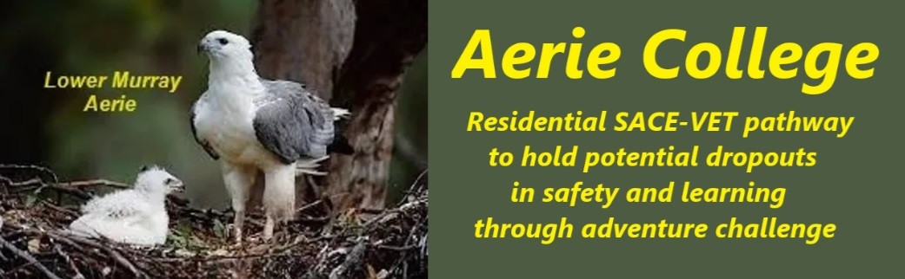

**Policies**

|  |  |
| --- | --- |
| Title | School Legal Structure |
| Category | School Governance |
| Document ID | 1.1 |
| Version | 1.0 |
| Date | 10/1/25 |
| Purpose | Special Assistance Senior High school in SA |
| Audience | Education Standards Board, Public Identification in register of schools, Parents of potential students, Potential employees, and Service industries employed by the school. |
| Registration requirement | **Aerie College** is required to be registered as a school under the Education Act SA. |
| Description | Aerie College is a registered name owned by the registered charity ANCOM ON MURRAY Inc. [ABN: 58 742 996 740] and acting as an independent financial entity. |
| Charity Board | The charity, is a DGR recipient managed by a board of public persons and may elect other members at an AGM. |
| Responsible person | Principal |
| Sign off by | Charity Board Chair, Capt Arthur Jones |
| Next review date | Sept 2027 |
| URL |  |