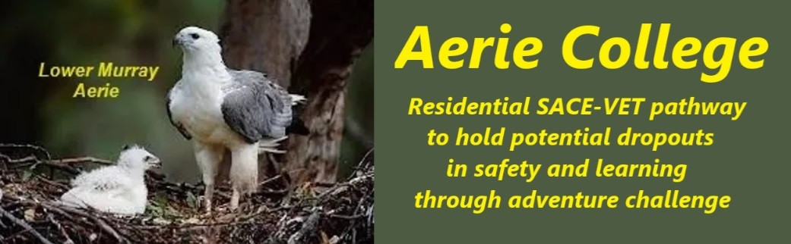

**Policies**

|  |  |
| --- | --- |
| Title | Documented Program Curricula |
| Category | Curricula and Planning |
| Document ID | 2.3 |
| Version | 1.0 |
| Date | 10/1/25 |
| Purpose | **Aerie SACE Curricula**  At Aerie, we believe in student-centered learning. Each curriculum selected by a student is supported by clear SACE or VETIS guidelines for completion. Aerie teachers collaborate closely with students to tailor requirements to their individual needs and document the agreed plan. Online learning resources will be provided to aid in planning and study.  We encourage teamwork and partnership between students working with teachers. This collaborative approach is essential for achieving success. It's not cheating; it's working together to reach shared goals. Partnerships and Teamwork is a cornerstone of everything we do at Aerie College |
| Audience | ESB  Parents/Carers of potential students  ANCOM Community members |
| Registration requirement | To satisfy the requirements of the Education Standards Board for registration as a school |
| Responsible person | Principal |
| Sign off by | Charity Board Chair, Capt Arthur Jones |
| Next review date | Sept 2027 |
| URL |  |