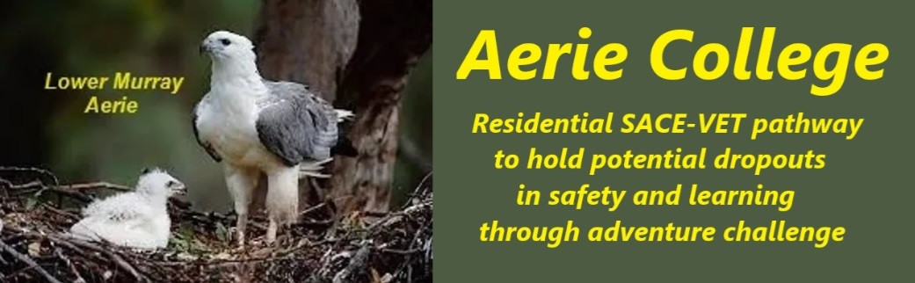

**Policies**

|  |  |
| --- | --- |
| Title | Resources to Support Teaching |
| Category | Learning and Assessment Resources |
| Document ID | 2.4 |
| Version | 1.0 |
| Date | 10/1/25 |
| Purpose | **Aerie SACE + VETIS Curricula: A Personalized Approach** Aerie assists students to search the SACE VETIS options and to modify their learning approach to best achieve a positive result. **At Aerie, we believe in empowering students to take ownership of their learning journey.** While satisfying the SACE essentials Our SACE / VETIS curricula options are designed to provide a flexible and supportive environment where students can explore their interests, set and achieve their goals. |
| Audience | ESB  Parents/Carers of potential students  ANCOM Community members |
| Registration requirement | To satisfy the requirements of the ESB for registration as a school |
| Responsible person | Principal |
| Sign off by | Charity Board Chair, Capt Arthur Jones |
| Next review date | Sept 2027 |
| URL |  |