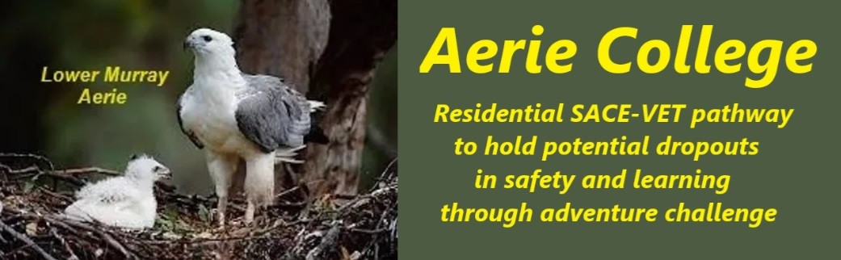

**Policies**

|  |  |
| --- | --- |
| Title | The SACE Curricula |
| Category | Curricula and teaching |
| Document ID | 2.2 |
| Version | 1.0 |
| Date | 10/1/25 |
| Purpose | **Aerie SACE Curricula contains:-**  * [See SACE search link for the wide range of study options](https://www.sace.sa.edu.au/studying/your-sace/what-is-the-sace) * **Must-Do SACE Essentials** * **Include VETIS** * **To meet legal requirements, Aerie College mandates a daily student task log as evidence of schooling.** This log, signed off by teachers serves as evidence of schooling. |
| Audience | ESB  Parents/Carers of potential students  ANCOM Community members |
| Registration requirement | To satisfy the requirements of the Education Standards Board for registration as a school and a source of Government funding. |
| Background | Current research indicates a 24% dropout rate at senior school level. |
| Responsible person | Principal |
| Sign off by | Charity Board Chair, Capt Arthur Jones |
| Next review date | Sept 2027 |
| URL |  |