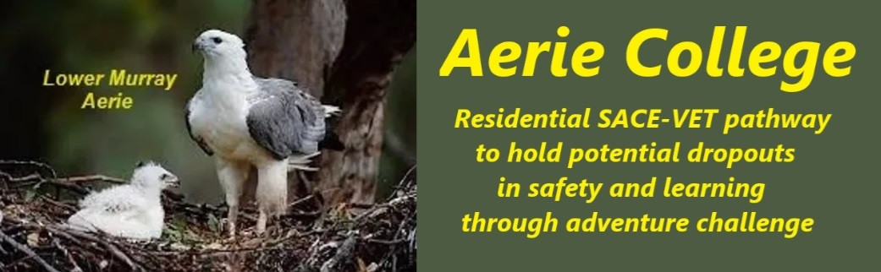

**Policies**

|  |  |
| --- | --- |
| Title | Competent Management |
| Category | School Governance |
| Document ID | 1.4 |
| Version | 1.0 |
| Date | 10/1/25 |
| Purpose | Managing a residential Senior High school requires a board consisting of experienced educators, youth residence manager and the provision of vocational training in hospitality skills. |
| Complies with Law | **Aerie College fulfils all relevant State and Federal law.**  The Board members, Principal and Deputy Principal, have retained teacher registration and have many years of experience in the management of schools, and RTO’s both State Government and Independent schools, including, management of a large outdoor adventure school camp business. They will bring the RTO scope into the VETIS part of the Aerie Curriculum.  Board members with teacher registration will retain active engagement as the Wise Elder Teacher support role as the school enrolment grows with younger teaching staff. |
| Recognised industry  Accounting fimr | **Ensure financial viability and reporting**  The Board will contract with Coles School Specialists to manage the school accounting functions and prepare required financial reporting.  Coles School Specialists will prepare reports for board meeting and may attend on occasions. |
| World evidence of quality education approach | **Education philosophy and approach**  The Aerie College approach will focus on the benefits or wilderness living experience, homeskills education and training, low cost travel and backpacker living lifestyle. It will ensure that this focus continues for the benefit our our students who need Special Assistance from a wide range of reasons and from many different family backgrounds**.** |
| Complies with law | **Aerie College in compliance with Commonwealth and State laws**  Australian youth are required to remain in schooling until their 17th Birthday, in effect the completion of the SA SACE years 11 and 12.  The current State High School dropout rate prior to this age is 24%.  Aerie College offers a residential alternative as special assistance to remain in school. Aerie will maintain the key elements of schooling through use of the SACE and VETIS curriculum options and the associated assessment standards.  Subjects selected by students will be sourced from these curriculum documents and their completion requirements.  Wilderness adventure learning leading to tourism leadership and home skills will be the dominant teaching process. |
| Qualified leadership | **Leadership staff to ensure continuing education services.**  As the enrolment expands the school will employ young teaching staff and the elders will coach and mould then into the Aerie College teaching style. We expect to hold them as team leaders as the number of school campuses expand. |
| Fit & proper persons | **School leaders remain fit and proper persons.**  When the need for replacement Board members occurs the board will select appropriate persons who agree with the general approach of the Earie College teaching model. |
| Prncipal responsible | **Person responsible for compliance**  The Principal is responsible for maintenance of compliance on behalf of the Board. |
| Audience | ESB,  Parents of potential students,  Government funding podies,  Financial grant bodies. |
| Registration requirement | To satisfy the requirements of the ESB for registration as a school and receive Government financial assistance. |
| Charity Background | 1980 The charity was incorporated in South Australia on 20th November as Encounter Coast Outdoor School Inc. to operate school camps in association with a resort property.  1995 it was registered as a Senior High school located in Grahams Castle Conference Centre, Goolwa, offering a specific senior school curriculum related to the lower Murray and Coorong region.  The charity has always remained financially viable and has no debts.  The charity maintains a vehicle on term purchase contact. |
| Responsible person | Principal |
| Sign off by | Charity Board Chair, Capt Arthur Jones |
| Next review date | Sept 2027 |