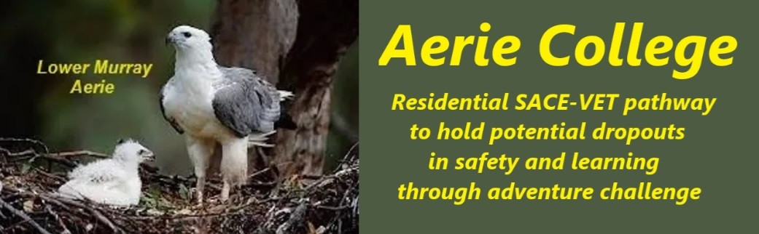

**Procedures**

|  |  |
| --- | --- |
| Title | Monitor, Review, Record |
| Category | Records & reports student performance |
| Document ID | 2.6 |
| Version | 1.0 |
| Date | ***10/01/25*** |
| Purpose | **Monitoring, Recording, and Reporting: A Focus on Wellness**  Regular physical activity significantly improves overall wellness and cognitive function. Fostering strong partnerships and teamwork also enhances well-being, encouraging individuals to support each other's growth. Our focus on adventure challenge activities working with partners and teams enhances fitness and wellness.  Our residential learning environment promotes home catering, housekeeping and care skills as practical applications for their SACE learning. Aerie students work as partners and in teams in mutually supportive relationships delivering peer services in all their activities. This team model expands into adventure challenge outdoor adventure environmental studies.  There is no intent of “comparing apples with oranges” in Arie. Each child can be competent or not yet competent to their best ability. This is a skill required of our teachers.  **Students' daily logbooks and end-of-day reflections** will be used by teachers to track student learning progress, with a **particular emphasis on reported feelings of wellness.** |
| Audience | ESB |
| Registration requirement | To satisfy the requirements of the ESB for registration as a school |
| Responsible person | Principal |
| Sign off by | Charity Board Chair, Capt Arthur Jones |
| Next review date | Sept 2027 |
| URL |  |