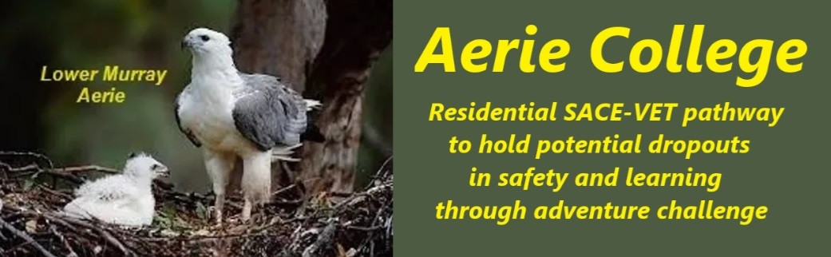

**Policies**

|  |  |
| --- | --- |
| Title | Professional development teachers |
| Category | Registered teachers & Prof. Dev. |
| Document ID | 2.8 |
| Version | 1.0 |
| Date | 10/1/25 |
| Purpose | **Aerie College Special Assistance** is committed to fostering a supportive environment where both students and teachers can thrive academically and emotionally. Our residential college offers frequent opportunities for teachers to collaborate on student and their own well-being.  We prioritize **in-service training** for our staff, emphasizing strategies to promote **wellness and happiness** in young people. By addressing emotional needs, we aim to create a positive learning atmosphere where students can **excel In their learning tasks.** .  We recognize the detrimental impact of negative school experiences on mental health of both students and teachers. Our approach involves **rebuilding wellness and happiness** in both students and teachers, providing targeted support to address the challenges of depression and other emotional issues.  As a resort precinct working all year we promote vacation Inservice holidays for teachers. Our students participate. |
| Audience | ESB |
| Registration requirement | To satisfy the requirements of the Education Standards Board for registration as a school |
| Responsible person | Principal |
| Sign off by | Charity Board Chair, Capt Arthur Jones |
| Next review date | Sept 2027 |
| URL |  |