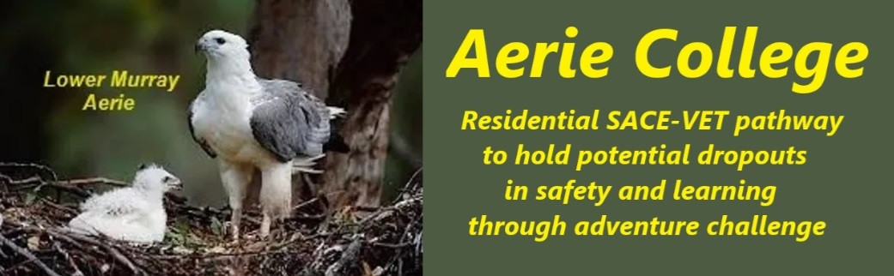

**Procedures**

|  |  |
| --- | --- |
| Title | Professional Development |
| Category | Registered teachers & Prof. Dev. |
| Document ID | 2.8 |
| Version | 1.0 |
| Date | ***10/01/25*** |
| Description | Our teachers have a unique role in motivating learning skills and positive attitude towards developing competency to an acceptable level for each child at a given task and for them to be happy with their result.  Aerie College Special Assistance is dedicated to creating a nurturing environment where students can thrive academically and emotionally. Our residential college fosters a strong sense of community, encouraging frequent collaboration among teachers to ensure the well-being of every student.  As part of a larger community charity, we promote a resort-style living experience, inviting families to share holidays with us. This includes teachers and their families, offering valuable opportunities for professional exchange and in-service training.  Aerie teachers use the power of mentorship and collaboration. Experienced teachers work closely with newer staff, providing guidance and support as they develop their teaching skills. This peer-to-peer learning approach creates a dynamic and supportive environment for all. Our college operates as a multi-generational family, with teachers working together in small care groups to provide personalized attention to each student.  Prioritizing in-service training, we equip our staff with strategies to promote wellness and happiness in young people. By addressing emotional needs, we aim to create a positive learning atmosphere where students can excel academically. Recognizing the detrimental effects of negative school experiences on mental health, we focus on rebuilding wellness and happiness in both students and teachers. Our targeted support programs address depression and other emotional issues, ensuring that everyone receives the care they need. |
| Audience | ESB |
| Registration requirement | To satisfy the requirements of the Education Standards Board for registration as a school |
| Responsible person | Principal |
| Sign off by | Charity Board Chair, Capt Arthur Jones |
| Next review date | Sept 2027 |
| URL |  |