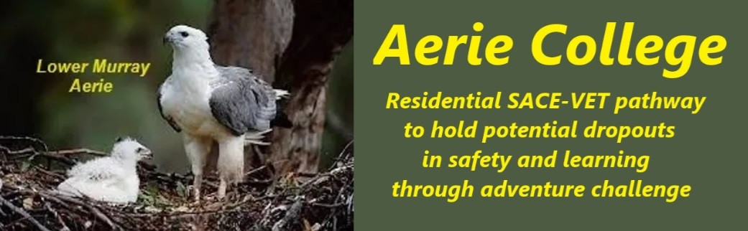

**Policies**

|  |  |
| --- | --- |
| Title | Complies with safety, health and welfare laws and policies |
| Category | Safety health & Welfare |
| Document ID | 3.1 |
| Version | 1.0 |
| Date | 10/1/25 |
| Purpose | The school provides a safe, healthy and supportive learning environment that protects the well-being of students living within a supportive backpacker style Community facility |
| Audience | ESB |
| Registration requirement | To satisfy the requirements of the Education Standards Board for registration as a school |
| About | Our school campus and learning spaces are regularly inspected to ensure they meet strict child safety standards. While most of our students are 15 or older, we prioritize the safety of all community individuals.  Our child protection policies and procedures are specifically designed for older adolescents, providing age-appropriate safety measures and support.  All Community employees are required to complete training and follow these guidelines. |
| Education SA Reference | <https://www.education.sa.gov.au/policies/shared/sporting-and-adventure-activities-standard.pdf> |
| Responsible person | Principal |
| Sign off by | Charity Board Chair, Capt Arthur Jones |
| Next review date | Sept 2027 |
| URL |  |