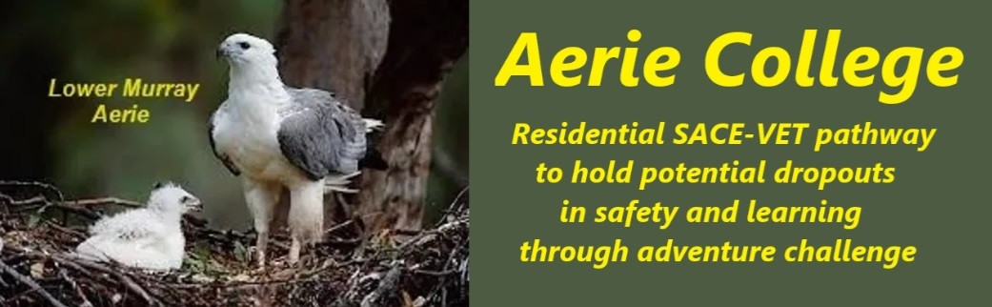

**Policies**

|  |  |
| --- | --- |
| Title | The School Facilities |
| Category | Property, Facilities & Equipment |
| Document ID | 2.11 |
| Version | 1.0 |
| Date | 10/1/25 |
| Purpose | **Aerie College Unique Learning Environments are appropriate for our age cohort: -**  Aerie Students are all of age 15+, many well experienced in the adult world. Our facilities are based on the facilities throughout the world identified as licensed Youth Hostels Association members with a common set of structure and rules specific to the safety and wellbeing of this older teenage cohort and older. They are suitable for the stages of schooling the college offers and for the student cohorts and age levels enrolled and will support the delivery of quality education and achievement of its curriculum outcomes with focus on tourism, hospitality, cookery, Outdoor Recreation and music performance.  Existing proposed facilities are well maintained, and comply with Commonwealth, State and Local governments laws that apply to its built environment, infrastructure, grounds and facilities. |
| Education SA | <https://www.education.sa.gov.au/policies/shared/asset-management-policy.pdf> |
| Audience | ESB  Parents/Carers of potential students  ANCOM Community members |
| Registration requirement | To satisfy the requirements of the ESB for registration as a school |
| Responsible person | Principal |
| Sign off by | Charity Board Chair, Capt Arthur Jones |
| Next review date | Sept 2027 |
| URL |  |