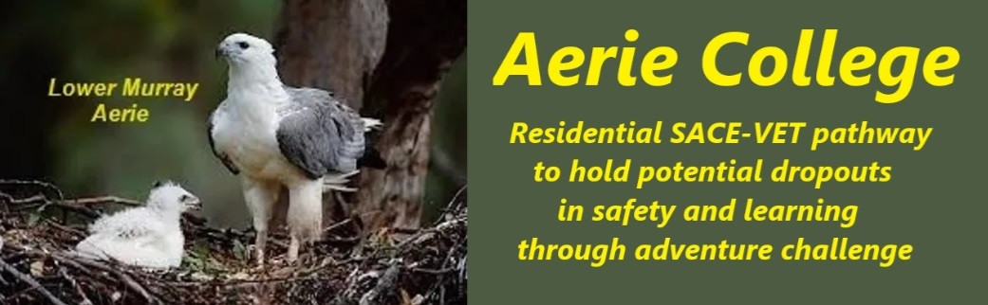

**Procedures**

|  |  |
| --- | --- |
| Title | School Registration & Management |
| Category | School Governance |
| Document ID | 1.1 |
| Version | 1.0 |
| Date | 10/1/25 |
| Purpose | Registration of a Special Assistance Senior High school |
| Audience | ESB  Aerie Board |
| School Registration requirement | The school name Aerie College is owned by the ACNC-registered Charity ANCOM ON MURRAY Inc. ABN: 58 742 996 740, Incorporated In SA under the Associations Incorporation Act SA and Listed with the ACNC. Its principal purpose is the provision of education and training. |
| Description | * Aerie College is the Registered Business name of the school. * The school operates as a separate financial entity within the parent charity ANCOM ON MURRAY Inc. |
| Preparation of registration document | The principalprepares and manages the new Special Assistance school registration documentation and regularly reports to Board members for comment and approval. |
| Approval of registration documentation | The Boardapproves the final documentation for presentation to ESB for registration. |
| Responsible person | Principal |
| Sign off by | Charity Board Chair, Capt Arthur Jones |
| Next review date | Sept 2027 |
| URL |  |