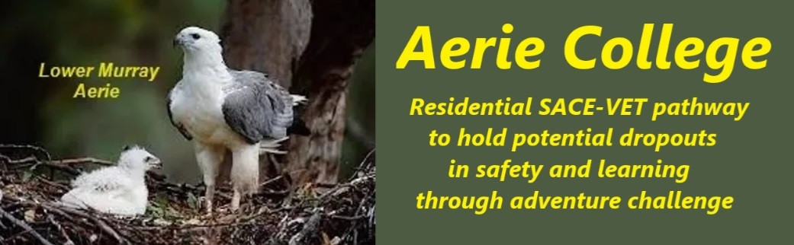

**Procedures**

|  |  |
| --- | --- |
| Title | Compliance with Gov. Safety, Health Welfare |
| Category | Safety health & Welfare |
| Document ID | 3.1 |
| Version | 1.0 |
| Date | 10/01/25 |
| Purpose | The school provides a safe, healthy and supportive learning environment, relevant to our age cohort, that protects the well-being of students. |
| Audience | ESB  Community membership |
| Registration requirement | To satisfy the requirements of the ESB for registration as a school |
| About | Aerie College: Commitment to Student Well-being  Aerie College is dedicated to fostering a safe, healthy, and supportive learning environment that prioritizes the well-being of all students and community members. Part of well being is feelings of success after completing a new challenge.  1. Safety and Security:   * **Safety and Risk assessment plans** are part of our entry level curriculum and are reviewed for every new adventure. * **Regular Safety Drills**: Conduct regular safety drills, including fire drills, lockdown procedures, and evacuation plans, to ensure students and staff are prepared for emergencies. * **Security Measures**: Maintain robust security measures, such as controlled access points, surveillance systems, to protect the campus and its occupants. * **Crisis Management Plan for each campus**: Develop and regularly update a crisis management plan to outline procedures for responding to various emergencies, including natural disasters, medical incidents, and threats to safety.   2. Healthy Environment:   * **Health and Hygiene Standards:** Enforce high standards of health and hygiene, including regular cleaning of facilities, promoting handwashing practices, and providing access to sanitizers. * **Health Services:** Provide and maintain updates for first aid training for all staff. Designate a local health professional as community member to address minor health concerns, manage medication administration, and coordinate referrals to healthcare providers when necessary. * **Mental Health Support:** Offer mental health resources and support services, such as counseling, social work, and peer support programs, to address the emotional and psychological well-being of students and other community members.   3. Supportive Learning Environment:   * **Anti-Bullying Policies:** Implement and enforce strict anti-bullying policies to prevent and address bullying behaviors, promoting a respectful and inclusive community culture. * **Positive School and community Climate:** Foster a positive opportunities, extracurricular activities, and celebrations of diversity. * **Student Support Services:** Provide academic support services, such as tutoring and mentoring programs, to help students succeed and build confidence. * **Open Communication:** Encourage open communication between students, staff, parents and other community members to address concerns and promote a sense of belonging.   Aerie College is committed to continuously reviewing and improving these procedures to ensure that our students have a safe, healthy, and supportive learning environment that promotes their overall well-being. |
| Education SA Reference | <https://www.education.sa.gov.au/policies/shared/sporting-and-adventure-activities-standard.pdf> |
| Responsible person | Principal |
| Sign off by | Charity Board Chair, Capt Arthur Jones |
| Next review date | Sept 2027 |
| URL |  |