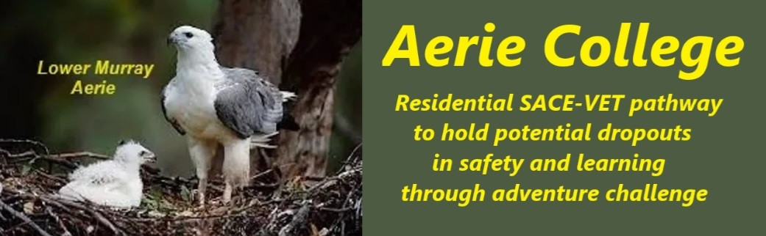

**Procedures**

|  |  |
| --- | --- |
| Title | Reporting Student Performance |
| Category | School Governance |
| Document ID | 1.6 |
| Version | 1.0 |
| Date | ***10/01/25*** |
| Purpose | **The Private Student Log is the AERIE tracking & reporting tool: SEE Student Log template**   * Students will maintain a daily work log for all activities.   + The student log is the teacher/student management record   + The log will be signed off each week by the supervising teachers and filed in private school records.   + The summary of weekly logs will be the basis for end of term reports to parents   + We recognize for student privacy; some may request that their student log remains confidential between them and their teachers. This will be respected. A term summary will be provided to parents. * **Students and their families will be active participants in the school's activities** within the associated community resort facilities providing firsthand contact with the student learning programs.   + On campus, students will gain hands-on experience in resort management, including river recreation and houseboat operations.   + Parents will not only be informed but will also be involved in the school's activities and its community.   + Parents will be briefed on the understanding that the student is under the direction of the teacher in school managed events. This concept will be amplified in the enrollment documentation. |
| Audience | ESB |
| Registration requirement | To satisfy the requirements of the ESB for registration as a school |
| Responsible person | Principal |
| Sign off by | Charity Board Chair, Capt Arthur Jones |
| Next review date | Sept 2027 |
| URL |  |