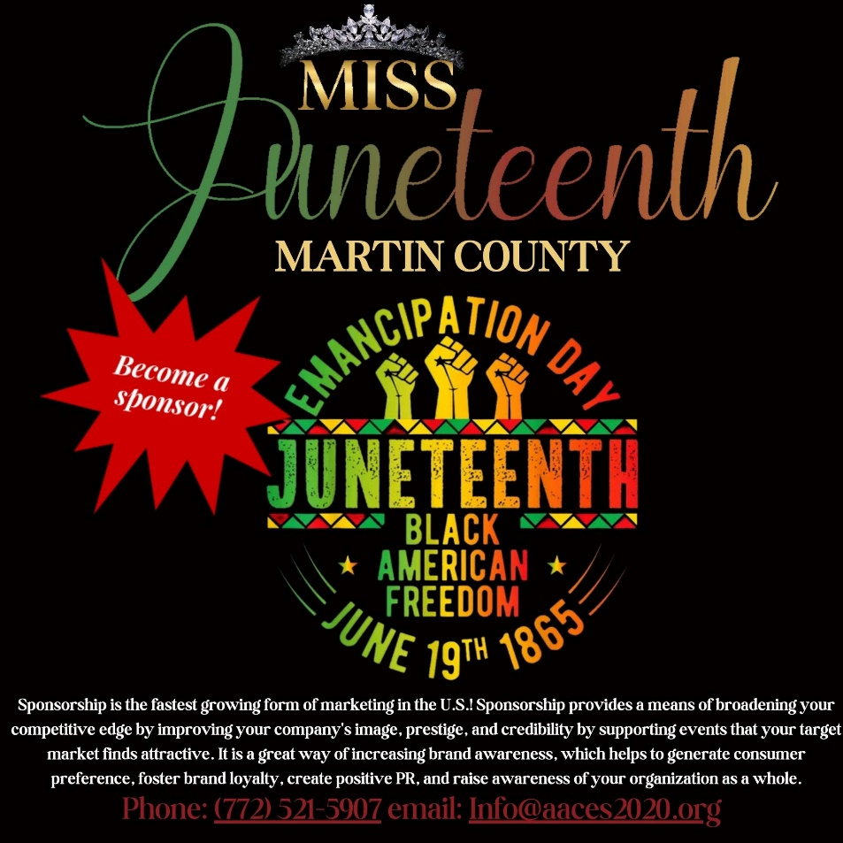

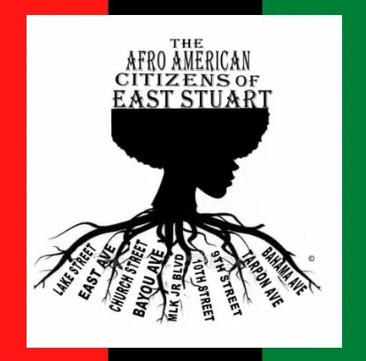
Dear Prospective Donor/Sponsor:
AACES Inc. is a local non-profit 501c3 organization in the City of Stuart, that’s committed to addressing the needs, concerns, and ideas of the community to make a better community for all citizens. Juneteenth (short for June Nineteenth) is a holiday that marks the end of slavery in the United States and is celebrated each year across the country. This event will be held at the Boys and Girls Club 551 SE Dr. Martin Luther King Jr. Blvd. Stuart, FL 34994
This year we’re hosting our third annual Miss Juneteenth pageant. This program is a unique pageantry experience for young ladies between the ages 13 and 18. This pageant experience aims not only to showcase the inherent beauty and talent of these young ladies but to minimize stereotypes; develop a sense of self confidence and pride; and deepen the understanding of African American history and culture. The date of this year’s pageant will be held on June 20, 2026. The Miss Juneteenth pageant is well-promoted through social media, word of mouth, press releases and press coverage. It is our hope that you will partner with us to make the 3rd annual Miss Juneteenth Pageant a huge success for these young ladies. Given that we are a non-profit organization, your donation is tax deductible and serves as an excellent way to give back to your community.
To become a sponsor/donor please fill out sponsorship forms and select the best package that represents you and your business/organization. Your support is greatly appreciated.

Sincerely,
Nina Dooley

DIAMOND SPONSOR – $5,000
Sponsor the registration fee for Twenty (20) Miss Juneteenth Martin County Pageantry Participants
Title Recognition- website for a year, all promos, and flyers
A full-page ad inside of the Program Souvenir Booklet
Eight (8) copies of the Program Souvenir Booklets

PLATINUM SPONSOR – $3,000+
- Sponsor the registration fee for Twelve (12) Miss Juneteenth Martin County Pageantry Participants.
- Name recognition during the program
- A half-page (1/2) ad inside of the Program Souvenir Booklet
- Six (6) copies of the Program Souvenir Booklet

GOLD SPONSOR – $1,500+
- Sponsor the registration fee for Six (6) Miss Juneteenth Martin County Pageantry Participants.
- Name recognition during the program
- A Fourth page (1/4) ad inside of the Program Souvenir Booklet
- Four (4) copies of the Program Souvenir Booklet

SILVER SPONSOR – $500+
- Sponsor the registration fee for two (2) Miss Juneteenth Martin County Pageantry Participants.
- Name recognition during the program
- Listing inside of the Program Souvenir Booklet
- One (1) copy of the Program Souvenir Booklet

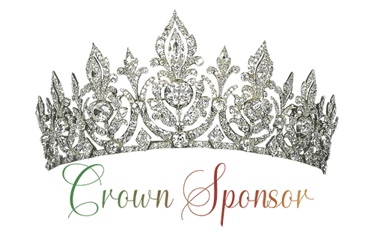

$250.00
- Sponsor the registration fee for one (1) Miss Juneteenth Martin County Pageantry Participant.
- Name recognition during the program.
- Name recognition on the website.
- Recognition inside of the Program Souvenir Booklet.
- One (1) copy of the Program Souvenir Booklet.

To become a sponsor of the 2026 Miss Juneteenth Martin County Pageantry Program please fill in your contact information.

Donation/Sponsorship Form
Cash App: AACES East Stuart
Zelle: The Afro American Citizens of East Stuart
Please make checks payable to:
The Afro American Citizens of East Stuart Inc.
917 SE 9th Street
Stuart, FL 34994

COMPANY NAME: ___________________________________________________________
CONTACT: _________________________________________________________________
ADDRESS: __________________________________________________________________
EMAIL: _____________________________________________________________________
PHONE NUMBER: ____________________________________________________________
AUTHORIZED SIGNATURE: _____________________________________________________
Which Sponsorship Level are you interested in?

Diamond Sponsor
Platinum Sponsor
Gold Sponsor
Silver Sponsor
Crown Sponsor

