**TALL PINES RV RESORT, INC.**

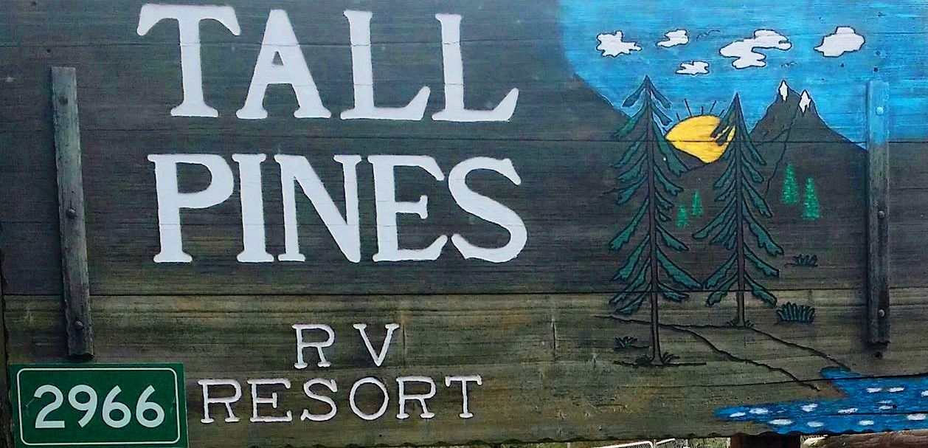

**2966 Tall Pine Road, #66**

**Show Low, AZ 85901**

2025

Attention Members Selling Units

It is critical when you are selling your unit that you contact the board secretary. The secretary is responsible for notifying all regulatory agencies that a sale has taken place and that a unit has changed ownership.

Your prospective buyer will need to read, understand and agree to comply with the Rules & Regulations, Architectural Guidelines and By-Laws before signing the application.

The buyer must fill out an application which requires a background check current fee is $55.00-(Rules & Regulations, Number 6 – potential buyer (s) have to be 45 years of age or older, which is to be approved by the Board of Directors. Without conducting this initial step, the sale will be void.   
  
You may enlist any member to show your home if you are unavailable. We don’t use realtors or one specific member.

At the time the sale is closed, both the seller and buyer are involved in completing the Membership Interest Purchase Agreement/Proprietary Lease with the board secretary, or designated member of the board. It is at that time that the seller pays a $100 transfer fee to Tall Pines RV Park, Inc. Seller is to turn in the Membership Certificate to board secretary. Buyer is to pay a $100 new member fee to Tall Pines RV Park, Inc.

Should you have any questions, you may contact the board secretary or assistant secretary by phone or email.

Please have all financial matters and personal property in home settled prior to ‘closing’ with TPRVR. Including but not limited to deed paperwork, park dues and fee balance and property tax billing status.

Tall Pines RV Resort  
 2966 Tall Pine Rd, #66, Show Low, AZ 85901   
 [tallpinesrvresort@gmail.com](mailto:tallpinesrvresort@gmail.com)   
tallpinesrvresort.com   
 facebook.com/Tallpinesrvresort