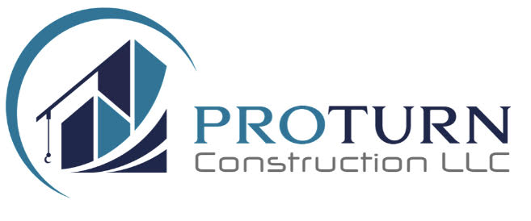

# **Pro Turn Construction LLC**

## **Capability Statement**

### **CORE COMPETENCIES**

Pro Turn Construction LLC specializes in commercial renovation and facility maintenance with expertise in:

* Office Space Reconfiguration & Renovation
* Federal Compliance Implementation:
  + ADA Compliance
  + Life Safety Compliance
  + Federal Housing Quality Standards
* Sustainable Facility Maintenance Solutions
* Multi-Site Project Management
* Environmental-Friendly Operations

### **DIFFERENTIATORS**

* Proven track record of 100% specification compliance in federal projects
* Digital project tracking system ensuring transparent documentation and progress monitoring
* Leadership with OSHA 30 certification ensuring workplace safety compliance
* 6-48 hour response time for urgent facility needs based on location
* Eco-friendly cleaning and maintenance protocols using environmentally certified products
* Dedicated project management team with 40+ years combined experience
* Comprehensive digital quality control and documentation systems
* Demonstrated expertise in occupied space renovations

### **PAST PERFORMANCE HIGHLIGHTS**

**Current Federal Compliance Project - HUD Standards, Philadelphia, PA (2024-2025)** *Contract Value: $89,000*

* Ongoing implementation of federal housing quality standards
* Meeting HUD compliance requirements and guidelines
* Demonstrating continued excellence in federal project management Contact: Gabrielle Ramos, Sr Lead Manager Phone: (267) 882-9088

**National Multi-Site Operations Management (2022-2023)** *Unite Here - $700,000 Annual Contract*

* Successfully managed operations across 5 cities, 4 states, 3 regions
* Achieved 100% delivery rate on 19,000+ deliverables
* Implemented cross-regional communication protocols
* Maintained perfect client satisfaction scores Contact: Kelley Ford, International Representative Phone: (312) 576-9929

**Federal Compliance Project - Atlantic City, NJ** *Contract Value: $112,000*

* Achieved 100% federal compliance with specifications
* Established comprehensive quality management systems
* Successfully managed multiple concurrent federal compliance projects Contact: Maurice Cantey, Facility Assistant Manager Phone: (856) 522-3743

**Multi-Unit Development Project - Philadelphia, PA** *Contract Value: $650,000*

* Managed complex supply chain and vendor relationships
* Implemented efficient resource allocation systems
* Maintained perfect quality scores and zero rejected deliveries
* Demonstrated successful multi-site coordination Contact: Ann Ramos, Regional Manager Phone: (267) 616-8379

### **ENVIRONMENTAL COMMITMENT**

* Use of eco-friendly, EPA-approved cleaning products
* Implementation of sustainable construction practices
* Proper disposal and recycling protocols
* Green cleaning methodologies for improved indoor air quality
* Energy-efficient maintenance solutions

### **QUALITY METRICS**

* 100% specification compliance rate
* Zero rejected deliveries across all projects
* Perfect quality scores on federal compliance projects
* 100% on-time delivery performance
* Rapid emergency response capabilities

### **CAPACITY & RESOURCES**

* Core Staff: 17 full-time employees
  + Administrative Team: 3
  + Field Operations: 14
* Extended Workforce: Access to 16 additional vetted subcontractors
* National accounts with major manufacturers and distributors ensuring immediate access to required tools and equipment
* Comprehensive supply chain network for rapid procurement
* Multiple project management capability
* Flexible scheduling for sensitive facility requirements
* Full compliance with facility security protocols
* Commitment to protecting sensitive information and following client security procedures

### **INSURANCE & BONDING**

* General Liability: $2 Million
* Workers Compensation: State Required Coverage
* Automobile Liability: $1 Million
* Additional coverage available as required

### **LICENSING & CERTIFICATIONS**

* Licensed Commercial Contractor
* OSHA 30 Certification
* Lead Paint Supervisor Accreditation
* Mold Training Certification

### **COMPANY DATA**

* DUNS Number: [Insert DUNS]
* CAGE Code: [Insert CAGE]
* SAM Registration: Active
* Business Type: [Insert business type/certifications]

### **CONTACT INFORMATION**

**Primary Contact:** [Insert Name] **Title:** [Insert Title] **Address:** [Insert Address] **Phone:** 215-433-0049 **Email:** [info@proturnconstruction.com](mailto:info@proturnconstruction.com) **Website:** [www.proturnconstruction.com](http://www.proturnconstruction.com/)

*Pro Turn Construction LLC is committed to delivering excellence in federal facility projects while maintaining the highest standards of safety, security, and compliance. Our proven track record of managing complex projects with perfect delivery rates positions us as an ideal partner for federal facility renovations.*