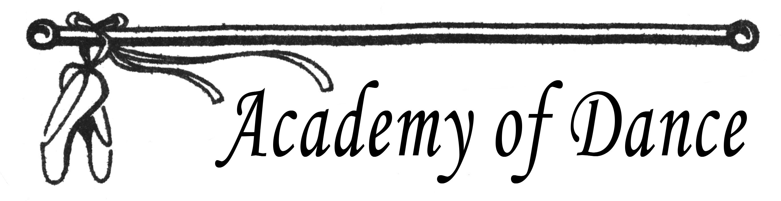
2021 Summer Classes Registration Form

Student:
Parent Name:
Email:
Age/Date of Birth
Address:
Phone: Cell:
Driver’s License (Parent):
Class/Day:
- _____________________________________________________________
- _____________________________________________________________
- _____________________________________________________________
- _____________________________________________________________
- _____________________________________________________________
- _____________________________________________________________
- _____________________________________________________________
- _____________________________________________________________
- _____________________________________________________________
- _____________________________________________________________

Due Now: $20 deposit (will be applied to total tuition)

Total Number of Classes/Total Tuition: ________/_________

Parent/Guardian Signature: ____________________________________________________

*By signing, Parent/Guardian & Student agree to all Policy and Procedures set by Academy of Dance and have signed a Covid Liability Waiver (current for 2020-2021season)

