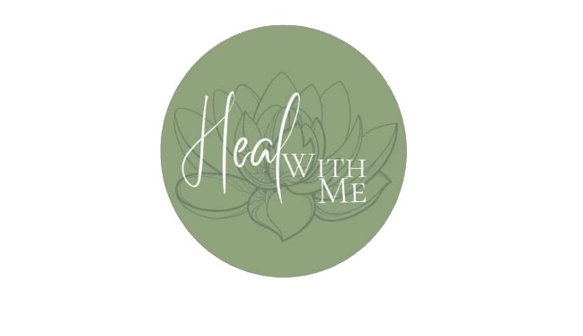Once an online, written, or verbal booking has been accepted by Heal with Me, the client will have entered into an agreement to have therapy based on the following terms and conditions:
TERMS AND CONDITIONS:
FEES: Therapy prices are variable. The agreed amount is payable upon booking of a single therapy appointment via online payment.
CANCELLATION/NON-ARRIVAL: A £30 fee will apply if 24 hours’ notice is not given for a cancellation, reschedule of appointment or non-arrival. I appreciate that you probably have a very good reason for not being able to attend your appointment and so the full fee is not requested; however, your appointment space has been reserved for you thus preventing another client from utilising this time. Discretionary waiver of charges may be undertaken for emergencies.
CONFIDENTIALITY: All communication taking place during therapy is confidential, subject to certain provisions. Therapists are not at liberty to withhold information from the police. As a therapist, I am required to inform the authorities if there is a possibility that you or a member of the public is at risk.
Parts of your conversation may be referred to during supervision, a requirement for registered therapists, although your name or any identifying details would not be disclosed.
If I see you somewhere outside of our sessions, to ensure your confidentiality, I will not approach you or act as if I know you. However, if you acknowledge me first then I will acknowledge you.
LATE OR EARLY ARRIVAL: If you arrive early, please wait for your appointment and you will be held in a zoom waiting room.
If you arrive late for an appointment, I will attempt to offer the best possible service within the time remaining, however the appointment will end at the agreed time with no adjustment to the fee.
DATA PROTECTION ACT: Therapists are required to keep your records on file for 10 years, kept on either hard copy or computer, this information will be kept secure, as per the NCH guidelines on client security. Your personal details will be retained by Heal with Me for statutory reasons, and you are protected in accordance with the Data Protection Act. We will never share your personal information for marketing purposes.
GUARANTEES: There are several complex factors influencing the success of individual therapy, whilst benefits are typically observed in most cases, there can be no guarantees of success or cure in relation to a condition or its treatment, reference NCH, CHNC guidelines.
CHILDREN: Clients under the age of 16 are welcome if accompanied by a parent or legal guardian, who will be asked to give signed consent. They will also be asked to remain present for the duration of the agreed treatment.
We both agree to abide by these boundaries, and you can download a copy for your own reference.

