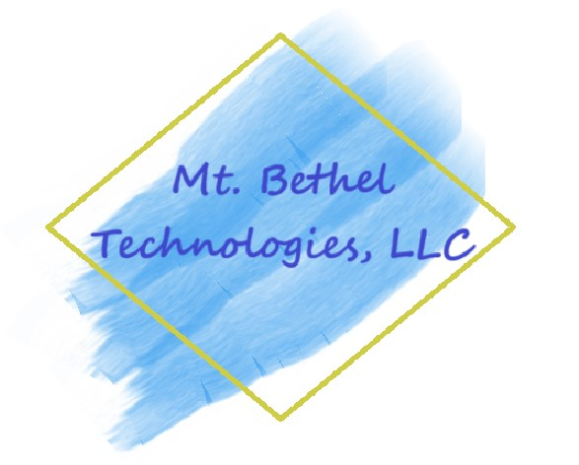

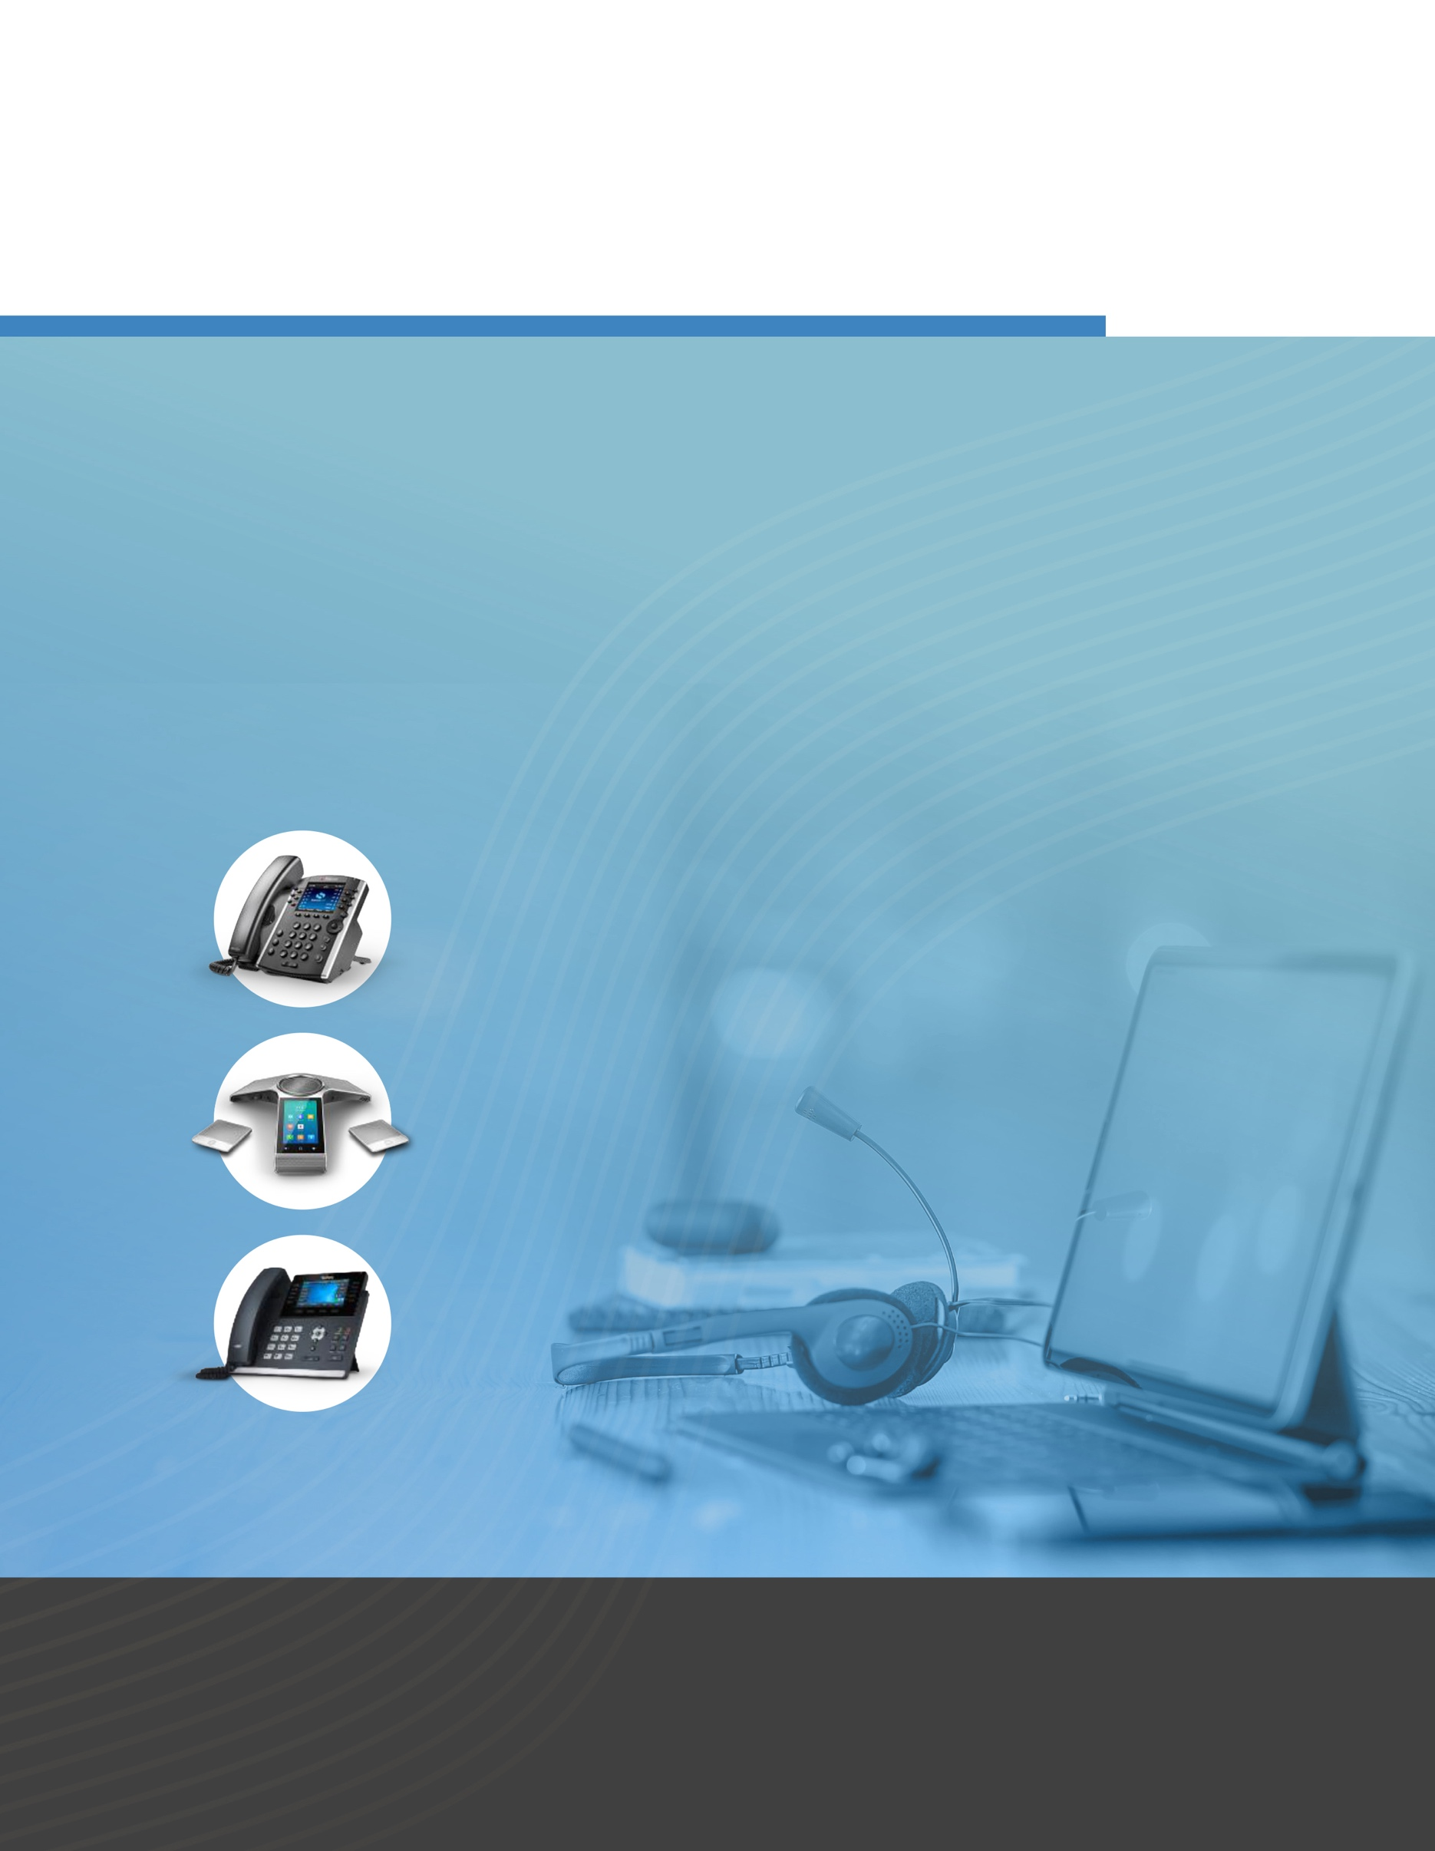

##### Our feature-rich platform can improve your communications, streamline your business processes, and facilitate your business growth and success

Future-proof your business

Cloud Communications: Hosted PBX/VoIP, SIP Trunking, Unified Communications, and more

About us

Your company overview goes here. Your company overview goes here. Your company overview goes here. Your company overview goes here. Your company overview goes here. Your company overview goes here. Your company overview goes here. Your company overview goes here. Your company overview goes here. Your company overview goes here. Your company overview goes here. Your company overview goes here. Your company overview goes here. Your company overview goes here. Your company overview goes here. Your company overview goes here. Your company overview goes here.

### The communications industry is undergoing an unprecedented phase of technological innovations.

Cloud communications products and services continue to improve and innovate enabling your company to leverage features and capabilities that were unavailable or too expensive to take advantage of in the past.

The future is now—get ready

### What makes us the clear choice?

##### We understand the latest and greatest technologies so you don’t have to

**Our solution is reliable, easy to use, feature-rich and scalable. Our customer**

**support is second to none and our experienced technology team will help streamline your business processes to better support your customers so you can continue to compete and win—and sound great doing it!**

**As your needs change over time our features and capabilities change with you. Scalable, flexible, and reliable, our cloud communications platform will help facilitate your growth and success. You can focus on your business—and know that your communications solution will always remain relevant and competitive.**

Whether you are a large or small organization, we

have a solution that meets your needs.

# Products and services

#### Icon Description automatically generated Hosted PBX and VoIP

You want a reliable, high-quality phone system that simply works—so you can focus on your business and not your communications platform. Our system adapts to your needs and seamlessly works the way you do.

* **• Easy to use and easy to manage • Future-proof your phone systems**
* **• Every communications feature your business needs • Reduced monthly phone bills**
* **• Eliminate the maintenance costs of a traditional • Employees can work from anywhere   
   phone “closet”**

#### SIP Trunking

We offer SIP Trunking solutions for any premise-based phone system via your existing broadband connection. Whether you’re looking for the flexibility and cost savings of VoIP or business continuity,   
disaster recovery and unlimited or metered calling plans, we help you reduce costs and improve reliability over traditional telephone systems and services.

#### Virtual Auto Attendant & Mobile VoIP

*Have a remote or mobile workforce?* Use auto attendants, cloud extensions and mailboxes to stay connected with your customers and employees—with all the features of a high end phone system. It’s easy to use and manage, without the cost of a tradition PBX solution. Best of all, you can seamlessly connect mobile and home workers with current or future office locations. It’s all the same cloud communications framework,   
so you can scale up as needed, and connect based on your specific business requirements.

#### Icon Description automatically generated API Integration

*Does your business utilize CRM applications or 3rd party web applications?* Use auto attendants, cloud extensions and voicemail transcription to stay connected with your customers and employees—with all the features of a high end phone system. It’s easy to use and manage, without the cost of a tradition PBX solution. Best of all, you can seamlessly connect mobile and remote workers with current or future office locations. Regardless of location, everyone is on the same communications platform, so you can scale up or down as needed, and communicate based on your specific requirements.

**Cloud Communications: Virtually limitless configuration possibilities so you can decide how you want to make and take calls based on your desired work environment.**

**UC Console: Helps your business maintain complete visibility**

and transparency across the enterprise through a standard web interface, that allows you to: see extension presence, click to dial, monitor & manage call center features (queues, agents, callers), manage conference bridges, and much more.

**Scalability: With the potential for change in your business, scalability is important in today’s business world. With our unified communications platform services can be provided based on your needs as they evolve, providing flexibility and eliminating unnecessary costs.**

**Disaster Recovery: Because our communications platform resides in multiple “hardened” co-location facilities around the country, your business can rest easy in the event of a local service emergency. All of your business’ communications capabilities are backed- up, managed, and ready for rapid recovery.**

Unified   
Communications (UC)

**UC is the seamless integration of voice, video, presence, chat, call center agents, call recording, visual voicemail, tasks, notes, etc. that help dramatically improve your communication processes and business productivity. Our software and services enable**

**you to seamlessly communicate via a desk phone, your computer or your mobile device and take advantage of our high-value cloud communication services.**



here

**Ready to switch?**

Call **908-798-7522** to receive a customized quote detailing the benefits of using our innovative products and services. When you’re ready, we’ll install your new phone system with **5-9s of reliability**, so you can get back to business.

Features and benefits

Business continuity

Virtually eliminate business downtime should your local area network (LAN) or wide area network (WAN) communications

go down. Your communications solution is still running in our cloud environment, so your customers, vendors, and employee calls can keep flowing.

A good disaster recovery plan will help your business in good times and bad.

With our solution, a good business continuity plan is extremely cost effective, and readily available, based on

your individual business needs.

Supportive   
staff

We are here to support your business at   
every level with

our always-available, skilled and professional support team.

We’ll help you with   
your specific needs   
and concerns, while giving you personalized customer support

that you won’t find anywhere else.

Mobility mastered

Mobility is paramount in today’s business world. Our mobile application is designed to help

you conduct business anywhere using any mobile device.

Keep your company connected with an array of mobile features—from cloud extensions, find-me follow-me, group and simultaneous ring, to voicemail transcription, and much more.

Configuration flexibility

Reliable and feature- rich, our hosted phone services adjust to your business needs. We make it easy for you, creating an in-office experience right at your fingertips— wherever you are

and on whichever device you choose.

Features include:

call center capabilities, call recording, ring groups, find me follow me, and many more.

CUSTOMER TESTIMONIAL(S)

**John Smith**  
Company Name

Customer tested

**Our reliable platform has enabled countless businesses to improve their communication with their customers, employees and vendors. With a full range of front and back-office features, you can rest easy knowing your business’ communications needs are will be addressed now and into the future.**

Mtbetheltechnologies.com