**Hosted PBX & VoIP**

Reliable and Easy-to-Use Phone Systems



What is Hosted PBX & VoIP?

**Hosted PBX**

**Private Branch Exchange**

**It’s the modern version of the traditional telephone system. The new hosted, or “cloud,” phone system moves the central nervous system into professionally maintained data centers, helping businesses like yours to transform their communications and improve reliability and capabilities—without the need to purchase expensive, complex, depreciating phone system software and hardware.**

**We manage and monitor your system 24/7, allowing you to focus on your business.**

**VoIP**

**Voice over Internet Protocol**

**It refers to phone services that travel over your Company’s Internet connection. VoIP is typically more cost-effective, reliable and scalable than traditional alternatives.**

**With both Hosted PBX and VoIP,**

**your team can work from the office, home,   
or on the road, and always be connected to   
your company’s communications solution.**

# Businesses today need technology solutions that help improve communications, while driving productivity across the enterprise.

They also want a reliable, high quality phone system that simply works. And as your business evolves, you need a solution that’s both flexible, easy to learn and easy to use.

Today, transforming your phone system is simple and cost-effective, regardless of the size of your business. Our

communications solution adapts and adjusts to your needs, seamlessly working the way you need it to. That way, you can focus on your business, not your communications system.

# Get a reliable phone system that:

* Is high quality and resides in the cloud
* Utilizes modern features with enterprise capabilities
* Costs less up-front and over time
* Is continually updated with the latest features and does not require uniquely trained service technicians

# Leverage powerful features and benefits, including:

* + Flexibility to scale up or down as needed
  + The ability to work from anywhere!
  + The ability to communicate via a desk phone, browser and mobile device
  + Near limitless call-routing features for optimal productivity



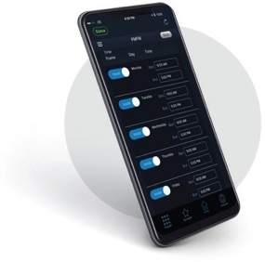



ere

**Ready to switch?**

Call **908-798-7522** to receive a customized quote detailing the benefits of using our innovative products and services. When you’re ready, we’ll install your new phone system with **ZERO downtime**, so you can get back to business.

Mtbetheltechnologies.com