NIST 800-171 Cybersecurity Policy and Procedure Form CUI 3.13.16

3.13.16 Protect the confidentiality of CUI at rest.

CMMC SC.3.191Protect the confidentiality of CUI at rest.

3.13.16 Self-Assessment Workbook Questions
- Are there controls used to protect CUI while stored in company information systems?
- Does the system protect the confidentiality of information at rest?

<Organization Name> <Date of Current Revision>

NIST Safeguard SC-28

SC-28 PROTECTION OF INFORMATION AT REST

CMMC SC.3.191Protect the confidentiality of CUI at rest.

Control: The information system protects the confidentiality of [Assignment: organization-defined information at rest].

Suggested Policy Clauses:

- The IT Manager shall appropriately encrypt any protected information residing in the information system.
- The data protection plan shall be approved by the Compliance Officer.

Implementation Date: ____<Date of Current Revision>_______________________
Authorizing Official: ____<Name of Authorizing Official>_____________________
☐ Inserting my typed signature on the line below I hereby attest that I am an authorizing official or designated representative of an authorizing official and I approve the above Policy/Procedure on behalf of my organization.
Typed Signature: ____<Typed Name of Authorizing Official or Designee>______
NIST 800-171A Assessment of Policy Effectiveness
3.13.16 ASSESSMENT OBJECTIVE
Determine if the confidentiality of CUI at rest is protected
Suggested ACRMS data inputs

Screen shot of front of ACRMS data input page
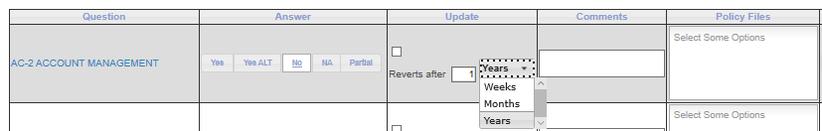
Question SC-28: PROTECTION OF INFORMATION AT REST
Answer SC-28: ☐ Yes ☐ Yes Alt ☐ No ☐ NA ☐ Partial
Update SC-28: 1 ☐ Week ☐ Month ☐ Year
Comments SC-28: Specify _________________________
Policy File SC-28: CUI 3.13.16 SC28 0820

Screen shot of back of ACRMS data input page
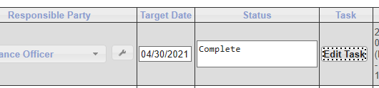
Responsible Party SC-28: ☐ Compliance Officer ☐ IT Manager ☐ IT Consultant
☐ Other: Specify _________________________
Status SC-28: ☐ Pending ☐ In Process ☐ Complete ☐ Other: Specify ____________
Target Date (for task) SC-28: ☐ Default (+1 year) ☐ Other: Specify ____________
Task Edit SC-28: ☐ None ☐ Other: The IT Manager shall appropriately encrypt any protected information residing in the information system.

The data protection plan shall be approved by the Compliance Officer.

Screen shot of ACRMS task edit page
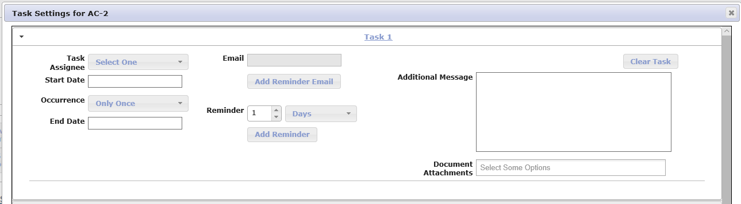

Video Link: https://attendee.gotowebinar.com/recording/5883155077189961729

